STRATEGIC REPORT
FM14-21

Estonia

Reporting period:
01 April 2021 - 31 March 2022

Contents
1. EXECUTIVE SUMMARY 3
2. Political, economic and social context 4
3. Effects of the Grants 4
4. Status of programmes 10
EE-INNOVATION Competitiveness 10
EE-LOCALDEV Local Development and Poverty Reduction 12
EE-RESEARCH Research and Education 14
EE-CLIMATE Climate Change Mitigation and Adaptation 15
5. Status of bilateral funds 16
6. Management and implementation 22
a. Management and control systems (MCS) 22
b. Complaints 22
c. Irregularities 22
d. Audit 23
7. Communication 25
8. Monitoring and evaluation 26
a. Monitoring 26
b. Evaluation 28
9. Issues for the annual meeting 28
ANNEXES 28
Annex A: Risk assessment and management plan 29
Annex B: Evaluation plan 36
Annex C: Cooperation with Donor Programme Partners and International Partner Organisations 37
Annex D: Technical assistance report 39
Overview of main activities 39
Budget overview 41
Procurement 41
Staffing 42

1. EXECUTIVE SUMMARY
State Shared Service Centre, acting as the National Focal Point (further referred as NFP) for the implementation of the EEA and Norwegian Financial Mechanism in Estonia has prepared the Annual Strategic Report No. 4 on the Implementation of the EEA and Norwegian Financial Mechanisms 2014-2021 in Estonia (further referred as the Strategic Report). The Strategic Report reflects the implementation of the financial mechanisms during the period from 1 April 2021 (next day of the cut-off of previous Strategic Report) to 31 March 2022.
While in 2021 programmes/projects and Estonia overall begun to cope with the long lasting COVID-19 situation quite well, the new crisis caused by Russia’s invasion to Ukraine brought new uncertainty. Nevertheless the status of programmes can be considered good. The commitment rate is 86% (31 March 2022) compared to 64% with the cut-off date of the previous Strategic Report (31 March 2021). The disbursement rate[1] has doubled since the cut-off date of the previous Strategic Report (from 12% to 24%). By the end of 2022 NFP foresees the commitment rate to be around 95% and the disbursement rate to be around 44%. The years of 2022-2024 are foreseen to be the most active implementing years.
All programmes are in full implementation now. All 13 pre-defined projects concerning all 4 programmes are carrying out their activities. 20 out of 21 calls have been launched, the final call under EE-Climate programme will be launched in April 2022. EE-Innovation programme plans to have a restricted call with the surplus funds in autumn 2022.
Given the complicated situation the absorption of bilateral funds can be considered satisfactory. Alternative solutions to initially planned activities have been searched, virtual channels have been used. Alternative thinking instead of waiting for better times has been and will be encouraged. As a result, two bilateral initiatives have successfully finished their activities during the reporting period with being able to meet physically. And there are many more good examples in ongoing initiatives with events recently organised or events coming up. The Joint Committee for Bilateral Funds (further referred as JCBF) is coming together twice a year and/or is discussing Bilateral Fund matters virtually or in written format in order to be up to date with progress made, challenges faced and in order to share experience/give advice.
The main risks faced are the delays that are likely to occur due to the situation caused by COVID-19 and the refugee crisis caused by Russia’s invasion to Ukraine. There is a risk of low possibility of cooperation among Estonian and donor state organisations at project level due to COVID-19 pandemic and its consequences. Changes in the economic environment (inflation, logistics, demand etc) caused by Russia’s invasion to Ukraine may lead to insufficient project financial resources to acquire all needed goods and services for the successful implementation and delivering all results promised. The risk of violating state aid rules is still high as the rules and the area overall is quite complicated. Overall risk level of programmes is 2 on a scale of 1 to 4. Although the complicated situation in the world is a big threat to meeting indicators, staying in the timeframe, bilateral cooperation etc, the overall risk is not considered very high due to the good communication and active monitoring of the situation.
Looking forward, the most crucial challenge in the second half of 2022 is to react effectively to the consequences of the crises in the world and the risks foreseen (Annex A) in order to minimize the negative effect they might have on the EEA and Norwegian Financial Mechanisms 2014-2021 in Estonia. All parties have to communicate/cooperate and respond quickly in order to have projects implemented before the end of the eligibility period and outputs, outcomes, objectives of programmes achieved.

[1] Incurred expenditure (payments to PPs) on the basis of our information system SFOS

2. Political, economic and social context
In 2021 the Estonian economy was already recovering from the Covid-19 pandemic. As a whole, the economy grew by 8,3% exceeding the pre-pandemic levels.
The full-scale Russian invasion is now the next shadow and potential risk factor over the successful implementation and is slowing down the recovery from the negative impact of the Covid-19.
According to the prognosis of Estonian Bank Russia´s invasion of Ukraine will affect the Estonian economy through supply difficulties and higher inflation. The Estonian economy will grow strongly during 2022 by over 9% in euros at current prices, but the counter effect of inflation means real growth in the economy will probably be close to zero or even negative.
Unemployment will increase because of the economic difficulties. Employment will fall in reaction to the difficulties in the economy, though its sensitivity to this recession will be weaker than that during the pandemic, as businesses have smaller buffers in their labour. Unemployment will also rise because refugees from the war in Ukraine will be added to the labour force and will at first be looking for employment.
Number of registered unemployed persons (including the number of new registered unemployed persons) was 36 681 on 29.02.2020 and 57 103 on 11.02.2021, 57 566 on 8.04.2021 and decreased by the end of 2021 to 44 109.
The refugees have been registered as unemployed since 10.03.2022 and on 04.04 there were 2096 persons registered, which is 4,5% of the unemployed persons.

3. Effects of the Grants
The year 2021 has been the 2nd full year of implementation and the programmes are contributing in addition to programme specific outcomes also to national high-level objectives despite the negative effects of COVID-19. Activities were adjusted accordingly, and progress has been made supported also by the economic recovery during the year.
Estonian Government has set in the Competitiveness Strategy “Estonia2035” five key strategic goals, with indicators and steps to be taken to cover national development needs and enable moving towards reducing social and economic disparities as well as moving towards global objective of sustainable development. Smart and active people caring for one´s health, open, caring and cooperative society, strong, innovative and responsible economy, good living environment and innovative, reliable and people centered governance. Support under EEA and Norwegian Financial Mechanisms contributes with activities running under the programmes moving towards every objective.
The innovation capacity of companies has increased in recent years. Innovation capacity is characterized by productivity per employed person.
By the end of 2020 the level of productivity per person employed was higher than the year before and above the objective set for 2020 in the Estonian competitiveness strategy “Estonia2020” - 80,8% (77,9% in 2019, 76,8% in 2018 and 74,5% in 2017). By the end of 2021 the achievement level was 84,8%. The national objective for 2035 is 110% of the EU average.
Estonia´s place in the Innovation Scoreboard published in the summer of 2021 also shows progress, Estonia is considered to be one of the top ten innovators in Europe. Estonia´s results improved by more than 20% compared to a year earlier.
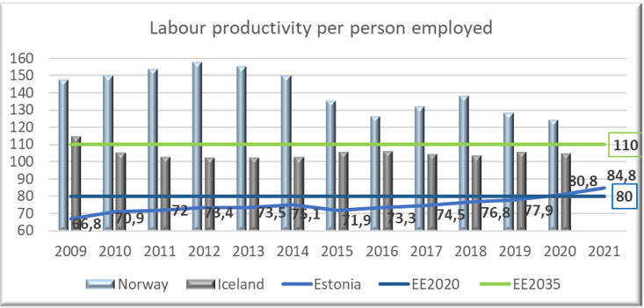
Source: Eurostat
The share of R&D expenditure in gross domestic product (GDP) amounted to 1,79% in 2020 (1,63% in 2019, 1,42% in 2018, 1,28% in 2017). The target level of 3% set for 2020, was not achieved. In the national long-term development strategy “Estonia 2035” the objective is to achieve 2% R&D expenditure in the private sector. Baseline reference value was 0,89% in 2019 and in 2020 the achievement level was slightly higher – 1,01% of GDP.
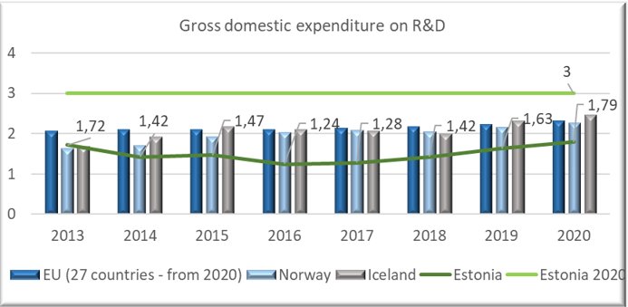
Source: Eurostat
As an impact of COVID-19 crisis the employment rate in the age group 15 to 74 fell to 66,7% in 2021 being 68,4% in 2019. The labour force participation rate was 71,1% in 2021, falling by 0,5 percentage points compared to 2020. Unemployment rate fell from 6,8 in 2020 to 6,2% in 2021 (being 4,4% in 2019).
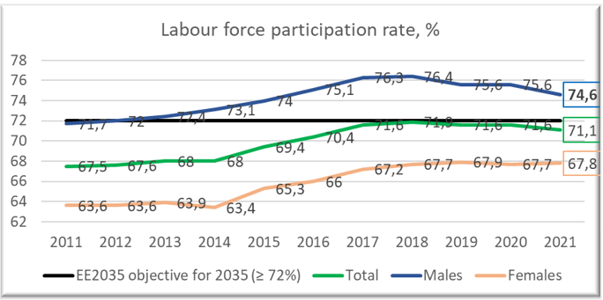
Source: Statistics Estonia
The EE-Innovation programme projects with strong focus on innovation contribute to increasing the capacity of R&D and uptake of new technologies, business, and service models, leading to improved value chains.
The projects also contribute to raise in share of R&D investments, increased productivity, but also the objectives of lowering the CO2 emissions and increasing the healthy life years.
The EE-Research programme contributes among others to the objectives of the Estonian R&D&I strategy 2014-2020 and to the new TAIE Strategy for 2021-2035 to enable high level and diverse research, the efficient networking of research institutions and that Estonia would be active and visible in international RDI co-operation, which helps to solve the tasks that Estonia and other countries are facing in different sectors whether health, technology or environment.
The EE-Localdev programme contributes to diverse essential objectives like reducing violence, including gender-based violence and increasing gender equality (virtual centre of expertise, victim support system development, public awareness on domestic violence, trafficking in human beings and implementation of community-based restorative justice with the aim to restore the circumstances prior to offence), these are specified in the strategies “Violence prevention agreement 2021-2025”, General Principles in “Criminal Policy up to year 2030” and “Welfare Development Plan 2016-2023”. Activities aiming at reducing regional health inequalities contribute to the “National Health Plan 2020-2030”. Decreasing the number of youth unemployment and early leavers from education and training (transition programmes from basic education to VET, smart youth work etc.) and at risk of poverty rate are among the objectives of “Youth Field Development Plan 2021-2035” and “Education Strategy 2035”.
In the national long-term development strategy “Estonia 2035” the objective is to reduce the rate of persistent relative poverty to ≤ 15.6%. Baseline being 16,7% in 2018 and 13,8% in 2019.
Youth unemployment has been decreasing over the years, but increased again during the Covid-19 crisis and the objective of “Estonia 2020“ was not achieved.
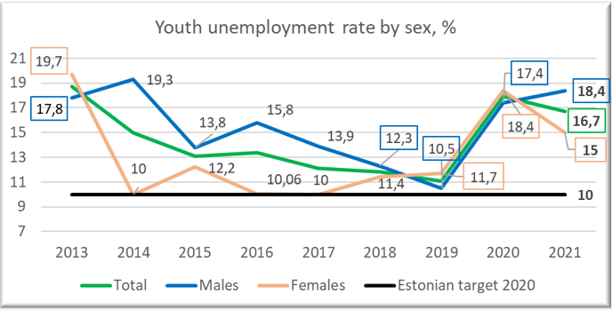
Source: Statistics Estonia (TT330)
The level of education significantly affects the risk of falling into poverty. The share of early leavers from education and training (18-24-year-olds) was 7,5% in 2020 (9,8% in 2019, 11,3% in 2018 and 10,8% in 2017).
COVID-19 restrictions have negative impact on young people´s ability to cope and learn and increase the risk of exclusion or falling into NEET status. According to Statistics Estonia, in 2021, the NEET rate has risen to 10,8% (10% in 2020, 7,6% in 2019).
Most NEETs are young people with basic and general secondary education. The youth unemployment rate in the age group 15-26 has slightly declined from 14.9% in 2020 to 14% in 2021 but it was significantly lower before the COVId-19 crisis - 8.8% in 2019.
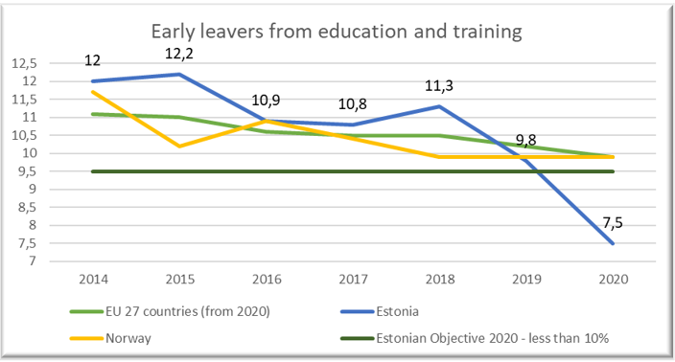
Source: Eurostat[1]
According to the European Institute for Gender Equality Estonia ranks 17th in the EU on the Gender Equality Index for the 2021 with 61,6 points out of 100. Estonia´s score is 6,4 points below the EU´s score. According to Statistics Estonia, the gender pay gap was 15,6% in 2020 (17,1% in 2019, 18,0% in 2018, 20,9% in 2017, 24,6% in 2012).
Despite the Estonian government´s clear commitment and measures taken, gender-based violence remains a challenge for Estonia, with projects under Norwegian Grants preventive actions can be taken. 2563 victims of gender-based violence were assisted in the supported shelters already in 2020, 2397 in 2021.
In 2020, the growth in the number of domestic violence crimes stopped, there were 3987 cases of domestic violence registered, which is 3% less than in 2019 and the downward trend continued in 2021. There were 3760 cases of domestic violence, which is 6% less than in 2020.
According to preliminary data, the number of domestic violence-related homicides (including attempts) fell to its lowest level in recent years, 3 cases were registered in 2021. Compared to 14 in 2020, 7 in 2019, 11 in 2018 and 15 in 2017.
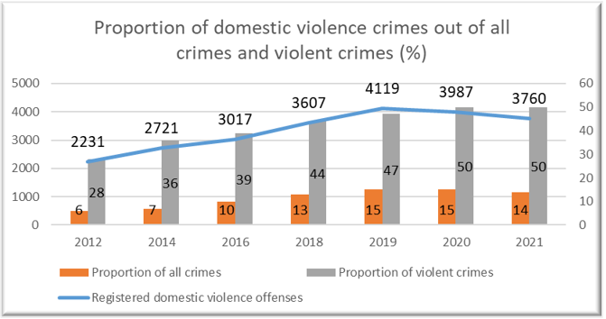
Source: Ministry of Justice
The EE-Climate programme contributes to national objectives in the field of climate and energy, to high level objectives of reduced CO2 emissions and increased share of renewable energy in final energy consumption. Support under the European Economic Area funds enabled preparation of climate and energy plans for local authorities.
Estonia aims to reduce greenhouse gas emissions by almost 80% by 2050 compared to 1990 emission levels. This entails reduction of 70% by 2030 and 72% by 2040.
According to the Estonian greenhouse gas inventory data for 2020, the total greenhouse gas emissions were 12,8 million tons of CO2 equivalent (18,8 million tons in 2018 and 14,3 in 2019). Compared to 1990, Estonia's total GHG emissions have decreased by 65%. The downward trend in greenhouse gas emissions is continuing, but it should be considered that total emissions were lower than expected due to the COVID-19 pandemic.
Estonia has already met its 2020 renewable energy target of 25% in gross final energy consumption and is on good track to meet the 2030 target of 42%.
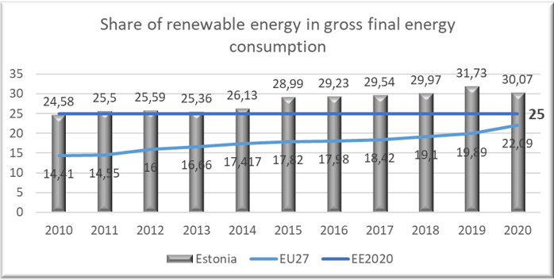
Source: Eurostat[2]
Due to COVID-19 still affecting the everyday life in 2021, strengthening bilateral relations has not gone as initially planned. COVID-19 pandemic has restricted the possibilities of organising physical matchmaking events between Project Promoters (further referred as PP) and donor/foreign project partners. But thanks to the adaptation to the situation and the introduction of new means of communication and digital technology, the projects have succeeded in developing remote cooperation, which on the other hand has made communication faster and, in some cases, more convenient. Partnerships already made are strong and even new partnerships have been agreed during this complicated phase and furthermore some new ideas for initiatives with donor state partners are in process. Hopefully now that the pandemic seems to be receding, there will come more opportunities for PPs and Partners to meet physically during the implementation of the project and also opportunities for the Programme Operators (further referred as PO) to start organising possible events to strengthen bilateral relations. Today it is too early to say how much the crisis in Ukraine and due to that in the whole world affects bilateral relations with donor states. Despite the ongoing crisis and the new crisis no major losses are foreseen if POs and PPs continue to consider alternatives in their way, re-schedule and adapt to the situation when needed and search for creative solutions.

[1] https://appsso.eurostat.ec.europa.eu/nui/show.do?dataset=edat_lfse_14&lang=en
[2] Statistics | Eurostat (europa.eu)

4. Status of programmes

EE-INNOVATION Competitiveness

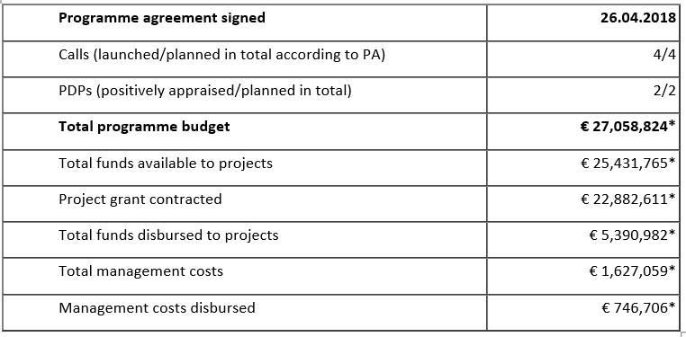
*Norway grants + national co-financing, national information system, cut-off 31.03.2022.
First Small Grant Scheme call resulted with 42 implemented projects and payments done in total amount of 691,895.79 euros.
After two main calls there are 34 supported main call projects:
I main call: 44 submitted applications, 22 supported projects (14 bilateral partnerships), grant in amount of 19,397,597.55 euros.
II main call: 18 submitted applications, 12 supported projects (3 bilateral partnerships), grant in amount of 6,375,554.71 euros.
Due to uncertainty towards the future, participation of Estonian and Norwegian entrepreneurs in open calls of EE-Innovation programme has been a bit less active than predicted. The interest towards the second main call can be considered modest compared to the first call, with total of 18 applications submitted. As a lesson learned we see that limited communication due to COVI-19 has negatively affected the bilateral cooperation in the programme. That is also reflected in the results of the second main call as well as bilateral indicators not achieved.
In addition to open calls for proposals launched during previous reporting periods, PO and implementing agency launched another open call for proposals (Small Grant Scheme) in focus areas of Green Industry Innovation and Welfare Technologies with budget of 2,636,915.33 euros in autumn of 2021. Nine applicants applied grant in amount of 1,511,667.50 euros. One application was non-compliant with requirements of the programme and did not qualify for evaluation. Selection Committee discussed eight applications at the Selection Committee meeting on March 31, 2022. Independent evaluators had rated one of the projects below the required threshold and Selection Committee had some doubts regarding another project application. Selection Committee downgraded it below the required threshold after re-evaluation. Finally, Selection Committee made a suggestion to finance six projects in grant amount of 969,217.50 euros.
That leaves 1,667,697.83 euros available for projects currently in implementation process that are interested in additional activities for enhancing project results. A restricted call for proposals is planned to be launched in autumn 2022.
Both predefined projects have started their planned activities. They are slightly behind the planned schedule due to slow start but expected to be in full implementation speed soon. There is a need for extending the implementation deadline of “Health Sense” project. We hope to report first results in both projects in early 2023.

EE-LOCALDEV Local Development and Poverty Reduction
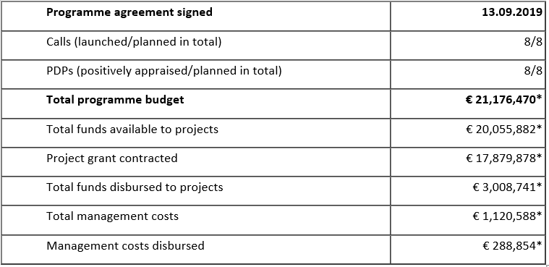
*Norway/EEA grants + national co-financing, national information system, cut-off 31.03.2022.
The programme has entered into a full-phase implementation period. All 8 pre-defined projects within the programme are carrying out their activities. The projects are running satisfactorily and are being flexible in making necessary shuffle in the original timescale and – in case feasible – implementing some of the activities virtually. The eligibility period of PDP-s No 3, 4 and 8 is set to end in the 2nd half of 2022, but the PPs have informally indicated that they would need an extension of the eligibility period to successfully carry out all activities foreseen.
All 8 different calls for proposals have been carried out:
- Outcome 2 SGS “Training of domestic violence specialists and establishment of a programme(s) for sex buyers” à 3 projects have been awarded a grant and contracted, the last of the three started in Sept 2021.
- Outcome 2 open call “Awareness raising activities on domestic violence and to discourage the demand for commercial sex“ à 1 project has been awarded a grant, contracted, and is running as of May 2021.
- Outcome 4 open call “Historic old town centres with cultural heritage protection areas“ à 7 projects have been awarded a grant and contracted, all running as of May 2021.
- Outcome 1 SGS “Developing Restorative Justice Measures in Estonia” à 1st tranche of the SGS: 3 projects have been awarded a grant, contracted, and are running as of July 2021. 2nd trance of the SGS: application submission deadline was March 21, 2022; approx. 5-6 project are expected to be financed and to start their activities in 2nd quarter of 2022.
- Outcome 1 SGS “Implementation of Vocational Orientation Curriculum in Vocational Education Institutions” à 12 projects have been awarded a grant and contracted, 10 out of 12 have started their activities by Sept 2021, 2 projects have had still problems in initiating their activities (completing students for a career orienteering class). They have indicated to make a greater effort during the summer recruitment period of 2022.
- Outcome 3 open call “Integrated services to support health and safety in home environment” à 2 projects have been awarded a grant, contracted, and are running as of Sept 2021.
- Outcome 1 open call “Smart Youth Work Solutions” à The initial selection process was carried out in the summer of 2021. Before any formal grant decisions were made, the Auditing Authority as well as the National Focal Point saw it necessary to carry out the selection process from the beginning in order to eliminate any accusation of conflict of interest. This derived from the fact that the 2nd tier of selection process, i.e. the Selection Committee had included experts from the Ministry of Education and Research (MoE) and one of the projects under discussion was Education and Youth Board that is a government institution subject to Minister of Education and Research.
Therefore, the PO started a new selection process. Both projects were given an equal opportunity to improve their project proposals according to the deficiencies and comments brought out by the independent experts. Programme Operator Implementing Agency (State Shared Service Centre) carried out the assessment of the project applications and were forwarded for evaluation by new impartial, independent, and reliable experts. As a result, 2 projects were awarded a grant, contracted, and are running as of March 2022.
- Outcome 1 open call “Integrated services provision to prevent early school leaving” à application submission deadline was Jan 17, 2022, evaluation process is under way; approx. 5-6 project are expected to be financed and to start their activities in 2nd quarter of 2022.
By cut-off date there have not been too big obstacles in EE-LOCALDEV programme related to project activities, most difficulties have occurred due to Covid-19 restrictions in the field of bilateral relations – finding donor project partners while submitting the project applications as well as implementing bilateral activities between partners (public health situation all over the world, travel restrictions etc). Still, a lot has been successfully carried out behind the desk and virtually. In case the situation would normalise in 2022 and no severe surges and restrictions occur, then there is still good chance to achieve positive results and bilateral cooperation via the programme until the eligibility end date of bilateral activities in April 2025.
On the other hand, the war in Ukraine has destabilised significantly the world and economy – inflation, logistics, labour force shortages – that could have a destructive effect on the projects, especially financially, when the budgeting made in 2020-2021 could not be sufficient any more to cover the project costs needed to achieve the results promised.

EE-RESEARCH Research and Education
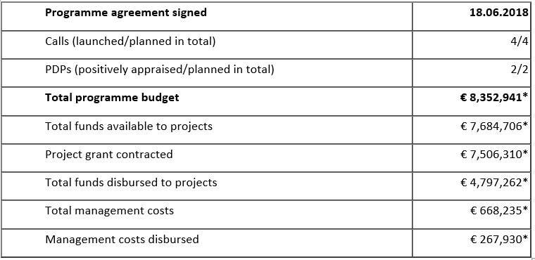
* EEA grants + national co-financing, national information system, cut-off 31.03.2022.
In the context of the second year of the pandemic, it has been a continuous challenge to achieve the programme’s objectives – reduce social and economic disparities and strengthen bilateral relations.
On March 10, 2021, the 3rd and last call for cooperation projects for higher education institutions was announced. The call was open until May 10. 13 proposals were received from which 4 were decided to grant. Although it was not possible to organize face-to-face meetings to increase the visibility of the application round, the competition received the usual number of applications. Therefore, it can be said that universities are ready to overcome the challenge of implementing cooperation projects in a pandemic situation and remain optimistic when planning international cooperation.
In October 2021, the programme agreement (“EE-Research (Baltic Research Programme)” was amended. The amendments were necessitated by the need to amend the outcome 2 conditions set for the eligible project partners and specify that at least one partner from the Donor States must be a public or private higher education institution.
In total, 19 projects (7 research projects led by Estonian scientists with partners from Latvia, Lithuania, 2 pre-defined projects and 8 higher educational projects) in cooperation with Norway and Iceland have been continued the implementation of joint projects with the aim of achieving the major goals of the Baltic Research Programme. Last open call for higher educational projects resulted in 4 projects: 2 projects signed their contracts in 2021, 2 of them did it early in 2022.
Social distancing, national measures and travel restrictions to contain the pandemic affected the implementation of projects in all participating countries. In the higher education cooperation projects, meetings and courses organised in the partner country are integral part of the action plan. Often, the pandemic situation and restrictions varied from country to country - when one country was ready to travel or host, the restrictions were adopted by another and vice versa. In research projects, majority of conferences organized or attended were online, and only few were face to face conferences.
Due to Covid-19, the involvement of external experts – researchers from the UK, Canada, Spain, Portugal, Denmark, Sweden, Finland – has also been somewhat difficult. The inability to conduct planned research visits abroad has significantly reduced the scope for multilateral collaboration between research teams to exchange complementary skills, knowledge and resources to jointly address a research problem. There have been delays in some research activities (e.g. data collection, field work) and publication.
In higher education, all contracted projects have started their activities, although they needed to be flexible and resourceful in implementing their work plans. The possibility of organising events virtually in case of urgency has certainly brought some relief. Despite the pandemic, all cooperation projects are progressing well.
Lessons learned from implementation: in the higher education part of programme, there is a need for greater clarity on the principles for implementing state aid when granting support to private higher education institutions. Different parties have different views, which has made the final decision-making process on this issue excessively time-consuming. One idea for a new period will be to design a call only to public law universities for applying a grant.

EE-CLIMATE Climate Change Mitigation and Adaptation
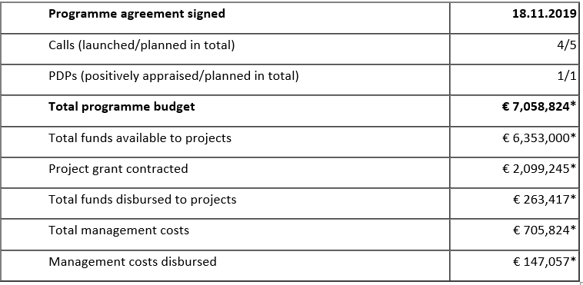
* EEA grants + national co-financing, national information system, cut-off 31.03.2021.
Since the cut-off date of the last strategic report, there was a third programme agreement modification made in the EE-Climate programme. This modification was about splitting the open call 3 into two, keeping the climate change awareness activities under open call 3 and implementing the activities related to the framework of circular economy under pre-defined project.
By cut-off date, 4 open calls from 5 have been published and also closed already.
Outcome 2 SGS: ”Climate change mitigation and adaption plans” - > 19 applications received, 10 projects awarded with grant, all contracted and running. 7 projects with donor state partners.
Outcome 1 open call “Ecosystem resilience increased” -> 2 applications received, 2 projects awarded with grant, all contracted and running. 2 projects with donor state partners.
Outcome 3 pre-defined project “Enhanced capacity of Circular Economy” –> Project contract signed and project activities have started. Project has a donor state partner.
Outcome 3 open call “Circular Economy pilot measures” -> The call was open from 13.12.2021-14.02.2022. There are 4 project applications in the ongoing evaluation process. 2-3 projects are expected to receive the awarding of the grant.
Outcome 2 open call “Raising awareness on climate change” -> The call was open from 10.01.2021-14.03.2022. One project application was received and the evaluation process is ongoing.
Outcome 2 open call “Climate change mitigation and adaption measures” -> The call is to be launched on 18.04.2022.
There has not been any big challenges related to absorption/disbursements, as all planning, launching calls and starting with the projects has been done virtually so far (due to COVID-19) .

5. Status of bilateral funds
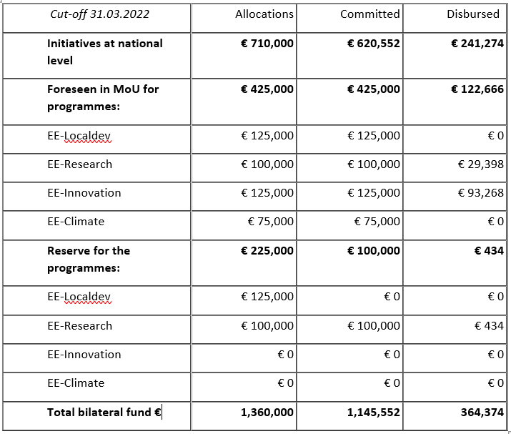
COVID-19 restrictions have affected bilateral funds the most. Meetings that can be held virtually (eg JCBF/CC meetings, opening events, conferences, workshops, seminars) have been held virtually and some meetings that are better held physically (eg study visits) have been postponed, although more and more face-to face meetings can already be arranged. Project periods have been extended where necessary. Unfortunately we have to live with two crisis now, while Russia’s invasion to Ukraine is a crisis that also affects the whole world. All people in Estonia are somewhat now involved in helping to mitigate the refugee crisis in Estonia therefore affecting the availability and the mental as well as physical health of human resources. And changes in the economic environment (inflation, logistics, demand etc) may lead to insufficient project financial resources to acquire all needed goods and services for the successful implementation.
Under the COVID-19 and the refugee crisis circumstances and having still 3 years until the end of eligibility period of Bilateral Fund initiatives, NFP considers the absorption satisfactory. Although the numbers in some cases (eg EE-Localdev, EE-Climate, EE-Research) are still quite low, there are concrete plans/ideas that lead us to believe that the disbursement rate for Bilateral Fund activities will start growing faster. NFP will support POs and PPs in their challenges throughout both crises.
There have been two JCBF meetings since the cut-off date of the previous Strategic Report: in June 2021 and in April 2022. One new initiative „ECOC 2024 Duo networking“ was presented in June 2021 and approved in July 2021. Two additional initiatives were approved via written procedure in July and August 2021: “Co-operation between Pärnu county and Viken county” and „From Nidaros to Novgorod: Cultures Along the Historic St Olav Routes. An Estonian-Norwegian Cooperation Project in Humanities Research“. April 2022 meeting had also one new initiative proposal: a co-operation project between the Louis Kahn Estonia Foundation and the Oslo School of Architecture and Design “Estonian - Norwegian Cooperation Towards a Sustainable Architectural Education and Diverse Creative Output” (final minutes of the meeting have not approved yet). There have also been indications that Estonian Forensic Science Institute (Estonia) and National Criminal Investigation Service (Norway) want to do a cooperation project. They are aiming for the proposal to be sent for the next JCBF meeting in June 2022. The use of NO/EEA funds to address the refugee crisis in Estonia was also an important topic. NFP has had discussions with several relevant authorities on that topic and Social Insurance Board has presented initial idea for initiative focusing on psychological help. JCBF members considered it to be an important measure to mitigate refugee crisis in Estonia and now the initiative is being written in a bit more detail and submitted as soon as possible. The next JCBF meeting is planned to be held in June 2022 before the Annual Meeting.
In addition to that NFP has also actively participated in Cooperation Committee meetings and other meetings with POs where programme level bilateral issues are discussed.
National Level initiatives finalised in the reporting period
The initiative “Estonian-Norwegian cooperation in the United Nations and its Security Council: Defending and renewing multilateralism” with the budget of 66 697 EUR was approved by the JCBF in May 14, 2020. The project period was from May 2020 to December 2021. Beneficiary State entity Estonian Foreign Policy Institute of the International Centre for Defence and Security (EFPI/ICDS) in cooperation with the donor partner Norwegian Institute of International Affairs (NUPI) were able to finish the project successfully. Policy paper “Small States, Different Approaches: Estonia and Norway on the UN Security Council” was written. Final conference was physically held in Tallinn, November 18, 2021 (75 people attended physically + 230 people watched via Livestream). Final costs of the project are 62 961 EUR.
The initiative “Co-operation between Pärnu county and Viken county” with the budget of 18 000 EUR was approved by the JCBF in August 4, 2021. The project period was from August 2021 to February 2022. Beneficiary State entity the Association of Local Authorities of Pärnu County in cooperation with the donor partner Viken Fylkeskommune, Fylkestinget were able to finish the project successfully. Study trip to Norway took place in the beginning of September 2021. The project aim was fulfilled, which was to bring local political leaders from Pärnu and Viken together to discuss the present situation and find the best solutions for the future co-operation. Together with celebrating the 30 years of co-operation, the book “Pärnu and Buskerud county” was published in Estonian in February 2022. The book focuses to the most successful and interesting projects. Final costs of the project are 18 000 EUR. the Association of Local Authorities of Pärnu County has submitted an additional initiative proposal in order to publish the book also in Norwegian.
Ongoing initiatives at National Level
The initiative “Co-operation for decent work and fair competition in labour market” with the budget of 151 500 EUR was approved by JCBF in 2018. Learning visits to Norway and to Estonia took place in autumn, 2021. Annual meeting was held virtually in December 2021. The monitoring work in both countries is still disturbed. Estonian Labour Inspectorate is waiting for proposals from the Norwegian partner for joint inspections. Joint communication campaign „Know Your Rights“ activities have been done and will continue as planned (https://www.arbeidstilsynet.no/en/knowyourrights). 2022 plans involve learning visits, joint inspection if there are no restrictions, communication campaign activities, annual meeting. There might come problems with resources while the priority now is the refugee crisis. They will not probably use the whole budget by the end of 2022 (the end of project period) and therefore would probably be interested in extending the project period.
The initiative „Estonian-Icelandic Cooperation Towards a Sustainable Artic“ with the budget of 9 500 EUR was approved by JCBF in October 2020. The planned project period is from October 2020 to June 2022 (extended twice due to COVID-19). Beneficiary State implementing entity is the Estonian School of Diplomacy and donor implementing entity is the Institute of International Affairs IIA (University of Iceland), donor project partner is the Icelandic Centre for Research (Rannis). The aim of this proposal is to recognize and promote early stage development, strategy planning, capacity building, networking and awareness of cooperation between the Estonian School of Diplomacy and the Institute of International Affairs at the University of Iceland with specific focus on Arctic affairs and hybrid threats. It has been agreed to organise one bigger more substantial and visible event in Iceland with the same budget and same targets in May/June 2022 instead of two smaller physical visits foreseen in the proposal initially.
The initiative „e-Healthcare Initiative: providing equal treatment opportunities for everyone“ with the budget of 60 000 EUR was approved by JCBF on 26.11.2020. The planned project period is from November 2020 to December 2022. Beneficiary State implementing entity is SA Tallinn Science Park Tehnopol, donor partners are Norwegian Smart Care Cluster, HelseINN, Conteir AS and Estonian partners are AS Hoolekandeteenused, Viljandi Hospital. The mission for the e-Healthcare Initiative is to educate, promote and activate health and social care institutions in the use of distance-spanning technologies with the goal of providing equal treatment opportunities for everyone. The opening event was held virtually in the end of April, 2021 and virtual workshop “Service design for distance-spanning technologies in healthcare: theory and best practices from Estonia and Norway” was organised in March 2022. 2022 plans involve two visits (Estonia and Norway) and two workshops. The biggest challenge is to build good connections with donor partners. This might lead to changing partners or involving new partners and most probably the need to extend the project period. NFP will ask for updated information and keep an eye on the project activities.
The initiative „ECOC 2024 Duo networking“ with the budget of 83 600 EUR was approved by JCBF in July 2021. The planned project period is from July 2021 to October 2022. Beneficiary State implementing entity is Tartu2024 Foundation, donor partner is Bodø2024 Intercommunal co (IKS). The outcome of this initiative should be a well-connected matrix of cultural partners in the two cities, ready for the final stages of European Capital of Culture (ECOC) preparations. Bodø 2024 team (with Connecting Waste and Norwegian Aviation Museum) managed to visit Tartu in the end of March, 2022. Tartu 2024 team (with Estonian organisations) will visit Bodø next.
The initiative „From Nidaros to Novgorod: Cultures Along the Historic St Olav Routes. An Estonian-Norwegian Cooperation Project in Humanities Research“ with the budget of 150 000 EUR was approved by JCBF in August 2021. The planned project period is from August 2021 to October 2023. Beneficiary State implementing entity is Tallinn University, donor partner is Norwegian University of Science and Technology (NTNU). Scandinavian-led Nordic-Baltic trade system in the period between the Viking age and the area of the domination of the Hanseatic League is a largely unexplored field of research. This initiative allows to launch an active debate about the cultures along the historic St Olav routes both locally and across regions involving all relevant institutions. There have been site visits together with donor partner in March 2022 and 2022 plans involve workshops, fieldwork and archaeological investigations.
EE-Innovation
A webinar under the focus area of Welfare Technology was organised on December 14th, 2021. The main objective of the event was to attract Estonian and Norwegian companies to form new partnerships and participate in the ongoing Small Grant Scheme (available on www.eas.ee/norwaygrants). Event was organised in close cooperation with donor programme partner Innovation Norway. Feedback from participants was positive; they appreciated the chance to take part in a professionally organised virtual event during the continuous restrictions due to spread of Covid-19.
Plans for 2022 in cooperation with Innovation Norway have been made. Interested Estonian companies will have a chance to take part virtually in Blue Growth conference in Greece in May 2022. It will involve participants from countries (Croatia, Greece, Poland, Portugal and Romania) with business programme that have blue growth focus area and also participants from countries that have business programmes and interest towards business opportunities in blue growth (Bulgaria, Estonia, Latvia, Lithuania and Slovakia).
Another idea that has been discussed is to offer Estonian companies an option to visit a space centre in Norway. It would be an excellent chance for Estonian, Latvian, Lithuanian and Norwegian companies to exchange their ideas, discover other business opportunities connected to space and start to cooperate in the field.
At this point of time it is foreseen that the allocation confirmed in MoU (125 000 euros) will be absorbed by the end of the eligibility period.
EE-Localdev
Bilateral activities in the area of restorative justice – that were agreed upon already in year 2020 – will launch in April (youth exchange workshop as well as 4 regional seminars). The total budget for the activity is 20 875 euros.
Bilateral finances earmarked for the cultural heritage protection area in the sum of 33 520 euros are being re-focused as the original request how to use the funds did not realise due to the Covid-19 pandemic. The Ministry of Culture in cooperation with the donor partner Riksantikvaren are actively reshaping the activity linking cultural heritage protection with climate issues.
At this point of time it is foreseen that the allocation confirmed in MoU (125 000 euros) will be absorbed by the end of the eligibility period.
EE-Research
Regular skype meetings were held between the Baltic Research Programme PO´s and implementing agencies from Estonia, Latvia, Lithuania and Norway (RCN). As started from 2019, donor programme partners (RCN, DIKU) and Baltic counterparts have been regularly consulted through e-mails, video and phone conferences. Programme operators and implementing agencies took part in the PO seminars organised by donor programme partners in December 2021.
In May 2022 EARMA conference will take place in Oslo and Baltic Research Programme will be represented in discussion table with the theme: A unique opportunity to promote regional cooperation between scientists, research institutions, national policy makers and policy implementers. Also POs seminars (for research and education PO´s separately) in Norway will be planned for May.
The first activity in the Baltic-EEA Research Managers Cooperation Project funded by the bilateral fund, took place in November 2020 when a webinar “Mental Well-being and Joy of Work in Times of Pandemic” was held. After a keynote presentation by Dr Kelli Lehto, the Nordic and Baltic colleagues shared their good practices related to the topic.
In May 2021 joint hybrid seminar of Latvian Council of Science, Estonian Reserch Council and Research Council of Lithuania for the Analytics teams´ was held. The aim of this seminar was to exchange experiences between analysis teams and to find possible ways for cooperation. Most of research administrators use different data in their work. It is therefore very important that the data is collected correctly and that the analysis is carried out correctly. Comparable data to other countries are increasingly needed.
At the end of March 2022 “Train the trainer” seminar for EEA-Baltic NCPs will take place in Tallinn which objective will be to get practical knowledge and additional experience on good presentations and knowledge transfer and especially on the design and implementation of training packages, to increase trainer skills for NCPs etc. Participants will be from Estonia, Latvia, Lithuania, Norway and Iceland.
At the end of April 2022 joint study visit to Brussels will be planned for Baltic research administrators, project managers, researchers, with a thematic focus on cities and environment. The two-days training is organised by the Estonian and Lithuanian Liaison Offices for EU RTD in Brussels in cooperation with NORCORE, RANNIS and the Latvian Council of Science and is supported by the EEA and Norway Grants Funds for Bilateral Relations. The aim of the study visit is to increase the professional capacity of project managers by providing targeted information with added value from Brussels. Study visit will consist of presentations and interactive sessions during which the participants will be able to share their experience and best practices.
The main activity planned for autumn 2020 – the Nordic-Baltic Conference on International Research Cooperation - had to be cancelled due to the pandemic and postponed until June 2022. In June 9th an inspiring conference “The role of research funding organizations in a shifting world” will take place in Tartu. An event will be supposed to provide many good opportunities to learn from each other’s experience, to establish new contacts and networks between the staff of the research councils and research administrators from Estonia, Latvia, Lithuania, Norway and Iceland.
At this point of time it is foreseen that the allocation confirmed in MoU (100 000 euros) as well as the allocation approved by the JCBF from the Bilateral Fund programme reserve (initiative “(Joint) Baltic-Nordic Cooperation Platform for Research Managers”, 100 000 euros) will be absorbed by the end of the eligibility period.
EE-Climate
Due to the ongoing COVID-19 pandemic, no physical matchmaking events were held. All partnership search has been virtual. Fortunately a lot of projects have managed to find good donor state partners.
PO is currently preparing to make amendments in the plan for the programme level bilateral activities, that was adopted in the Cooperation Committee meeting on 19th of May 2021. They are planning a study visit regarding to the final open call “Climate change mitigation and adaption measures” to Oslo with potential project applicants to provide our applicants various examples of potential activities that could also be implemented here in Estonia, on local level. This would also serve the purpose of strengthening bilateral relations and study from the experience of Norway, also possibly find potential partners.
At this point of time it is foreseen that the allocation confirmed in MoU (75 000 euros) will be absorbed by the end of the eligibility period.

6. Management and implementation

a. Management and control systems (MCS)
The BDO LLP have conducted the Systems Audit of the National Structure in Estonia for the EEA and Norwegian Financial Mechanisms 2014-2021 on request of the FMO in 2021. The audit was conducted in May 2021 and the report was finalised in September 2021. The audit report confirmed the adequacy of the MCS. Two minor observations were made, which were closed in the FMO information system Grace in October 2021.
EE-Research programme MCS description has been amended while the implementing agency changed in August 2020 when Archimedes Foundation joined together with other educational institutions into one organisation called Education and Youth Board.
There have been no significant changes in relation to other POs and the national level MCS concerning NFP, CA, AA and Irregularities Authority, in the setup or staffing of the national authorities involved in the implementation of the EEA and Norway Grants.

b. Complaints
Until now the Irregularities Authority has not received any complaints.

c. Irregularities
All irregularity cases were reported by the implementing agencies via SFOS and checked by the Irregularities Authority.
Since the previous Strategic Report (cut-off March 2021) the Irregularities Authority has reported to FMO via GrACE four new irregularity cases: IR 54, IR 69 IR 70, and IR 75. All listed cases have been solved by Estonian authorities.
Three of the new irregularities had arithmetical calculation errors (tax or salary calculation) and the fourth had problems in public procurement regarding travel services. This procurement was not conducted due to the Norway/EMP projects but within the purchase of travel services of an enterprise as a whole, i.e., within the travel services procurement framework.
Two smaller irregular cases were not reported to FMO, they both are finalised by now and were below the threshold (EUR 2000).
From previously notified cases: IR 37, IR 46, and IR 47 have been solved by Estonian authorities and closed by FMO too. Only IR 45 is still being worked on, but we hope to solve it in the first quarter of 2022.
The first quarter report of 2022 (no new cases) will be sent by the deadline, by the end of May.

d. Audit
The background (methodology, principles etc) is described in the Audit Strategy document of AA and the results of the audits carried out were reported in the Annual Audit Report submitted in February 2022.
- Compliance audit
The Audit Authority did not carry out any compliance audits on the reporting period since all the programmes have been audited. All the compliance audits have been carried out in the previous reporting periods and since there have not been any significant changes in the management and control system, compliance audits were not foreseen.
The real functioning of the systems will be tested during the MCS audit, when planned in the AA’s work plan (will be compiled on the basis of risk assessment).
- Management and Control System Audit
The AA has taken into account that the auditors of the BDO LLP have already conducted the Systems Audit of the National Structure in Estonia for the EEA and Norwegian Financial Mechanisms 2014-2021 on request of the FMO during the year 2021.
The audit included also an assessment of whether the design of the Management and Control Systems sufficiently mitigates the main risks to the achievement of the objectives of the FM, including risks to the funding provided not being used in conformity with the applicable legal framework, whether it is proportionate, and whether it is operating effectively. The scope of the Systems Audit included the assessments of processes of the FM Management and Control Systems of the:
• National Focal Point and the Certifying Authority, which tasks are performed by State Shared Service Centre.
• Audit Authority and Irregularities Authority, tasks are performed by Ministry of Finance of the Republic of Estonia.
As a result of the audit the BDO LLP has given the unqualified opinion: in their opinion the Management and Control Systems set up and operated by the Entity were seen to be designed in compliance with all the regulatory / contractual requirements, were proportionate and operated effectively in the period from 9 May 2017 to 19 May 2021. The auditors of BDO LLP have brought out only minor weaknesses in the Management and Control Systems. As these weaknesses do not pose a significant risk to the achievement of the objectives of the EEA and Norwegian Financial Mechanisms 2014-2021, they are not considered to be material in the context of the System Audit.
The AA has analysed the content of the report, methodology and scope of the Systems Audit published by 3rd of September 2021 and made the following conclusions:
• The scope of the audit covers major entities of the FM implementation system;
• The processes have been tested also by a Programme Operator (EE-Research);
• The analysis and tests made during the Systems Audit indicate that the FM management and control systems work properly;
• Only few weaknesses have been found, but these have no financial impact on the expenditures or results of the programmes;
• There have been only few irregularities and audit recommendations during last years.
Considering all the abovementioned circumstances the AA relied on the results of the System Audit and decided not to conduct any additional system audits of the FM during the year 2021.
The new risk analyses and decisions about the scope of the Management Control System audits of the year 2022 will be made in the first quarter of the year 2022.
2. Project audits
The audit population was compiled based on the IFRs submitted to the FMC the 1st of July 2020 until 30th of June 2021, covering the expenditure actually incurred until 31st of December 2020.
The audit work was finalized in September 2021, all the project audits were without ineligible costs.
The results of the project audits are the following:
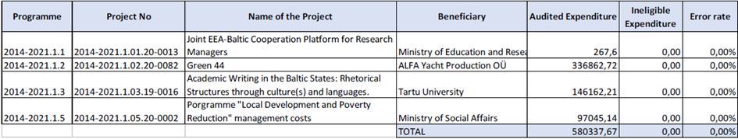
The auditors conclude from the calculations that the population does not contain material error and is not misstated; the expenditure declared to the FMO is in all material aspects legal and regular.
AA issues an opinion on the assurance to the MCSs as a whole, taking into account the results of both the system audits and the audits of operations. Based on the previously declared information, AA issued an unqualified opinion for the year 2021.
Audit work plan for 2022
For 2022, the AA has planned the following audit activities:
- carrying out risk assessment of the FMs to detect any high risk areas to be audited with the MCS audits – one system audit on programme level will be carried out. The programme implementation to be audited will be selected on the basis of risk assessment and actual expenditure made from the projects;
- carrying out sample based audits on projects as defined with the Art 5.5 (c) of the Regulations – six projects have been selected and the audit procedures have started;
- updating the audit strategy for the programming period 2014-2021 of the FMs in accordance with the Art 5.5 (d) of the Regulations.
The results of the audits on projects will be reported in the next Annual Audit Report.

7. Communication
In last three years, the public awareness has been following: 14% (2019), 14% (2020) and 14% (2021). The next public awareness survey will take place in September 2022 and the results will be public in the first half of November 2022.
Social media 2021/2023
Last year when writing the strategic report, the EEA and Norway Grants Estonia Facebook page had 568 followers. Now, by April 2022 Facebook page has 648 followers. The initial goal was that by the end of new financing period, EEA and Norway Grants Estonia page in Facebook should have at least 500 followers. As the goal was achieved, we set the next goal to 600 followers in 2021. New goal will be 700 followers and will be updated in communication strategy.
We actively keep sharing the news about grants and the projects achieved with the help of EEA and Norway grants in Estonia.
Main activities from April 2021
- Press releases about open calls in cooperation with programme operators, adding information onto webite and sharing it on social meedia. PR and news about donors giving 2 extra millions to Estonian civil society organisations in cooperation with FMO.
- Social media quiz/lottery. After answering 3 questions about EEA and Norway grants people entered to win a cooler bag and a bottle branded with EEA and Norway grants logo. 542 participants.
- Two TV clips in a TV show called “Estonia - full of experiences” presenting projects supported through Active Citizen Fund (Vabamu exhibition and Rohetiiger) in August (approx 71 580 viewers per episode with repetitions). Videos had also sponsored ads on social media (18 200 reached times watched, 3900 through plays).
- A special newspaper about the implementation of programmes and projects of this financial period inserted into Estonian most read weekly magazine Maaleht (36 000 pieces).
- 9 articles from the newspaper up in the most popular Estonian news portal Delfi. 26 539 readers in 2 weeks.
Main activities in 2022
- Updating webpage by focusing on developments, so open calls and success stories would be easily found on new webpage.
- We order again two TV clips in a TV show called “Estonia - full of experiences”. Clips will be on air in summer and afterwards we will share and boost them also on social media.
- Social media lottery/quiz again on Facebook in May.
- Ordering article(s) to a newspaper with a large readership.
- Public awareness survey in September.

8. Monitoring and evaluation

a. Monitoring
The main activities carried out/findings discovered as a result of the monitoring plan for 2021:
- Information system SFOS requirements and new functionalities have been communicated to POs and implementing agencies in more detailed way including meetings with POs/ implementing agencies, trainings to POs/ implementing agencies.
- Customer feedback survey has been conducted. Although the proportion of respondents to the questionnaire was small, the results show that satisfaction with the services provided was high. For example the cooperation with State Shared Service Centre was rated high and even if all rules might not be clear enough there are always project coordinators who happily help.
- During the commenting procedure of call texts, problems with defining state aid/de minimis aid were identified in 2020. Because of that increased focus in 2021 was on state aid/de minimis aid. NFP has encouraged POs to turn to the state aid experts in the Ministry of Finance and State Shared Service Centre while compiling call texts/writing state aid analysis and with any other related issue. NFP has forwarded training invitations to POs in that field. Risk-based check concerning determination of categories of SME-s was conducted. In the sampled projects, the final conclusions on the size of the company were correct or were defined as larger, which does not affect the legality of the aid as far as the stricter rules are concerned. There were few minor remarks for check-list improvement.
- Check of payment processing deadlines on the basis of information system SFOS report and concerning all programmes and projects. Where the deadlines were exceeded, coordinators were notified and asked for clarifications. The results show that payment process deadlines have only been exceeded in justified cases – eg irregularity relation, additional queries.
- Check of irregularity processing deadlines on the basis of information system SFOS report and concerning all programmes and projects. The results show that the deadlines are mostly exceeded in State Shared Service Centre (regarding EE-BF and EE-Localdev projects) and the main cause of that is lack of resources. Risk Management and Supervision Division of the State Shared Service Centre has recruited new staff and looked through their processes and with that it can be expected that the processing times for new irregularities will normalise.
In addition to monitoring activities listed above NFP has ensured effective implementation through following activities:
- NFP is actively involved in Annual Programme Reports commenting; calls for proposal texts commenting; programme agreements, programme MCS and other relevant documents modification commenting.
- NFP advises POs and implementing agencies on any issue that may occur regarding EEA/Norway Grants.
- NFP organises regular meetings with POs (4 times a year) in order to get an overview of the programmes, bilateral relations and discuss current and problematic areas.
- Ad-hoc meetings are also organised when there is need.
- NFP participates actively in meetings organised by POs (CC, SC and other relevant).
- NFP participates in project events (eg opening/final events) when invited and if it is possible. This also allows to see a little bit into project level and therefore helps to broaden the view and note red flags or discover success stories.
- NFP in cooperation with other organisations (eg Ministry of Finance) organises trainings (eg procurement, state aid, payments/eligibility, financial corrections, irregularities, information system), if needed.
- NFP sends out guidance letters to POs, implementing agencies of any new issue or any issue that needs to be emphasized in the point of view of NFP.
- NFP asks POs for an overview/input if necessary (for Strategic Report, for IFR, for other inquiries).
- NFP carries out risk assessment once a year. NFP gathers together POs risks and assesses risks itself and then risks are being monitored (mitigating measures set). NFP monitors risks also in APRs and assesses key risks again while compiling the Strategic Report.
- NFP checks payments on risk-basis. It means that payments of projects that have open irregularities will be checked in order not to reimburse irregular amounts. NFP also checks financial corrections.
For the second time NFP carried out the performance analysis of the functioning of the system, of every aspect of the implementing (payments, eligibility, financial corrections, irregularities, audits etc) similarly to the structural funds. This analysis together with risk assessment provided input to the monitoring plan of 2022 that was the outcome of the performance analysis. The analysis together with monitoring plan was finalised on 31st of March 2022. As a result of the analysis NFP can confirm that overall the system is functioning well but some additional monitoring activities are needed for NFP to get the full confidence. Besides the everyday monitoring activities, the main additional monitoring activities planned for the year 2022 are as follows:
- Control over procurement checking procedure in EE-Innovation programme projects will be conducted concerning PPs who are not contracting authorities in national public procurement law.
- Payment procedure risk-based check will be conducted in Education and Youth Board, the new implementing agency of EE-Research programme higher education part.
- Check of procurements regarding Environmental Investment Centre due to MCS audit regarding Structural Funds. The auditors concluded that the MCS is partially operational and that significant improvements are needed (category III). Among other recommendations, the auditors have proposed for Managing Authority of Structural Funds to carry out additional follow-up checks. Since Structural Funds and NO/EEA funds have the same implementing agency Environmental Investment Centre (NO/EEA programme EE-Climate) it was decided to extend the check to NO/EEA procurements also.
- Start with the state aid network meetings. Check of de minimis aid in Education and Youth Board and check of entering the information of de minimis aid into the State Aid Register.
- Continue with the annual check of payment processing deadlines on the basis of information system SFOS report and concerning all programmes and projects.
- Continue with the annual check of irregularity processing deadlines on the basis of information system SFOS report and concerning all programmes and projects.
The next performance analysis is planned to be concluded in March 2023.
NFP has a good overview of the implementing of EEA/Norway Grants and communication between NFP and other parties (POs, implementing agencies, CA, AA, Irregularities Authority, FMO, the Royal Norwegian Embassy) is considered very good.

b. Evaluation
The evaluation plan was initially added to the Strategic Report in 2020 and updated with the Strategic Report in 2021. All evaluations will be ex-post evaluations starting in 2023 the earliest.

9. Issues for the annual meeting
No additional issues for the Annual Meeting.

ANNEXES
A. Risk assessment and management plan
B. Evaluation plan
C. Cooperation with Donor Programme Partners and International Partner Organisations
D. Technical assistance report

Annex A: Risk assessment and management plan
EE-INNOVATION |  |  | Overall level of risk  2
Risks | Previously planned response | Actual response | Planned future response
Low possibility of cooperation among Estonian and donor state organisations at project level due to COVID-19 consequences and its possible re-emergence | PO has tight communication with the DPPs in finding and encouraging Norwegian field experts and organisations to cooperate with Estonia. PO exchanges relevant contacts, re-schedules, is flexible, uses digital solutions. NFP is closely monitoring the situation by communicating with PO. NFP will encourage PO to find alternative solutions and use more digital channels, if the situation in the world does not go back to normal. | PO has tight communication with the DPPs in finding and encouraging Norwegian field experts and organisations to cooperate with Estonia. PO exchanges relevant contacts, re-schedules, is flexible, uses digital solutions. NFP has closely monitored the situation by communicating with PO. NFP has encouraged PO to find alternative solutions. | PO has tight communication with the DPPs in finding and encouraging Norwegian field experts and organisations to cooperate with Estonia. PO exchanges relevant contacts, re-schedules, is flexible, uses digital solutions. NFP is closely monitoring the situation by communicating with PO. NFP will encourage PO to find alternative solutions.
State aid rules not clear for PPs. Risk could result in project irregularities (i.e. miscalculated eligible activities, costs and aid intensity). | Counselling of applicants continues in implementation phase.  NFP will continue to encourage POs to turn to the state aid experts in the Ministry of Finance and State Shared Service Centre and ask for guidance and trainings, if needed. | Counselling of applicants has continued in implementation phase.  NFP has encouraged POs to turn to the state aid experts in the Ministry of Finance and State Shared Service Centre and forwarded training invitations to POs in that field. | Counselling of applicants will continue in implementation phase.  NFP will continue to encourage POs to turn to the state aid experts in the Ministry of Finance and State Shared Service Centre and ask for guidance and trainings, if needed.
Projects are cancelled or activities not started due to the lack of project promoter's co-financing, thus grant cannot be paid to project promoter and set targets are not met. | Thorough assessment of project promoter's financial capability before granting and continuous monitoring of project promoter during the implementation phase. | 3 Main Call project terminations in 2021 due to PPs financial difficulties and economic burden of the COVID-19 situation. Assessments before granting have been done but financial incapability has not been obvious before granting and COVID-19 has been considered as a force majeure. | Thorough assessment of project promoter's financial capability before granting and continuous monitoring of project promoter during the implementation phase.
The delays in the timeframe of a programme may threat the implementation of activities by the final date of eligibility 30.04.2024. | Since all programmes have to face two crises in the world at the same time, then the issue of being able to implement all activities foreseen before the final eligibility date has become more relevant again. The risk has to be acknowledged and monitored. Timely and active communication is crucial. | Timely and active communication is crucial. | Timely and active communication is crucial.
Changes in the economic environment (inflation, logistics, demand etc) leads to insufficient project financial resources to acquire all needed goods and services for the successful implementation and delivering all results promised. | Regular communication with the Project Promoter, Implementing Agency and Programme Operator to find flexible solutions least damaging the original goals set by the project and delivering results that constitute an integral part that can be taken into use in real life. | Regular communication with the Project Promoter, Implementing Agency and Programme Operator to find flexible solutions least damaging the original goals set by the project and delivering results that constitute an integral part that can be taken into use in real life. | Regular communication with the Project Promoter, Implementing Agency and Programme Operator to find flexible solutions least damaging the original goals set by the project and delivering results that constitute an integral part that can be taken into use in real life.
EE-LOCALDEV |  |  | Overall level of risk  2
Risks | Previously planned response | Actual response | Planned future response
Low possibility of cooperation among Estonian and donor state organisations at project level due to COVID-19 consequences and its possible re-emergence | POs have tight communication with the DPPs in finding and encouraging Norwegian field experts and organisations to cooperate with Estonia. POs exchange relevant contacts, re-schedule, are flexible, use digital solutions. NFP is closely monitoring the situation by communicating with PO. NFP will encourage PO to find alternative solutions and use more digital channels, if the situation in the world does not go back to normal. | PO has tight communication with the DPPs in finding and encouraging Norwegian field experts and organisations to cooperate with Estonia. PO exchanges relevant contacts, re-schedules, is flexible, uses digital solutions. NFP has closely monitored the situation by communicating with PO. NFP has encouraged PO to find alternative solutions. | PO has tight communication with the DPPs in finding and encouraging Norwegian field experts and organisations to cooperate with Estonia. PO exchanges relevant contacts, re-schedules, is flexible, uses digital solutions. NFP is closely monitoring the situation by communicating with PO. NFP will encourage PO to find alternative solutions.
Changes in the economic environment (inflation, logistics, demand etc) leads to insufficient project financial resources to acquire all needed goods and services for the successful implementation and delivering all results promised. | Regular communication with the Project Promoter, Implementing Agency and Programme Operator to find flexible solutions least damaging the original goals set by the project and delivering results that constitute an integral part that can be taken into use in real life. | Regular communication with the Project Promoter, Implementing Agency and Programme Operator to find flexible solutions least damaging the original goals set by the project and delivering results that constitute an integral part that can be taken into use in real life. | Regular communication with the Project Promoter, Implementing Agency and Programme Operator to find flexible solutions least damaging the original goals set by the project and delivering results that constitute an integral part that can be taken into use in real life.
The delays in the timeframe of a programme may threat the implementation of activities by the final date of eligibility 30.04.2024. | Since all programmes have to face two crises in the world at the same time, then the issue of being able to implement all activities foreseen before the final eligibility date has become more relevant again. The risk has to be acknowledged and monitored. Timely and active communication is crucial. | Timely and active communication is crucial. | Timely and active communication is crucial.
EE-RESEARCH |  |  | Overall level of risk  2
Risks | Previously planned response | Actual response | Planned future response
Low possibility of cooperation among Estonian and donor state organisations at project level due to COVID-19 consequences and its possible re-emergence | POs have tight communication with the DPPs in finding and encouraging Norwegian field experts and organisations to cooperate with Estonia. POs exchange relevant contacts, re-schedule, are flexible, use digital solutions. NFP is closely monitoring the situation by communicating with PO. NFP will encourage PO to find alternative solutions and use more digital channels, if the situation in the world does not go back to normal. | PO has tight communication with the DPPs in finding and encouraging Norwegian field experts and organisations to cooperate with Estonia. PO exchanges relevant contacts, re-schedules, is flexible, uses digital solutions. NFP has closely monitored the situation by communicating with PO. NFP has encouraged PO to find alternative solutions. | PO has tight communication with the DPPs in finding and encouraging Norwegian field experts and organisations to cooperate with Estonia. PO exchanges relevant contacts, re-schedules, is flexible, uses digital solutions. NFP is closely monitoring the situation by communicating with PO. NFP will encourage PO to find alternative solutions.
The delays in the timeframe of a programme may threat the implementation of activities by the final date of eligibility 30.04.2024. | Timely communication is crucial. Progress needs to be assessed systematically. 2021 is crucial for research projects to be able to meet face to face for research achievements and to achieve results by the end of the program. | EE-Research programme sees the risk of COVID-19 virus affecting the implementation period of the projects the most. PO and implementing agency have monitored the situation and supported the projects well - projects already have asked for prolongation and other modifications. As much as it has been possible communication was carried out via internet. | Since all programmes have to face two crises in the world at the same time, then the issue of being able to implement all activities foreseen before the final eligibility date has become more relevant again. The risk has to be acknowledged and monitored. Timely and active communication is crucial.
Risk of non-compliance with state aid rules. | There is need for greater clarity on the principles for implementing state aid when granting support to private higher education institutions. NFP will continue to encourage POs to turn to the state aid experts in the Ministry of Finance and State Shared Service Centre and ask for guidance and trainings, if needed. | NFP has encouraged POs to turn to the state aid experts in the Ministry of Finance and State Shared Service Centre and ask for guidance and trainings, if needed. PO and implementing agency have contacted relevant experts but since state aid issues are complicated, it has taken quite a lot of time. | NFP will continue to encourage POs to turn to the state aid experts in the Ministry of Finance and State Shared Service Centre and ask for guidance and trainings, if needed.
Changes in the economic environment (inflation, logistics, demand etc) leads to insufficient project financial resources to acquire all needed goods and services for the successful implementation and delivering all results promised. | Regular communication with the Project Promoter, Implementing Agency and Programme Operator to find flexible solutions least damaging the original goals set by the project and delivering results that constitute an integral part that can be taken into use in real life. | Regular communication with the Project Promoter, Implementing Agency and Programme Operator to find flexible solutions least damaging the original goals set by the project and delivering results that constitute an integral part that can be taken into use in real life. | Regular communication with the Project Promoter, Implementing Agency and Programme Operator to find flexible solutions least damaging the original goals set by the project and delivering results that constitute an integral part that can be taken into use in real life.
EE-CLIMATE |  |  | Overall level of risk  2
Risks | Previously planned response | Actual response | Planned future response
Low possibility of cooperation among Estonian and donor state organisations at project level due to COVID-19 consequences and its possible re-emergence | POs have tight communication with the DPPs in finding and encouraging Norwegian field experts and organisations to cooperate with Estonia. POs exchange relevant contacts, re-schedule, are flexible, use digital solutions (online events). NFP is closely monitoring the situation by communicating with PO.  NFP will encourage PO to find alternative solutions and use more digital channels, if the situation in the world does not go back to normal. | PO has tight communication with the DPPs in finding and encouraging Norwegian field experts and organisations to cooperate with Estonia. PO exchanges relevant contacts, re-schedules, is flexible, uses digital solutions. NFP has closely monitored the situation by communicating with PO. NFP has encouraged PO to find alternative solutions. | PO has tight communication with the DPPs in finding and encouraging Norwegian field experts and organisations to cooperate with Estonia. PO exchanges relevant contacts, re-schedules, is flexible, uses digital solutions. NFP is closely monitoring the situation by communicating with PO. NFP will encourage PO to find alternative solutions.
The delays in the timeframe of a programme may threat the implementation of activities by the final date of eligibility 30.04.2024. | Timely communication is crucial. The first calls have been launched at the beginning of 2021. The preparation of the call documents of next calls will not take as much time as preparation of call documents for first calls. But the risk has to be acknowledged and monitored while 3 calls are still to be launched and first calls have faced postponement. | 4 calls out of 5 have been launched, the 5th will be launched in April 2022. But nevertheless the impact of two crisis in the world may affect the implementation speed. | Since all programmes have to face two crises in the world at the same time, then the issue of being able to implement all activities foreseen before the final eligibility date has become more relevant again. The risk has to be acknowledged and monitored. Timely and active communication is crucial.
Risk of financial corrections to projects regarding mistakes in determining state aid | Analysis of potential state aid while drawing up the guidelines of calls for proposals.  NFP will continue to encourage POs to turn to the state aid experts in the Ministry of Finance and State Shared Service Centre and ask for guidance and trainings, if needed. | NFP has encouraged PO to turn to the state aid experts in the Ministry of Finance and NFP. Analysis of potential state aid has been done while drawing up the guidelines of calls for proposals together with consulting the experts in the Ministry of Finance and NFP. | NFP will continue to encourage POs to turn to the state aid experts in the Ministry of Finance and State Shared Service Centre and ask for guidance and trainings, if needed.
Changes in the economic environment (inflation, logistics, demand etc) leads to insufficient project financial resources to acquire all needed goods and services for the successful implementation and delivering all results promised. | Regular communication with the Project Promoter, Implementing Agency and Programme Operator to find flexible solutions least damaging the original goals set by the project and delivering results that constitute an integral part that can be taken into use in real life. | Regular communication with the Project Promoter, Implementing Agency and Programme Operator to find flexible solutions least damaging the original goals set by the project and delivering results that constitute an integral part that can be taken into use in real life. | Regular communication with the Project Promoter, Implementing Agency and Programme Operator to find flexible solutions least damaging the original goals set by the project and delivering results that constitute an integral part that can be taken into use in real life.

Annex B: Evaluation plan
Not Available

Annex C: Cooperation with Donor Programme Partners and International Partner Organisations
The cooperation with donor programme partners (DPPs) can be considered very good. DPPs have demonstrated active involvement in organizing bilateral events. Their comprehensive knowledge and experiences support the implementation of the programmes. All critical issues are always closely discussed with the partner organisations and their active involvement in Cooperation Committee and other meetings help to ensure that all the essential topics are mutually deliberated prior to any enforcements.
Despite the ongoing COVID-19 situation communication between POs and DPPs has not deteriorated. Although face-to-face meetings are very important to maintain good relations and add value to cooperation, virtual meetings have turned out to be very effective also.
EE-Innovation
Cooperation with Innovation Norway has been excellent. Cooperation Committee meetings have been held twice a year – in the reporting period in June 2021 and in December 2021. Discussion about organisation of joint events for entities in Estonia and Norway is important part of each Cooperation Committee meeting. There are several joint events organised primarily, but not only in connection with open calls for creating partnerships between entrepreneurs. Initially set bilateral cooperation targets have not been met yet, but continuous effort is put into reaching the level as high as possible by the end of the programme period.
EE-Localdev
All DPP-s - Norwegian Directorate of Health, Norwegian Institute of Public Health and Directorate of Cultural Heritage – have been active and engaged in programme implementation. The contact person in Directorate of Cultural Heritage changed in fall 2021 with some additional structural changes in the organisation, but by today the challenges have been overcome and the cooperation is back on track. Communication has been quick via e-mails and conference calls. After the previous cut-off date of strategic report the Cooperation Committee virtual meetings have taken place in April 2021 and October 2021. The next meeting is scheduled for May 2022.
EE-Research
Regular skype meetings were held between the Baltic Research Programme PO´s and implementing agencies from Estonia, Latvia, Lithuania and Norway (RCN). Starting from 2019, DPP-s (RCN, HKdir) and Baltic counterparts have been regularly consulted through e-mails, video and phone conferences. Programme operators and implementers took part in the PO´s seminars organised by donor programme partners in 2021. Cooperation Committee meeting in the field of higher education was held virtually in January 2022. Programme Committee meeting in the field of research was held virtually in February 2022.
EE-Climate
DPP is participating in Cooperation Committee meetings and gives advice and knowhow on the implementing of the programme - the last meeting was held in May 2021. During last year, the DPP Norwegian Environment Agency (NEA) has provided valuable insight and comments for prepared call texts and helped with any possible questions regarding to potential donor state project partners. DPP will also be participating on the selecting of the projects as a non-voting member.

Annex D: Technical assistance report

Overview of main activities
National Focal Point
Guidance to the POs/implementing agencies (informal communication, regular meetings, ad-hoc meetings);
Preparing and submitting IFRs (July 2021, January 2022);
Comments to the Annual Programme Reports, call texts, September IFRs, PDP appraisals;
Participating in the NFP virtual workshop, in February 2022;
Preparing and submitting Strategic Report;
Conducting performance analysis and adopting the monitoring plan of 2022;
MoU modification, Programme Agreements/ programme MCS modifications;
Sponsored posts in social media (Estonia-Norway 100 years of diplomatic relations);
Communication activities (incl being active in (social) media; social media game; ACF funded project clips in TV show/sponsored posts in social media; public opinion survey; meetings with POs, FMO contact, webpage developments);
Participating in FMO organised trainings (programme modifications, evaluations, data collection and analysis);
National MCS audit concerning activities (May-October 2021);
Organising the JCBF meeting (June 2021) and other JCBF activities, incl organising written JCBF approvals (July-December 2021);
Organising the Annual Meeting (June 2021);
Conducting risk assessment;
Participating in Cooperation Committee and Selection Committee meetings;
Participating in the Annual Communication Workshop, virtually in autumn 2021;
Organising public awareness survey and analysing the results (autumn 2021);
Certifying Authority
Guidance to the POs;
Putting together forecast of likely payment applications;
Performing checks related to the IFRs;
Performing risk-based checks of TA and programme management costs;
Participating in Annual Meeting and FMO organised workshop/training.
Audit Authority
Sampling for project audits and conducting project audits;
Preparing annual audit report;
Participating in Annual Meeting and FMO organised workshop/training;
Meetings and discussions due to audits.
Irregularities Authority
Guidance to the POs/ implementing agencies;
Quarterly reporting of irregularities;
Quarterly check and analysis of project expenses (SFOS data);
Participating in FMO organised training;
Meetings and discussions due to irregularities.

Budget overview
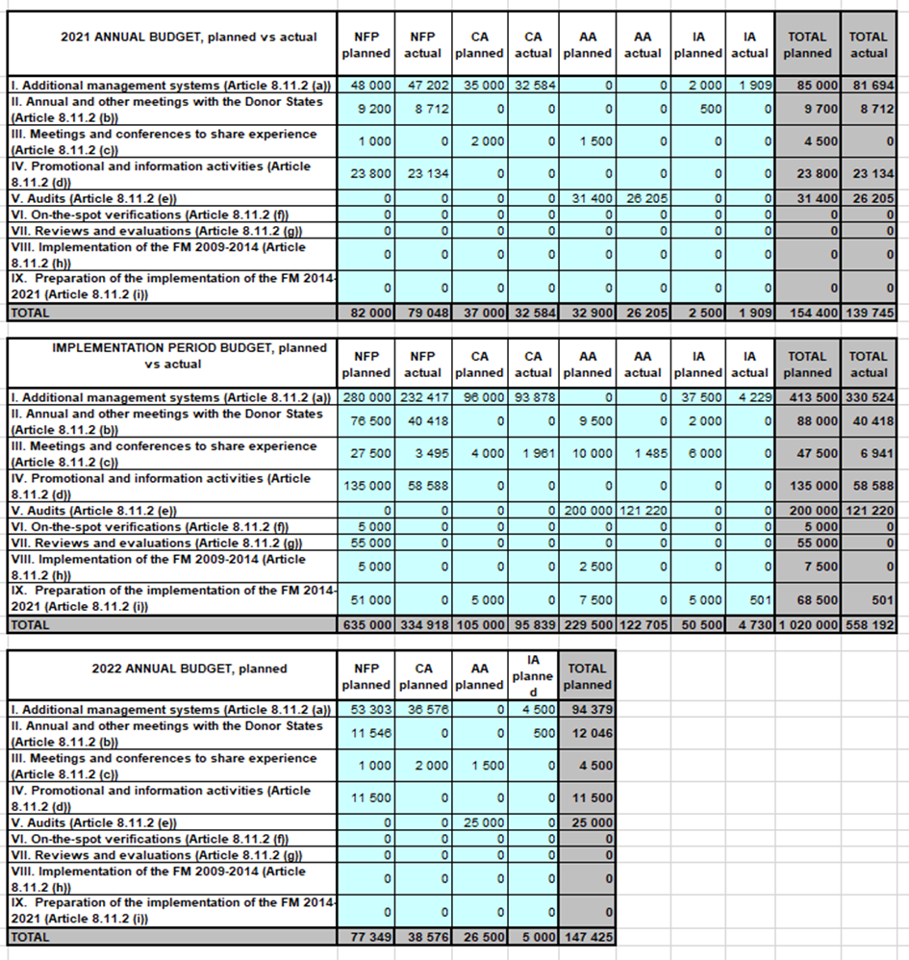

Procurement
No activities have been outsourced by national level institutions.

Staffing
National Focal Point
Name of staff | Official position | Main tasks | Level of effort (% of working time) | Funded through the Grants (Y/N)
Martin Karro | Deputy Director General of the State Shared Service Centre (SSSC) | Head of the National Focal Point | 5 | N
Urmo Merila | Head of the Grants Development Department (GDD) | Head of GDD | 2 | N
Kadi Raudsepp | Head of the Service Design Division of GDD | Head of the Service Design Division of GDD | 2 | N
Laura Pikkoja | Expert (Service Design Division) of GDD | First contact, overall coordination and implementation of Norway/EEA Grants in Estonia | 100 | Y
Marek Kübarsepp | Legal Expert (Grants Managing Division) of GDD | Legal issues, lawyer, MCS | 10 | Y
Annika Mändla | Communication specialist of Communication Department | Communication activities | 3 | Y
Aveliin Sule | Expert (Grants Managing Division) of GDD | Simplified costs | 1 | Y
Merje Rahn | Expert (Grants Managing Division) of GDD | Application of grants, durability requirements | 1 | Y
Anneli Kimmel | Expert (Grants Managing Division) of GDD | State aid | 1 | N
Kersti Kukk | Expert (Grants Managing Division) of GDD | Public procurement | 1 | N
Kaja Toom | Expert (Grants Managing Division) of GDD | Payments, incl eligibility | 1 | N
Mairi Uusen | Head of the Risk Management and Supervision Division of GDD | Risk management, follow-up on audits, irregularities, financial corrections | 2 | N
Kristiina Piikov | Expert (Risk Management and Supervision Division) of GDD | Risk-basis monitoring of payments, financial corrections | 3 | Y
Tiina Tamberg | Expert (Risk Management and Supervision Division) of GDD | Irregularities, financial corrections | 2 | Y
Kaidi Šatilov | Expert (Risk Management and Supervision Division) of GDD | Risk-basis monitoring of payments, financial corrections | 2 | Y
Anne-Ly Aalde | Expert (Risk Management and Supervision Division) of GDD | Risk assessment | 1 | N
Miryam Vahtra | Adviser in the State Budget Department in the Ministry of Finance of Estonia | Evaluation | 2 | N
Certifying Authority
Name of staff | Official position | Main tasks | Level of effort (% of working time) | Funded through the Grants (Y/N)
Tarmo Leppoja | Director General of the SSSC | Head of the Certifying Authority | 2 | N
Karin Viikmaa | Head of the Grants Payments Department (GPD) | Head of GPD | 2 | N
Jaanus Kants | Financial Expert of GPD | Coordination of financial reports, forecasts | 2 | Y
Kärt Kõljalg | Financial Expert of GPD | MCS, coordination of financial reports, forecasts | 15 | Y
Liina Thalfeldt | Financial Specialist of GPD | financial reports, forecasts | 85 | Y
Audit Authority
Name of staff | Official position | Main tasks | Level of effort (% of working time) | Funded through the Grants (Y/N)
Kaur Siruli | Head of the Financial Control Department of the Ministry of Finance | Head of the Audit Authority / Head of the Irregularities Authority | 5 | N
Kaisa Kallas | Head of the II Audit Unit of the Financial Control Department | Audit Strategy and annual audit work plan. Managing and controlling the work of auditors. | 15 | N
Liina Võrklaev | Lead Auditor of the II Audit Unit in Financial Control Department | Audit work | 30 | Y
Different auditors of the AA | Auditors of the Financial Control Department | Audit work | On the basis of hourly calculation | Y
Irregularities Authority
Name of staff | Official position | Main tasks | Level of effort (% of working time) | Funded through the Grants (Y/N)
Virve Teppart | AFCOS Adviser | Irregularities | 10 | Y

