STRATEGIC REPORT
FM14-21

Estonia

Reporting period:
01 July 2020 - 31 March 2021

1. EXECUTIVE SUMMARY
State Shared Service Centre, acting as the National Focal Point (further referred as NFP) for the implementation of the EEA and Norwegian Financial Mechanism in Estonia has prepared the Annual Strategic Report No. 3 on the Implementation of the EEA and Norwegian Financial Mechanisms 2014-2021 in Estonia (further referred as the Strategic Report). The Strategic Report reflects the implementation of the financial mechanisms during the period from 1 July 2020 (next day of the cut-off of previous Strategic Report) to 31 March 2021.
In 2020 the programmes were still in the early stage of implementation and in some cases the progress of the programme including participation in the open calls were affected by the COVID-19. It is still too early to show the attribution of the programmes to the latest development trends, but it can be expected, that with Norwegian and EEA Grants the recovery process goes smoother.
The status of programmes can be considered good given the COVID-19 situation lasting longer than expected. The disbursement rate is quite low (a bit more than 10%) due to the fact that programmes are still at early stage of implementing. A lot of effort has put into getting the implementation running. Due to the good work of preparing call texts/launching calls, appraisal of final pre-defined projects, contracting new projects, the commitment rate has grown remarkably (over 64% by 31.03.2021 while it was only around 35% by the cut-off date of previous Strategic Report). High and still fast growing commitment rate is expected to have its effect on the disbursement rate soon. By the end of 2021 NFP foresees the disbursement rate to be over 30%. The years of 2022 and 2023 are foreseen to be the most active implementing years.
All programme agreements have been signed. The compliance audit of the management and control system (further referred as MCS) of the Climate Change Mitigation and Adaptation (further referred as EE-Climate) programme was finished in July 2020. With that all programmes have their MCS finished. EE-Climate programme has also already 2 calls launched. Under Local Development and Poverty Reduction (further referred as EE-Localdev) programme 5 calls were launched after the cut-off date of previous Strategic Report and several effective Selection Committee meetings behind. As concerns Green ICT (further referred as EE-Innovation) and Baltic Research (further referred as EE-Research) programmes, programme agreements were signed already in 2018, successful calls behind, final calls launched and final Selection Committees ahead. All pre-defined projects described in programme agreements concerning all programmes have been appraised.
Bilateral activities are affected by the situation caused by COVID-19 the most. Given the complicated situation the absorption of bilateral funds can be considered satisfactory. Alternative solutions to initially planned activities have been searched, virtual channels have been used. Since we probably will not go back exactly to the same place we were before 2020 and COVID-19 pandemic, alternative thinking instead of waiting for better times has been and will be encouraged. The meeting of Joint Committee for Bilateral Funds (further referred as JCBF) is coming together twice a year in order to be up to date with progress made, challenges faced and in order to share experience/give advice on bilateral relations matters.
The main risks faced are the delays that are likely to occur due to the situation caused by COVID-19, due to possible changes in the staff, due to possible changes in the structure, due to the involvement of very many different parties. Of course there is a risk of low possibility of cooperation among Estonian and donor state organisations at project level due to COVID-19 pandemic and its consequences. Additionally the risk of violating state aid rules is quite high as the rules and the area overall is quite complicated. Overall risk level of programmes is 2 on a scale of 1 to 4. Although COVID-19 pandemic is a big threat to meeting indicators, staying in the timeframe, bilateral cooperation, mobilities etc, the overall risk is not considered high due to the good communication and active monitoring of the situation.
Looking forward, the most crucial challenge in the second half of 2021 is to react effectively to the consequences of COVID-19 and the risks foreseen (Annex A) in order to minimize the negative effect they might have on the EEA and Norwegian Financial Mechanisms 2014-2021 in Estonia. All parties have to communicate/cooperate and respond quickly in order to have the future calls launched in time, projects implemented before the end of the eligibility period and outputs, outcomes, objectives of programmes achieved.

2. Political, economic and social context
The COVID-19 crisis has triggered changes in several fields - economy, social, education, affecting the speed of implementation of the Financial Mechanisms but in turn increasing the value added of the support and potential impact to be seen in the coming years.
According to the Foresight Centre the COVID-19 crisis has accelerated structural changes in the economy: those sectors and enterprises that take advantage of automatization, digitalization and virtual channels are on the rise as well as those that see opportunities in green solutions.
In the society, new forms of inequalities are emerging – for example, in digital skills and teleworking opportunities. According to the latest COVID-19 survey, 32% of the working population can work from home, 53% of them full-time. Due to structural differences in the employment of Estonians and non-Estonians the share of people with possibilities to work from distance is higher among Estonians and lower among non-Estonians.
According to the prognosis of Eesti Pank the wave of the pandemic this spring will not raise unemployment very much, but it will increase the risk of long-term unemployment. Unemployment will rise because of the prolonged crisis, but not by as much as it did last spring. The tighter restrictions are making it harder for several sectors to operate and are reducing demand for labour.
Estonian Government approved the COVID-19 crisis exit strategy on 27th of April 2020. Aim of the strategy was to give Estonia a comprehensive approach to overcoming the crisis and preventing the health crisis from turning into a long-term economic crisis. In April 2021 new White Paper was prepared – “Social management plan in the context of the spread of the coronavirus”, which includes short-term as well as longer-term activities to control the spread of the coronavirus and to minimize its socio-economic impact. The support under the Financial Mechanism in the key areas contribute to these objectives and to the achievement of long-term positive change.
The indicators in the strategy reflecting the general health of the economy, most related to the implementation of the Financial Mechanisms are the following:
Number of registered unemployed persons (including the number of new registered unemployed persons) – 36 681 on 29.02.2020 and 51 027 on 8.06.2020 and 51 321 on 29.06.2020, 50 004 on 25.10.2020, 57 103 on 11.02.2021, 57 566 on 8.04.2021.
Certificates of incapacity for work, number, change compared to the previous year % 39 885 (-15,3%) in February 2020, 84 321 (+ 111,9%) in April 2020, 23 387 (-10,5%) in July 2020, 42 453 (+ 26,3) in December 2020, 46 479 (+19,3%) in January 2021.
Change in the number of workers compared to the same month in the previous year + 1848 on 29.02.2020 and -18 343 on 29.06.2020, - 15 643 end of December 2020.
Turnover of companies, million Euros, change compared to the previous year%, 5 805,3 MEUR, so -1% on 29.02.2020 and 5 314,2 MEUR, so -20 % on 8.06.2020, 8 071,44 MEUR, so +16% December 2020.

3. Effects of the Grants
The programmes were prepared, and programme agreements signed before the COVID-19 crisis, which changed the previous prognosis of socio-economic indicators and trends. Due to the coronavirus, Estonia, like other European countries, faces several additional challenges as the applied restrictions have not allowed the economy to function normally.
In the forecasts published in the second half of 2019, Estonia's GDP growth in 2020 was expected to be 2.3% (average of the forecasts of Eesti Pank, the Ministry of Finance, the European Commission, the IMF, the OECD, Consensus Economics, SEB and Swedbank). Statistics Estonia's data show that although the economic effects have turned out to be significantly smaller than feared in the initial phase of the crisis, economic growth was negative, instead of growth, the economy fell by 2.9% in 2020.^{[1]}
According to the 2021 spring economic forecast of the Ministry of Finance, it can be expected the 2,5% economic growth this year and 4,8% GDP growth in 2022. In the first half of 2021, economic recovery will continue to be hampered by operating and movement restrictions.
GDP per capita in comparison with the EU27 was 84% in 2019^{[2]} (EU27 being 100%; Norway 144%, Iceland 130%), and the primary reason is relatively low productivity.
Increasing the productivity and innovation of the economy and moving towards more capital- and knowledge intensive economic model is one of the most important preconditions of achieving the growth of GDP per capita. For that purpose, Estonian Government has set in the Competitiveness Strategy Estonia2035 an ambitious objective to increase the productivity per person employed up to 110% of EU average by 2035. The target for 2020 was 80%.
By the end of 2019 level of productivity per person employed was higher than the year before -78,8% (76,8% in 2018 and 74,6% in 2017), but remained still lower than national objectives and EU average.
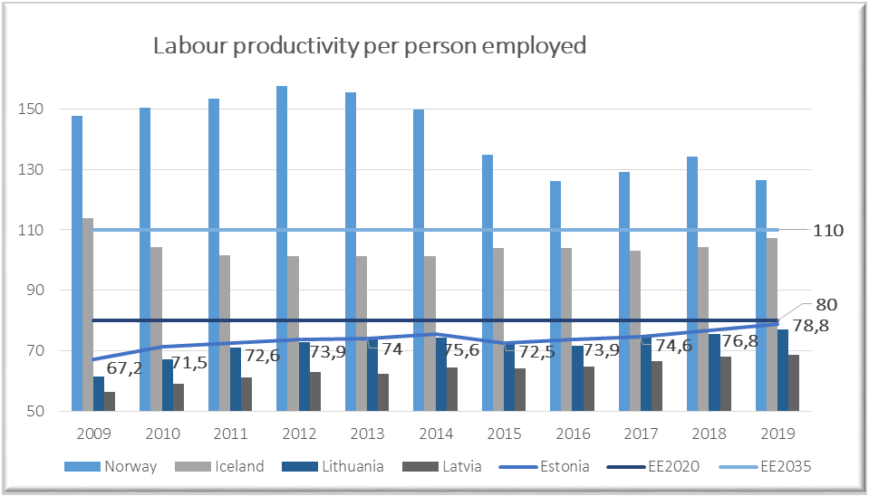
Source: Eurostat^{[3]}
The share of R&D expenditure in gross domestic product (GDP) amounted to 1,61% in 2019 (1,40% in 2018, 1,28% in 2017 and 1,25% in 2016). The target level of 3% set for 2020, was not achieved.
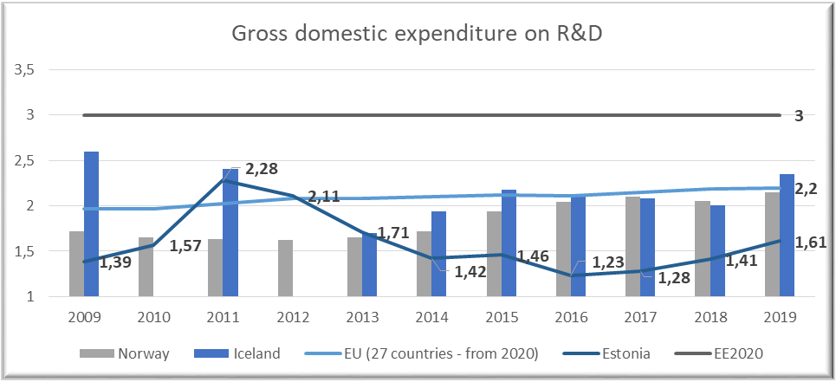
Source: Eurostat^{[4]}
In 2019 the employment rate reached 80,2%, which was the highest level in years. As an impact of COVID-19 crisis the employment rate among the 15-74 years olds fell by 1,7 percentage points, from 68,4% in 2019 to 66,7% in 2020. The duration of unemployment has also increased compared to previous year.
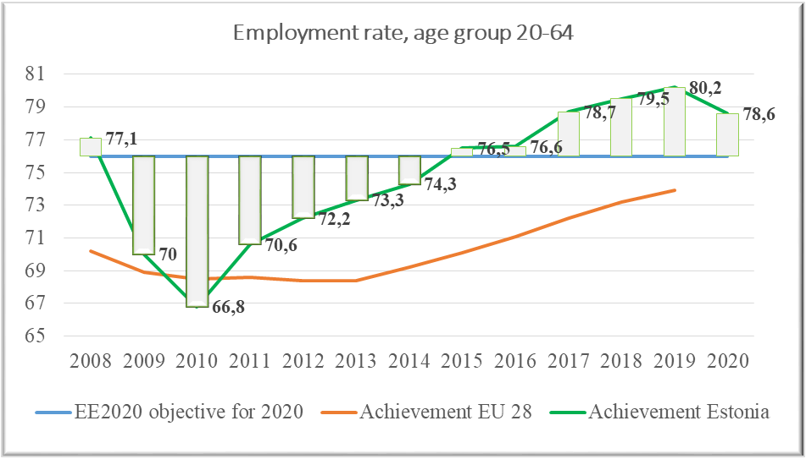
Source: Eurostat^{[5]}
It is still too early to show the attribution of the Norwegian and EEA Financial Mechanism programmes to the latest development trends, but it can be expected, that with Norwegian and EEA Grants the recovery process goes smoother. The EE-Innovation programme projects with strong focus on innovation contribute to increasing the capacity of R&D and uptake of new technologies, business and service models, leading to improved value chains. These projects contribute to raising the increase in innovative enterprises, which was 73,1% in 2018 according to the latest study.
The projects also contribute to raise in share of R&D investments, increased productivity, but also the objectives of lowering the CO2 emissions and increasing the healthy life years.
The EE-Research programme contributes among others to the objectives of the Estonian R&D&I strategy 2014-2020 and to the new TAIE^{[6]} Strategy for 2021-2035 to enable high level and diverse research, the efficient networking of research institutions and that Estonia would be active and visible in international RDI co-operation, which helps to solve the tasks that Estonia and other countries are facing in different sectors whether health, technology or environment.
The EE-Localdev programme contributes to diverse essential objectives like reducing gender-based violence and increasing gender equality (virtual centre of expertise, victim support system development, public awareness on domestic violence and trafficking in human beings), decreasing the number of youth unemployment and early leavers from education and training (transition programmes from basic education to VET, smart youth work etc.) and at risk of poverty rate.
The at risk of poverty rate after social transfers was 21,7 in 2019 (21,9% in 2018 and 21% in 2017). For 2020 the objective in the Competitiveness Strategy Estonia 2020 was set to 15%.
Youth unemployment has been decreasing over the years, but the objective of Estonia2020 is not yet achieved.
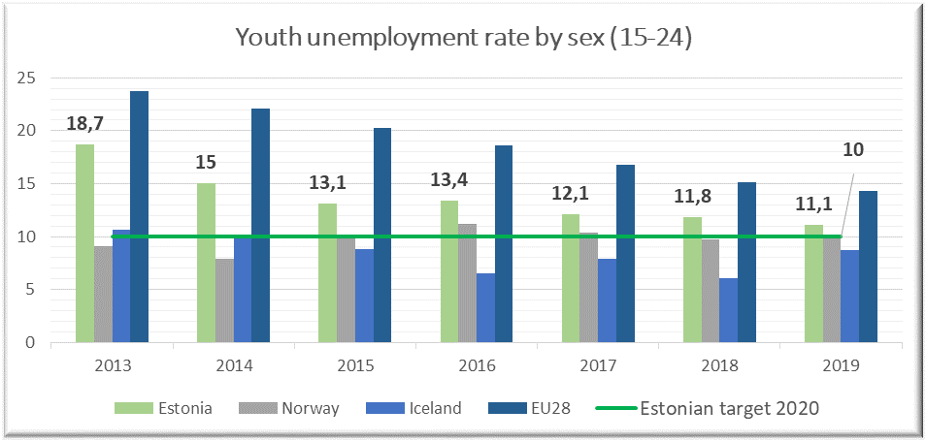
Source: Eurostat^{[7]}
The level of education significantly affects the risk of falling into poverty. The share of early leavers from education and training (18-24-year olds) was 9,8% in 2019 (11,3% in 2018 and 10,8% in 2017).
COVID-19 restrictions have negative impact on young people´s ability to cope and learn and increase the risk of exclusion or falling into NEET status. According to Statistics Estonia, in 2019 there were 11,600 NEETs aged 15–26 (the rate of NEETs was 7.6%). In 2020, the NEET rate has risen to 10%. Most NEETs are young people with basic and general secondary education. The youth unemployment rate in the age group 16–26 has risen to 14.9% in 2020 (8.8% a year earlier).
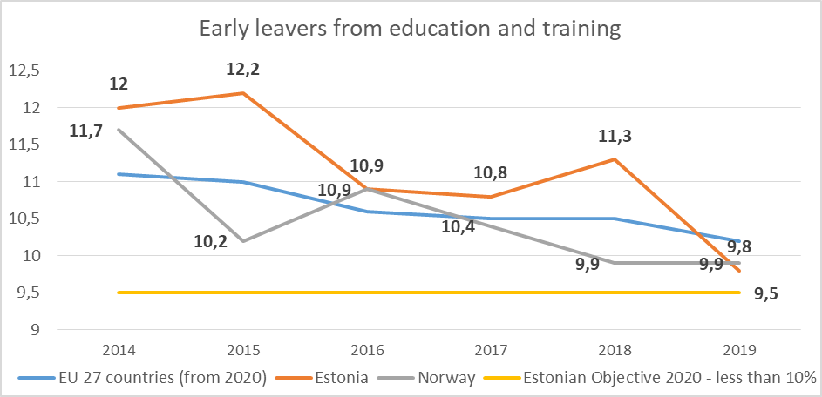
Source: Eurostat^{[8]}
According to the European Institute for Gender Equality Estonia ranks 18th in the EU on the Gender Equality Index with 60,7 out of 100 points. Estonia´s score is 7,2 points below the EU´s score.
According to the Ministry of Social Affairs, the pandemic has also had a negative impact on gender equality. A large proportion of high-risk frontline workers are women, working in the healthcare or commercial sphere. According to Statistics Estonia, in 2019, the gross hourly earnings of female employees were 17.1% lower than the gross hourly earnings of male employees. The gender pay gap decreased by 0.9 percentage points. The gender pay gap was 17,1% in 2019, 18,0% in 2018, 20,9% in 2017, 24,6% in 2012.
Despite the Estonian government´s clear commitment and measures taken, gender-based violence remains a challenge for Estonia, with projects under Norwegian Grants preventive actions can be taken. 2563 victims of gender-based violence were assisted in the supported shelters already in 2020.
In 2020, the growth in the number of domestic violence crimes stopped, there were 3987 cases of domestic violence registered, which is 3% less than in 2019, but there were more severe cases. According to preliminary data, a total of 16 people died in 2020 due to domestic violence, which is more than twice as many as in 2019 (6).
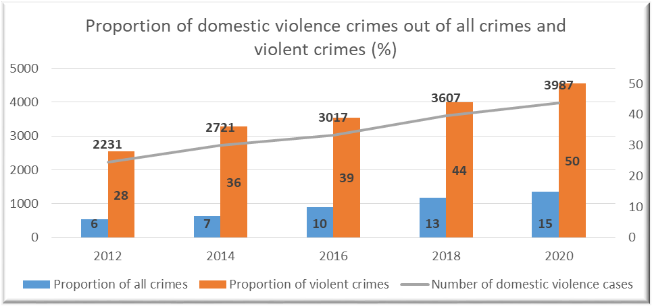
Source: Ministry of Justice
The EE-Climate programme contributes to national objectives in the field of climate and energy, to high level objectives of reduced CO2 emissions and increased share of renewable energy in final energy consumption. 2020 was still mostly the preparatory year for implementing the programme. Through programme activities the local level awareness in the respective field is expected to increase and quality of decisions and activities related to the living, business and natural environment will improve.
Estonia aims to reduce greenhouse gas emissions by almost 80% by 2050 compared to 1990 emission levels. This entails reduction of 70% by 2030 and 72% by 2040.
According to the Estonian greenhouse gas inventory data for 2019, the total greenhouse gas emissions were 14.7 million tons of CO2 equivalent. Compared to 1990, Estonia's total GHG emissions have decreased by 64%, whereas compared to 2018, the decrease was almost 27%. According to preliminary estimates, Estonia's total emissions in 2020 will be below the agreed target for 2020 (18.86 million tons of CO2 eq). To meet the 2024 target (16.17 million tons of CO2 equivalent), it is necessary to maintain today's GHG levels.
Estonia has already met its 2020 renewable energy target of 25% in gross final energy consumption and is on good track to meet the 2035 target of 42%. Due to environment and climate policies, the share of the oil shale energy is diminishing (production of oil shale electricity fell by half in 2019), and renewable energy production is increasing.
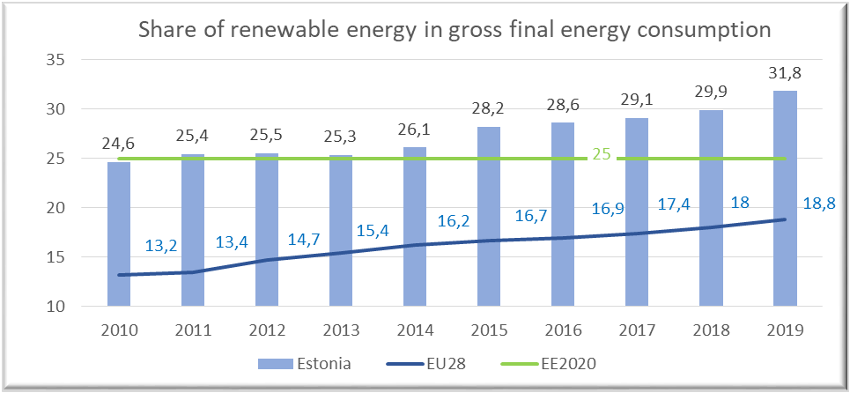
Source: Eurostat^{[9]}
Due to COVID-19 still affecting every aspect of life, strengthening bilateral relations has not gone as planned. COVID-19 pandemic has restricted the possibilities of organising physical matchmaking events between PPs and donor/foreign project partners. While the emphasis has been rather on surviving, then bilateral aspects have unintentionally and understandably been left somewhat on the background. The virtual communication is more important than ever but still online matchmaking events are not as effective as physical meetings when starting new cooperation. However partnerships already made are strong and even new partnerships have been agreed during this complicated phase and furthermore some new ideas for initiatives with donor state partners are on hold. No major losses are foreseen if Programme Operators (further referred as PO) and Project Promoters (further referred as PP) continue to consider alternatives in their way, re-schedule and adapt to the situation when needed, search for creative solutions.

[1] Foresight Centre newsletter April 2021
[2] GDP per capita in PPS Eurostat - https://ec.europa.eu/eurostat/databrowser/view/tec00114/default/table?lang=en
[3] Labour productivity - https://ec.europa.eu/eurostat/databrowser/view/tesem160/default/table?lang=en
[4] R&D - https://ec.europa.eu/eurostat/databrowser/view/t2020_20/default/table?lang=en
[5] Employment rate - https://ec.europa.eu/eurostat/databrowser/view/t2020_10/default/table?lang=en
[6] TAIE - abbreviation in Estonian for RDIE – Research, Development, Innovation and Entrepreneurship
[7] Youth unemployment - https://ec.europa.eu/eurostat/databrowser/view/tesem140/default/table?lang=en
[8] Early leavers from education and training - https://ec.europa.eu/eurostat/databrowser/view/t2020_40/default/table?lang=en
[9] Share of renewable energy - https://ec.europa.eu/eurostat/databrowser/view/t2020_31/default/table?lang=en

4. Status of programmes

EE-INNOVATION Competitiveness
Programme agreement signed | 26.04.2018
Calls (launched/planned in total) | 3/3
PDPs (positively appraised/planned in total) | 2/2
Total programme budget | € 27,058,824*
Total funds available to projects | € 25,031,765*
Project grant contracted | € 16,689,295*
Total funds disbursed to projects (as of most recent IFR) | € 843,484*
Total management costs | € 2,027,059*
Management costs disbursed (as of most recent IFR) | € 552,946*
*Norway grants + national co-financing, cut-off 31.03.2021.
The small grants scheme launched in March 2019 resulted with 42 supported projects and all have ended before the end of 2019. Main call launched in February 2020 resulted with 25 supported projects. Activities have started and first payments to PPs made.
With the surplus from small grants scheme and main call there was additional call for proposals in focus areas of Green Industry Innovation (grant budget 4,779,956.05 euros) and Welfare Technology (grant budget 2,457,246.20 euros) open during the period of the 16th of November 2020 until the 1st of February 2021. It resulted in 14 applications in Green Industry Innovation and 4 applications in Welfare Technology.
Total grant budget of additional call was 7,237,202.25 euros and there were applications submitted in amount of 8,959,473.56 euros of which 7,269,829.15 euros in focus area Green Industry Innovation and 1,689,644.41 euros in focus area Welfare Technology. That leaves at least 767,601.79 euros available. It is expected to finalise the evaluation process and select the projects for contracting in May 2021.
External and independent appraisal of pre-defined projects has been carried out with positive result and the contracts with PPs in total amount of 5,331,765 euros have been concluded.
Considered as force majeure, the COVID-19 global pandemic proved to be a challenge when building new partnerships. Organising face to face meetings internationally was difficult or even impossible. Without the direct communication, the trust between the newly established partnerships remained rather weak to submit a joint application, especially for partners with very short communication history. In some cases, electronic communication channels could be used, but not always. As a lesson learned we see that limited communication has negatively affected the bilateral cooperation in the programme. That is also reflected in the bilateral indicators not achieved in the results framework.

EE-LOCALDEV Local Development and Poverty Reduction
Programme agreement signed | 13.09.2019
Calls (launched/planned in total) | 7/8
PDPs (positively appraised/planned in total) | 8/8
Total programme budget | € 21,176,470*
Total funds available to projects | € 20,055,882*
Project grant contracted | € 12,141,033*
Total funds disbursed to projects (as of most recent IFR) | € 493,451*
Total management costs | € 1,120,588*
Management costs disbursed (as of most recent IFR) | € 126,146*
*Norway/EEA grants + national co-financing, cut-off 31.03.2021.
By cut-off date all 8 pre-defined projects have been contracted by the PO and have started their activities.
The last one, pre-defined project No 7 “Development of evaluation models and handling system for chronically mentally ill patients” (PP Viljandi Hospital) started in January 2021.
All pre-defined projects are running satisfactorily and are being flexible in making necessary shuffle in the original time-scale and – in case feasible - implementing some of the activities virtually.
Of the 8 different calls for proposals, 7 calls have been published and of them 5 have been closed already:
- Outcome 2 SGS “Training of domestic violence specialists and establishment of a programme(s) for sex buyers” → 3 projects awarded a grant, all contracted, 2 of them running and 1 to start in Sept 2021.
- Outcome 2 open call “Awareness raising activities on domestic violence and to discourage the demand for commercial sex“ (application submission deadline Sept 30, 2020) → 1 project awarded a grant, to be contracted and start in April 2021.
- Outcome 4 open call “Historic old town centres with cultural heritage protection areas“ (application submission deadline Nov 30, 2020) → Selection Committee meeting took place on March 25, 2021, selection process still ongoing. Up to 6-7 projects to be awarded a grant.
- Outcome 1 SGS “Developing Restorative Justice Measures in Estonia” → 3 projects awarded a grant, 2 of them contracted in March 2021 and to start in April 2021, 1 to be contracted and to start in April 2021 as well.
- Outcome 1 SGS “Implementation of Vocational Orientation Curriculum in Vocational Education
Institutions” → 12 projects awarded a grant, 10 of them contracted in March 2021 and 2 to be contracted in April 2021.
- Outcome 3 open call “Integrated services to support health and safety in home environment” → call launched on Jan 27, 2021 and will be closed on April 1, 2021.
- Outcome 1 open call “Smart Youth Work Solutions” → call launched on Feb 15, 2021 and will be closed on April 15, 2021.
Additionally, the text and evaluation criteria of Outcome 1 open call “Integrated services provision to prevent early school leaving“ is under finalisation is expected to be published in the 2nd quarter of 2021.
And as the second tranche of Outcome 1 SGS “Developing Restorative Justice Measures in Estonia” is also expected to be launched in the second half of 2021, then after that the EE-Localdev programme has concluded the launch of all calls for proposals foreseen in the programme agreement and can fully focus on the implementation side and reaching the outputs and outcomes of the programme by year 2024.
The programme has addressed special concerns/conditions set in the PA. Especially, the designed pre-defined projects and open call texts are engaging the target groups regardless of their nationality. Moreover, where applicable, the programme has highlighted to treat in particular also the national minorities and therefore a lot of activities / materials are implemented in Russian language. (i.e. there are supported projects implemented at Ida-Viru region with overwhelmingly populated with Russian-speaking minority, but not limited to that).
By cut-off date there have not been too big obstacles in EE-Localdev programme related to absorption/disbursements of funds as regard to COVID-19 situation as most of the work related to the launching, evaluation and contracting of the call has been successfully carried out behind the desk and virtually. Still, as the Estonian pandemic situation at present is very severe, then there is a possibility that important developments may occur in regard to activity restrictions in Estonia also through summer and autumn 2021, which could hamper the projects’ activities planned face-to-face and hands on in the field. In case the situation would stabilise during summer-autumn 2021 and normalise in years 2022-2023 with new realities being adapted, then there still good chance to achieve positive results and bilateral cooperation via the programme until the eligibility end date of April 2024.

EE-RESEARCH Research and Education
Programme agreement signed | 18.06.2018
Calls (launched/planned in total) | 4/4
PDPs (positively appraised/planned in total) | 2/2
Total programme budget | € 8 352 941*
Total funds available to projects | € 7 684 706*
Project grant contracted | € 7 284 206*
Total funds disbursed to projects (as of most recent IFR) | € 4 093 534*
Total management costs | € 668 235*
Management costs disbursed (as of most recent IFR) | € 226 122*
* EEA grants + national co-financing, cut-off 31.03.2021.
The programme agreement of the EE-Research programme was amended in early December, 2020. The amendments were necessitated by the need to align the results framework of the programme with the Results Guide and the Core Indicators Guideline (which were updated earlier, in particular with regard to the indicators related to exchanges and mobilities – due to the COVID-19).
The guidelines for higher education scholarships were approved in February 2020.
In connection with the consolidation of state institutions in Estonia, from 1st August 2020 the higher education part of the programme implemented by the Archimedes Foundation was transferred to the Estonian Education and Youth Board. During the transfer, some obstacles arose due to the change of staff in the foundation and board. The process was not smooth enough for the board due to the difficulties in communicating with the previous implementer. There were also many persons in the foundation who were related to the programme, but no concrete contact person for topics related to EEA Grants. As for the time of this report, the issues have been resolved. Due to the change of the implementer of the educational programme, the process of updating the overview of MCS has been started.
In the context of the pandemic, it has been a challenge to achieve the programme’s objectives – reduce social and economic disparities and strengthen bilateral relations. The outbreak of COVID-19 strongly affected all countries involved in the programme. Social distancing, travel restrictions, lockdown and other measures to control the pandemic had impact on all research groups.
Due to COVID-19 constraints, traditional research activities were largely suspended from spring to summer and from late autumn to end of the year. As a result, implementation of the working plans has been slower and some activities have been postponed to 2021.
Thanks to adapting to the situation and being willing to look for new ways to use more digital tools and web-based platforms, the research teams achieved most of their objectives with relatively minor deviations, and the work done in 2020 has prepared the ground for the successful continuation of the research projects in 2021. It can be hoped that gradually it will be possible to return to ‘normalcy’ and catch up with plans in years 2 to 4, including the use of unallocated funds from year 1.
Recently started joint projects between Estonian, Latvian, Lithuanian and Norwegian research groups support the unity of the Baltics and the strengthening of Baltic scientific cooperation as well as the establishment of closer ties with Scandinavia.
Outcome 1
All 7 financed projects started in 2020. 6 of them submitted annual technical reports, which were approved by the programme committee in February 2021.
The highest result achieved was the number of researchers supported by the programme, which is 82 (37 Male and 45 Female; target set 25). Of these, 13 are PhD Students (6 Male, 7 Female) and 11 are Post-Docs (5 Male, 6 Female). There is a good gender balance in terms of supported researchers, doctoral students and postdoctoral fellows. During the first year of implementation, four peer-reviewed joint publications were submitted (target 50). One joint application was submitted for further funding (target 10) and one for Intellectual Property Protection (target 3).
Outcome 2
In 2020, Estonian higher education institutions had a second opportunity to apply for support from the EEA/Norway higher education cooperation funding scheme in the areas of cooperation projects and staff mobilities. 4 cooperation projects were funded in the total amount of 422,776 euros. As the budget available was 423,165 euros, the leftover (389 €) was decided to transfer to the 2021 Call.
All four cooperation projects have started their activities in autumn 2020. Since all projects have a length of 16-24 months, it is too early to expect tangible results at this stage. The online kick-off meeting for successful applicants from the 2nd round took place on 19th of November 2020 in Zoom. During the second call, there were no applications for mobility projects. And overall during the two application rounds, no mobility projects have been financed. Although the implementing agency has carried out a number of personal consultations with universities to stimulate interest in mobility projects, there is still lack of interest in mobility projects. COVID-19 pandemic situation also plays a major role in this.
Due to the COVID-19 pandemic, all the 4 cooperation projects from 2019 call have been extended. Although projects are progressing and interim reports will be submitted in the 1st half of 2021, some achievements can be declared. 121 students with received ECTS credits (target set 150) and 1 joint intellectual output was created in cooperation project (target 10) during 2020.
The last open call (3rd) was announced in the beginning of March 2021 and will end in May 10th.
Pre-defined project – „Visiting lectureship of Norwegian language at Tartu University“
Norwegian lecturer started work at Tartu University in January 2020. Lecturer has carried out 7 courses: grammar; Norwegian pronunciation; an overview of Norwegian literature; Scandinavian languages; Norwegian for beginners; morphology and syntax of the Norwegian language; text analysis. Total number of registrations to the courses taught by the visiting lecturer in 2020 was 132 students. 106 female and 26 male students. 121 students received ECTS credits.
Pre-defined project “Developing and enhancing the teaching quality of inclusive education curriculum”.
During the implementation of the project, 3 articles were submitted to peer-reviewed publications, 1 training course on inclusive education for schools (60 EAP) was organised. In total 21 researchers were supported under the grant from which 6 are PhD students (all female; 4 from UT and 2 from TLU), 10 master’s students (5 from UT, all female; 5 from TLU - 1 male and 4 female) and 5 other researchers (4 female and 1 male).

EE-CLIMATE Climate Change Mitigation and Adaptation
Programme agreement signed | 18.11.2019
Calls (launched/planned in total) | 2/5**
PDPs (positively appraised/planned in total) | 0/0
Total programme budget | € 7 058 824*
Total funds available to projects | € 6 353 000*
Project grant contracted | € 0
Total funds disbursed to projects | € 0
Total management costs | € 705 824*
Management costs disbursed (as of most recent IFR) | € 107 500*
* EEA grants + national co-financing, cut-off 31.03.2021.
** Including the open call 1 launched after the cut-off date, on 9th of April, 2021.
The compliance audit of the MCS of the EE-Climate programme was finished on 13th of July 2020.
Since the cut-off date of the last strategic report, there has been two programme agreement modifications made in the EE-Climate programme and the third one is on proceed. Modifications 1 and 2 were needed to avoid the conflict with giving illegal state aid. The third modification is about splitting the open call 3 into two, keeping the climate change awareness activities under open call 3 and implementing the activities related to the framework of circular economy under pre-defined project.
Small grants scheme “Climate change mitigation and adaption plans” for local governments was launched on 26th of February 2021 and is open until 26th of April 2021. The open call 1 “Ecosystem resilience increased” was launched on 9th of April 2021 and is open until 9th of June 2021.
Several potential PPs in small grants scheme are hoping to find external partners to involve in their climate change mitigation and adaption plan projects for knowledge and experience change, who DPP Norwegian Environmental Agency is kindly helping to find.
PO is hoping to launch the call 3 in summer 2021 and calls 2 and 4 in autumn 2021.

5. Status of bilateral funds
 | Allocations | Committed | Disbursed
Initiatives at national level | € 510 000 | € 372 688 | € 252 633
Foreseen in MoU for programmes: | € 425 000 | € 234 848 | € 105 453
EE-Localdev | € 125 000 | € 54 395 | € 0
EE-Research | € 100 000 | € 29 167 | € 29 167
EE-Innovation | € 125 000 | € 76 286 | € 76 286
EE-Climate | € 75 000 | € 75 000 | € 0
Reserve for the programmes: | € 425 000 | € 100 000 | € 268
EE-Localdev | € 125 000 | € 0 | € 0
EE-Research | € 100 000 | € 100 000 | € 268
EE-Innovation | € 125 000 | € 0 | € 0
EE-Climate | € 75 000 | € 0 | € 0
Total bilateral fund | € 1 360 000 | € 707 536 | € 358 354

COVID-19 restrictions have effected bilateral funds the most. Meetings that can be held virtually (eg JCBF/CC meetings, opening events, conferences, workshops, seminars) have been held virtually and meetings that are better held physically (eg study visits, staff exchanges) have been postponed and project periods extended where necessary. Under the COVID-19 circumstances and being still at early stage of implementing, NFP considers the absorption satisfactory. Although it is very challenging for POs, NFP will continue to encourage and support POs to use more bilateral funds in order to strengthen the bilateral relations between Estonia and the donor states. NFP encourages POs to find alternative solutions and use more digital channels.
There has been one JCBF meeting since the cut-off date of the previous Strategic Report. It was held virtually in September, 2020. Two new initiatives were presented there. Initiative „Estonian-Icelandic Cooperation Towards a Sustainable Artic“ was approved by JCBF on 12.10.2020. Initiative „e-Healthcare Initiative: providing equal treatment opportunities for everyone“ was approved by JCBF on 26.11.2020. "Co-operation for decent work and fair competition in labour market" project period was extended second time until 31st December 2022 (previously was 31.12.2021) with the minutes of the JCBF meeting (12.10.2020). The next JCBF meeting is planned in June 2021.
In addition to that NFP has also actively participated in Cooperation Committee meetings and other meetings with POs where programme level bilateral issues are discussed.
Ongoing initiatives at National Level
The initiative “Co-operation for decent work and fair competition in labour market” with the budget of 151 500 EUR was approved in 2018. From March 2020 physical meetings are on hold and will not be held before the second half of 2021. Therefore there can’t be any staff exchanges and learning visits because these are dependent on travelling. In addition to that the monitoring work in both countries is disturbed as well as the movement of workers (as target group for monitoring) across borders. Activities under joint communication campaign „Know Your Rights“ can be and already have been done virtually. The campaign was publicized in autumn 2020. The joint information campaign, www.knowyourrights.no won two gold awards in an international competition regarding “content marketing”. The annual meeting in December 2020 was held as a Teams-web-meeting. To be able to fulfil the activities that have been agreed on, the project was extended until 31st December 2022.
The initiative “Estonian-Norwegian cooperation in the United Nations and its Security Council: Defending and renewing multilateralism” with the budget of 66 697 EUR was approved by the JCBF on 14.05.2020. The planned project period is from May 2020 to December 2021. Beneficiary State entity is Estonian Foreign Policy Institute of the International Centre for Defence and Security (EFPI/ICDS) and donor partner in this project is Norwegian Institute of International Affairs (NUPI). The opening event in November 2020 and events in March 2021 were successfully held virtually although initially planned as physical meetings. Research and writing can be done as planned. Publication and final event in September 2021 is hoped to be held as a physical meeting in Tallinn.
The initiative „Estonian-Icelandic Cooperation Towards a Sustainable Artic“ with the budget of 9 500 EUR was approved by JCBF on 12.10.2020. The planned project period is from October 2020 to June 2021. Beneficiary State implementing entity is the Estonian School of Diplomacy and donor implementing entity is the Institute of International Affairs IIA (University of Iceland), donor project partner is the Icelandic Centre fo Research (Rannis). The aim of this proposal is to recognize and promote early stage development, strategy planning, capacity building, networking and awareness of cooperation between the Estonian School of Diplomacy and the Institute of International Affairs at the University of Iceland through higher education staff exchanges, study trips and research, with specific focus on Arctic affairs and hybrid threats. Implementing entities and donor partner have postponed initially to the first half of 2021 planned visits to the second half of 2021 and therefore they are planning to ask for extension of the project.
The initiative „e-Healthcare Initiative: providing equal treatment opportunities for everyone“ with the budget of 60 000 EUR was approved by JCBF on 26.11.2020. The planned project period is from November 2020 to December 2022. Beneficiary State implementing entity is SA Tallinn Science Park Tehnopol, donor partners are Norwegian Smart Care Cluster, HelseINN, Conteir AS and Estonian partners are AS Hoolekandeteenused, Viljandi Hospital. The mission for the e-Healthcare Initiative is to educate, promote and activate health and social care institutions in the use of distance-spanning technologies with the goal of providing equal treatment opportunities for everyone. The opening event will be held virtually in the end of April, 2021.
EE-Innovation
After March, 2020 no bigger physical events have been organised due to COVID-19 situation. Since the cut-off of previous Strategic Report Webinar and Matchmaking event on 15 December, 2020 was organised by DPP Innovation Norway for beneficiary state countries. 15 Estonian entrepreneurs participated. The calls of different programmes in different beneficiary state countries were introduced which gave a good overview and entrepreneurs had a chance to meet virtually Norwegian entrepreneurs. It was a compact and an effective event with a very good feedback. So if the wish for cooperation is big enough then distance is not an issue and agreements can also be reached and cooperation developed meeting virtually.
With the bilateral amounts still left for the programme for organising bilateral events EE-Innovation programme has considered organising some joint seminar or conference for entrepreneurs. Though, probably not before 2022.
EE-Localdev
The COVID-19 pandemic has mostly unfortunately limited the possibilities to enhance bilateral relations with donor countries’ organisations (mostly travel leading to finding partners, networking, study trips, best practices exchange etc.). In case the situation would stabilise during summer-autumn 2021 and normalise in years 2022-2023, then there is still a good chance to achieve positive bilateral cooperation results before the eligibility end date.
To date, 33 520 EUR has been decided for bilateral activities in the area of cultural heritage protection and 20 875 EUR in the area of youth at risk (restorative justice measures). No activities have been done yet. But PO is optimistic that the amounts planned will be absorbed, although the form of activities and time-schedule may be redesigned due to the situation in the world. Overall PO sees that the whole amount foreseen for the programme (125 000 EUR) can be absorbed by the end of programme period because there is interest for bilateral activities from other areas of the programme. While managing the crisis is the priority then strengthening bilateral relations is affected at present time.
EE-Research
As COVID-19 pandemic led to social and travel restrictions, it was not easy to develop cooperation between Baltics and donor states participating in the programme. However, seven Baltic-Norwegian research consortia started their activities in various fields of research to focus on the challenges set by the programme. Most of the cooperation between project partners was conducted online – kick-off meetings, steering committee meetings, online discussions, webinars, conferences.
Also, regular skype meetings were held between the EE-Research programme PO´s and implementing agencies from Estonia, Latvia, Lithuania and Norway (RCN). As in 2019, donor programme partners (further referred as DPP) RCN, DIKU and Baltic counterparts have been regularly consulted through e-mails, video and phone conferences. PO took part in the webinars organised by DPPs in summer 2020.
The first activity in the Baltic-EEA Research Managers Cooperation Project funded by the bilateral fund, took place in November 2020 when a webinar “Mental Well-being and Joy of Work in Times of Pandemic” was held. After a keynote presentation by Dr Kelli Lehto, the Nordic and Baltic colleagues shared their good practices related to the topic.
The main activity planned for autumn 2020 – the Nordic-Baltic Conference on International Research Cooperation - had to be cancelled due to the pandemic and postponed until June 2021. Now it is clear that the event cannot be held on site as expected but must be organised virtually. It also affects the use of the budget as costs are reduced. A decision on whether the budget for the whole project needs to be adjusted will be taken by the end of June 2021, when it will be possible to see what the pandemic situation looks like and whether it will affect the planned Baltic NCP meeting in Riga and a study visit to Iceland.
EE-Climate
The plan for the programme level bilateral activities was adopted in the Cooperation Committee meeting on 9th of July 2020.
Due to development phase of the programme, not many bilateral activities have been implemented during this reporting period. No planned study trips or expert visits for PP-s were made due to COVID-19 in this period. PO is sharing contacts between potential PPs and Project Partners to help establish bilateral relations through online channels.
PO is currently searching for potential external partners for small grants scheme PP-s and also preparing to find potential partners for PP-s of call 1. It can also be noted, that the potential PP-s of Call 1 already have some good contacts with potential project partners from donor states, who they wish to include in their projects. All communication and matchmaking events (if necessary to organize) will be held virtually as long as the COVID-19 situation is ongoing. Hopefully some study trips and expert visits in autumn 2021 can be organised.

6. Management and implementation

a. Management and control systems (MCS)
The activities concerning the compliance assessment of the descriptions of MCS of EE-Climate programme have been done in the first half of 2020. A report and an opinion by the Audit Authority (further referred as AA) was completed on 13th of July 2020. As a result of the compliance audit the AA is in the opinion that the MCS of the PO (Ministry of Environment of the Republic of Estonia) and implementing agency (Foundation Environmental Investments Centre) for the implementation of the European Economic Area Financial Mechanisms 2014-2021 EE-Climate programme in Estonia covers all required functions and are in all material aspects proportional, effective and in compliance with generally accepted accounting principles in relation with achieving the objectives of the programme. With that all compliance assessments of the descriptions of MCSs of POs are performed by AA.
EE-Research programme PO has in March 2021 submitted to NFP the amended MCS description while the implementing agency has changed – in August 2020 Archimedes Foundation joined together with other educational institutions into one organisation called Education and Youth Board. Since this is a significant change, NFP will forward the amendment also to the AA for opinion.
There have been no significant changes in relation to other POs and the national level MCS concerning NFP, CA, AA and Irregularities Authority, in the setup or staffing of the national authorities involved in the implementation of the EEA and Norway Grants.

b. Complaints
Until now the Irregularities Authority has not received any complaints.

c. Irregularities
Since the previous Strategic Report (July 2020) Irregularities Authority has reported to Financial Mechanism Office (further referred as FMO) five irregularity cases - IR 14 (closed), IR 37 (will be closed in the first quarter of 2021), IR 45 (open), IR 46 (open) and IR 47 (open). One new irregularity will be reported in the first quarter of 2021.
Three of these mentioned irregularities had problems in different public procurements for travel services. These procurements have not been carried out due to these projects only but due to organisational needs for travel services overall. Two irregularities had arithmetical calculation errors. The first quarter reports of 2021 will be sent by the deadline (end of May).
Six smaller irregularity cases were not reported to FMO. Five (not finalised three) cases are below the threshold (EUR 2000) until now and one finalised case was just a doubt of the irregularity.
All cases were reported by the implementing agencies via SFOS and checked by the Irregularities Authority.

d. Audit

Summary of the audits conducted by AA and findings of audits
The background (methodology, principles etc) is described in the Audit Strategy document of AA and the results of the audits carried out were reported in the Annual Audit Report submitted in February 2021.
- Compliance audit
The activities concerning the compliance assessment of the descriptions of MCS of EE-Climate programme have been done in the first half of 2020. A report and an opinion by AA was completed on 13th of July 2020. As a result of the compliance audit the AA is in the opinion that the MCS of the PO (Ministry of Environment of the Republic of Estonia) and implementing agency (Foundation Environmental Investments Centre) for the implementation of the European Economic Area Financial Mechanisms 2014-2021 EE-Climate programme in Estonia covers all required functions and are in all material aspects proportional, effective and in compliance with generally accepted accounting principles in relation with achieving the objectives of the programme.
The real functioning of the systems will be tested during the MCS audit, when planned in the AA’s work plan (will be compiled on the basis of risk assessment).
- Management and Control System Audit
During 2020 AA finalised one MCS audit – the MCS audit of the Certifying Authority. As a result of this audit, the AA is in opinion that the MCS of the CA of the FM works, but some improvements are needed (Category 2 ).
The final audit report pointed out one significant and two non-significant audit findings:
- Remark No 1 (non-significant) – Decree of the Government is not updated and stipulates that the NFP performs the tasks of the CA. However, the auditors do not see the risk on the level of performing the tasks of the CA as the SSSC's statue, DMCS and the CA’s more detailed procedures are correct and the participants in the process know their rights and obligations. This ensures that the system as a whole works.
- Finding No 2.1 (non-significant) – The CA has certified to the FMO expenditure despite not being able to conduct risk based checks over the NFP’s risk-based monitoring, since the NFP has not carried out risk-based monitoring as defined in the DMCS. Taking into account that the Delegated bodies of the POs and PO-s are successfully implementing the projects/programmes of ESIF and significant part of the sums (especially by the Research and Education projects) submitted to FMO are actually advance payments which can be checked on the document level after the real activities have been done, the risk of the ineligible costs of the current early implementation phase is not very high. After getting additional information from the NFP about the risk assessment details of the FM, risk-based monitoring planned for 2021 and amendments made to the procedures of the NFP (in November 2020, inter alia the tasks for carrying out Performance Analysis of the Administration of the FM and the CA’s obligation to check the POs management costs were added to the RoP); the auditors got the assurance that the planned monitoring activities are in compliance with the requirements and evaluated the finding as non-significant. By the time of issuing the Annual Audit Report, the Performance Analyses had been already carried out, so the AA’s recommendation has been fulfilled.
- Finding No 2.2 (significant) – The management costs of the POs in amount of 786 492,47 euros was submitted to the FMO without conducting risk-based verification of the supporting documents by the CA. Also, the RoP of the CA did not include the CA’s procedures of risk-based checks of the PO management costs as stipulated in the Article 3.2.1 of the DMCS. The auditors checked that carrying out the risk-based controls of the management cost of the POs as a task of the CA were added to the RoP point 2.6 in November 2020, which should prevent this type of error in the future. As of current status, the AA has verified, the checks are being carried out.
The AA will monitor the implementation of the audit findings via the electronic monitoring system SFOS.
2. Project audits
The audit population was compiled based on the IFRs submitted to the FMC from the start of the programming period until 30th of June 2020, covering the expenditure actually incurred until 31st of December 2019.
The audit work was finalized in February 2021:
- Three project audits were finalised with no remarks;
- One project audit pointed out expenditure, which was not approved with the project application – instead of one month’s salary to be declared as project costs for a person involved with the project implementation, as agreed with the project application, two months’ salary was approved as eligible from the project’s budget. The sum of ineligible expenditure pointed out in the audit report was 2201,97 EUR and the ineligible grant to be reclaimed from the beneficiary 1154,93 EUR, which has been reclaimed from the beneficiary. The irregularity has been closed.
The results of the project audits are the following:
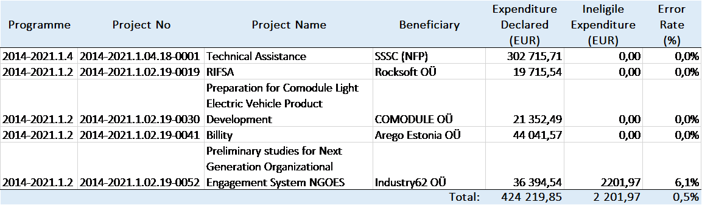
After analysing the detected error, the auditors are in opinion, that the error detected should not be evaluated as systematic on the programme level and there is no essential risk for ineligible expenditure. The total projected error rate as per the mean per unit method would be 1,29% and as per ration method 1,09% - in both cases, the total projected error rate lies below tolerable error rate of 2%.
The auditors conclude from the calculations that the population does not contain material error and is not misstated; the expenditure declared to the FMO is in all material aspects legal and regular.
AA issues an opinion on the assurance to the MCSs as a whole, taking into account the results of both the system audits and the audits of operations. Based on the previously declared information, AA issued an unqualified opinion for the year 2020.
Audit work plan for 2021
For 2021, the AA has planned the following audit activity:
- carrying out risk assessment of the FMs to detect any high risk areas to be audited with the MCS audits – one system audit on programme level will be carried out. The programme implementation to be audited will be selected on the basis of risk assessment and actual expenditure made from the projects;
- carrying out sample based audits on projects as defined with the Art 5.5 (c) of the Regulations – four projects have been selected and the audit procedures started;
- updating the audit strategy for the programming period 2014-2021 of the FMs in accordance with the Art 5.5 (d) of the Regulations.
The results of the audits on projects will be reported in the next Annual Audit Report.

7. Communication
In last three years, the public awareness has been following: 14% (2018), 14% (2019) and 14% (2020) so due to pandemic it has not decreased. The next public awareness survey will take place in September 2021 and the results will be public in the first half of November 2021.
Social media 2020/2021
Last year when writing the strategic report, the EEA and Norway Grants Estonia Facebook page had 504 followers. Now, by April 2020 Facebook page has 568 followers. The initial goal was that by the end of new financing period, EEA and Norway Grants Estonia page in Facebook should have at least 500 followers. As the goal was achieved, we set the next goal to 600 followers in updated communication strategy.
We actively keep sharing the news about grants and the projects achieved with the help of EEA and Norway grants in Estonia.
Communication Strategy updated
In August 2020 we (in collaboration with PO-s) updated the EEA and Norway Grants communication strategy 2014-2021 because much had changed since (budget, going more environmental friendly and digital).
Main activities from July 2020
The main activities that were done to raise public awareness about EEA and Norway Grants in Estonia:
- Participated 2 days in Estonian music event called Viru Folk in August that focused on Norwegian music and culture. We had a photobox (everyone got a free polaroid with the grants logo on it) with a viking, quiz about the grants and waffels as awards, also TV-screen on the background to show different video clips about the projects.
- Two TV clips in a TV show called “Estonia - full of experiences” presenting projects supported through Active Citizen Fund (The Opinion Festival and hand mowing training) in August (approx 60 000 viewers together with repetitions). Videos had also sponsored ads on social media (17 000 times watched, 5000 through plays).
Main activities in 2021
This year to celebrate the 100th anniversary of Estonian-Norwegian diplomatic relations we had content marketing on most popular news portal called Delfi from 05.02.-12.02.2021 – six articles about:
- the grants of all three funding periods and the goals of EEA and Norway Grants:
https://arileht.delfi.ee/artikkel/92463899/norra-ja-emp-finantsmehhanismid-on-mojutanud-eestis-vaga-erinevaid-valdkondi
- project examples and cooperation with Norway in environmental field: https://arileht.delfi.ee/artikkel/92473469/taotle-raha-norra-aitab-eestit-6-miljoni-euroga-kohalik-omavalitsus-taotle-raha-kliimakava-arendamiseks
- project examples and cooperation with Norway in science field: https://arileht.delfi.ee/artikkel/92469925/eesti-keel-ja-kultuur-nopivad-uha-uusi-koostoovilju
- project examples and cooperation with Norway in industry: https://arileht.delfi.ee/artikkel/92470067/majandussuhted-norraga-on-loonud-eesti-toostusele-uusi-arenguvoimalusi
- project examples and cooperation with Norway in social affairs: https://arileht.delfi.ee/artikkel/92472617/sotsiaalministeerium-ja-norra-rahvatervise-instituut-ootavad-koduohutuse-ja-vaikelaste-heaolu-projekte
- the support to our NGOs and contribution to our civil rights: https://arileht.delfi.ee/artikkel/92472993/arengukoostoo-lipulaev-norra-panustab-eesti-inimoiguste-kaitsmisse-miljoneid-eurosid
Number of readers in one week: 19 300.
NFP provided some of the translated material for FMO to share in their channels and is planning to make promoted posts on Facebook of the same content in April 2021.
- We are currently integrating EEA and Norway Grants to a new webpage of NFP that was launched this spring (www.rtk.ee) as was set in communication strategy. So using the web address https://eeagrants.fin.ee/ you will be redirected to here: https://www.rtk.ee/toetusfondid-ja-programmid/teised-programmid/euroopa-majanduspiirkonna-ja-norra-toetused In the first half of 2021 we focus on putting all the necessary information out both in Estonian in English so we can shut down the old web page. On the second half of the year we focus on developments, so open calls and success stories would be easily found on new webpage.
- We order again two TV clips in a TV show called “Estonia - full of experiences” if possible, the TV show has not yet made their final plans when to start filming. If everything goes right they will be on air in summer and afterwards we will share and boost them also on social media.
- Last year we postponed the social media campaign and will reschedule for this year (May-June): interesting facts that stand out from previous or ongoing financial period. For example: “Did you know that with the help on EEA and Norway Grants thousands of children in Estonia have gotten psychological help …” etc. We will design them following the rules of CVI.
- We have planned a special newspaper about the implementation of projects of this financial period in August 2021 in weekly newspaper called Maaleht (approximately 38 000 copies) and will also have the articles published in online media (Delfi) from where we can share them on social media as well.
Programme level communication
Overall the publicity activities on the programme are carried out according to the communication plan of the programme. There have been press releases informing the launch of the call. For all calls for proposals virtual information seminars for potential applicants/PPs have been carried out. POs and implementing agencies have been active in communicating the Grants. Besides the websites and social media channels of POs and implementing agencies EEA and Norway Grants Estonia page in Facebook https://www.facebook.com/EEANorwayGrantsEstonia is covering news on all programmes as well as the old webpage https://eeagrants.fin.ee/ (using this web address you will be redirected to the new webpage) and the new webpage https://www.rtk.ee/toetusfondid-ja-programmid/teised-programmid/euroopa-majanduspiirkonna-ja-norra-toetused. Longer descriptions of communication activities of programmes are brought out in the Annual Programme Reports, here are the main communication channels of POs/implementing agencies:
EE-Innovation
The main channel for the programme specific information is www.eas.ee/norwaygrants.
Website of PO https://www.mkm.ee/et/tegevused-eesmargid/valisvahendid/norra-ja-euroopa-majanduspiirkonna-finantsmehhanismid.
Social media channels of implementing agency: https://www.facebook.com/EnterpriseEstonia/ and LinkedIn profile https://www.linkedin.com/company/enterprise-estonia, IA Youtube channel https://www.youtube.com/user/EnterpriseEstonia.
EE-Localdev
Programme website https://www.sm.ee/en/norway-grants-2014-2021 (in Estonian https://www.sm.ee/et/norra-toetused-2014-2021).
Website of implementing agency: https://www.rtk.ee/toetusfondid-ja-programmid/teised-programmid/euroopa-majanduspiirkonna-ja-norra-toetused#rtk-rakendatavad-meetmed.
EE-Research
Research part of the programme – websites of ETAG www.etag.ee and the Estonian Research Information System www.etis.ee.
Implementer of higher education cooperation projects has the 3rd Call information doubled on both web-pages http://haridus.archimedes.ee/en/eeanorway-cooperation-program-higher-education (Archimedes Foundation) and https://harno.ee/en/news/final-round-eeanorway-grants-open (Education and Youth Board).
EE-Climate
The homepage of the programme was developed and is available: https://www.envir.ee/et/eesmargid-tegevused/valisfinantseerimine/euroopa-majanduspiirkonna-toetused-2014-2021 (in Estonian) and https://www.envir.ee/en/news-goals-activities/foreign-financing/european-economic-area-eea-grants-2014-2021 (in English). There are also programme webpages under the homepage of implementing agency (https://kik.ee/et/toetatav-tegevus/kliimamuutuste-leevendamine-ja-nendega-kohanemine (in Estonian) and https://kik.ee/en/supported-activity/climate-change-mitigation-and-adaptation (in English).
Facebook pages of the PO (https://www.facebook.com/keskkonnaministeerium) and the implementing agency (https://www.facebook.com/KeskkonnainvesteeringuteKeskus).

8. Monitoring and evaluation

a. Monitoring
The monitoring plan for 2021 was adopted by NFP on 30th of March 2021. Until the cut-off date of this report there are no findings of monitoring activities carried out by the NFP to report yet. NFP has ensured effective implementation by keeping an eye on EEA/Norway Grants related activities and by being a valuable partner (fast communication is the key word):
- NFP is actively involved in Annual Programme Reports commenting; calls for proposal texts commenting; programme agreements and other relevant documents modification commenting.
- NFP advises POs and implementing agencies on any issue that may occur regarding EEA/Norway Grants.
- NFP organises regular meetings with POs (4 times a year) in order to get an overview of the programmes, bilateral relations and discuss current and problematic areas.
- Ad-hoc meetings are also organised when there is need, nowadays it is easy and acceptable to do it also virtually.
- NFP participates actively in meetings organised by POs (CC, SC and other relevant).
- NFP in cooperation with other organisations (eg Ministry of Finance) organises trainings (eg procurement, state aid, payments/eligibility, financial corrections, irregularities, information system), if needed.
- NFP sends out guidance letters to POs, implementing agencies of any new issue or any issue that needs to be emphasized in the point of view of NFP
- NFP asks POs for an overview/input if necessary (for Strategic Report, for IFR, for other inquiries).
- NFP carries out risk assessment once a year. NFP gathers together POs risks and assesses risks itself and then risks are being monitored (mitigating measures set). NFP monitors risks also in APRs and assesses key risks again while compiling the Strategic Report.
- NFP checks payments on risk-basis. It means that payments of projects that have open irregularities will be checked in order not to reimburse irregular amounts. NFP also checks financial corrections.
- NFP carried out the first performance analysis of the functioning of the system, of every aspect of the implementing (payments, eligibility, financial corrections, irregularities, audits etc) similarly to the structural funds. This analysis together with risk assessment provided input to the monitoring plan that was the outcome of the performance analysis. The analysis together with monitoring plan was finalised on 30th of March 2021. As a result of the analysis NFP can confirm that overall the system is functioning well but some additional monitoring activities are needed for NFP to get the full confidence. Besides the everyday monitoring activities, the main additional monitoring activities planned for the year 2021 are as follows:
- Information system SFOS requirements and new functionalities communicated to POs, implementing agencies in more detailed way, meetings with POs/ implementing agencies, trainings to POs/ implementing agencies.
- Conducting customer feedback survey and making analysis twice a year and planning additional activities if needed.
- Control over procurement checking procedure in EE-Innovation programme projects will be conducted concerning PPs who are not contracting authorities in national public procurement law.
- During the commenting procedure of call texts, problems with defining state aid/de minimis aid were identified. Because of that the focus will be on state aid/de minimis aid. Risk-based check concerning determination of categories of SME-s will be conducted.
- Payment procedure risk-based check will be conducted in Education and Youth Board, the new implementing agency of EE-Research programme higher education part.
The performance analysis will be done annually – the next performance analysis is planned to be concluded in March 2022.
NFP has a good overview of the implementing of EEA/Norway Grants and communication between NFP and other parties (POs, implementing agencies, CA, AA, Irregularities Authority, FMO, the Royal Norwegian Embassy) is considered very good.

b. Evaluation
The evaluation plan was initially added to the previous Strategic Report. In that evaluation plan under EE-research programme mid-term evaluation was planned. But after consulting with FMO it was decided that all evaluations will be ex-post evaluations. Therefore no evaluations have been planned before 2023. The updated evaluation plan is in ANNEX B.

9. Issues for the annual meeting
No issues for the Annual Meeting.

ANNEXES

A. Risk assessment and management plan

B. Evaluation plan

C. Cooperation with Donor Programme Partners and International Partner Organisations

D. Technical assistance report

Annex A: Risk assessment and management plan
EE-INNOVATION |  |  | Overall level of risk  2
Risks | Previously planned response | Actual response | Planned future response
Low possibility of cooperation among Estonian and donor state organisations at project level due to COVID-19 consequences and its possible re-emergence | POs have tight communication with the DPPs in finding and encouraging Norwegian field experts and organisations to cooperate with Estonia. POs exchange relevant contacts, re-schedule, are flexible, use digital solutions. NFP is closely monitoring the situation by communicating with PO. | PO has tight communication with the DPPs in finding and encouraging Norwegian field experts and organisations to cooperate with Estonia. PO exchanges relevant contacts, re-schedules, is flexible, uses digital solutions. NFP is closely monitoring the situation by communicating with PO. NFP encourages PO to find alternative solutions and use more digital channels. | PO has tight communication with the DPPs in finding and encouraging Norwegian field experts and organisations to cooperate with Estonia. PO exchanges relevant contacts, re-schedules, is flexible, uses digital solutions. NFP is closely monitoring the situation by communicating with PO. NFP will encourage PO to find alternative solutions and use more digital channels, if the situation in the world does not go back to normal.
Change of key persons on the programme level (PO, Implementing Agency, FMO contact in the programme area) | Actively working on the programme, trainings and seminars for staff.  NFP advises PO. | Key persons have not changed | Not considered as a main risk anymore
Opening of the final call might be delayed, not enough time for implementing. With the surplus from previous calls it was decided to launch one more call.  Seen as a risk due to the unexpected situation (third call not foreseen in the PA). | More active communication and cooperation between PO and Implementing Agency, PO and NFP, PO and FMO, NFP and FMO in order to help the process go as smoothly as possible. NFP advises on modifying the relevant documents. | Call was launched in autumn 2020 | Not considered as a main risk anymore
Start of pre-defined projects delayed.  Seen as a risk due to the previous big unexpected delays. | More active communication and cooperation between PO and PPs, PO and NFP, PO and FMO, NFP and FMO in order to help the process go as smoothly as possible. | Pre-defined projects appraised and started | Not considered as a main risk anymore
The delays in the timeframe of a programme may threat the implementation of activities by the final date of eligibility 30.04.2024. | Timely communication is crucial. Progress needs to be assessed systematically. | Final call launched and ended and pre-defined projects started. | Not considered as a main risk anymore
With the start of implementation of projects, the risk of violating public procurement rules increases, as the contracting authorities' awareness of the rules is uneven | Communication between and  cooperation with  relevant parties.  Guidance and advice given to relevant parties.  Trainings, information events, information materials. | NFP has asked FMO for the interpretation of the Article 8.15 of the Regulation and forwarded the answer to all POs, implementing agencies. NFP has organised public procurement trainings. | Not considered as a main risk anymore
State aid rules not clear for PPs. Risk could result in project irregularities (i.e. miscalculated eligible activities, costs and aid intensity). | Different state aid categories have been described in detail in conditions of call for proposal. All the planned mitigation measures will be addressed in counselling of applicants during the application process. POs can turn to the state aid experts in the Ministry of Finance and NFP and ask for guidance and trainings, if needed. NFP has encouraged and will continue to encourage POs to turn to the state aid experts in the Ministry of Finance and NFP for guidance and trainings. | Different state aid categories have been described in detail in conditions of call for proposal.  NFP has encouraged POs to turn to the state aid experts in the Ministry of Finance and State Shared Service Centre and forwarded training invitations to POs in that field. | Counselling of applicants continues in implementation phase.  NFP will continue to encourage POs to turn to the state aid experts in the Ministry of Finance and State Shared Service Centre and ask for guidance and trainings, if needed.
Transfer of application and monitoring process into centralised information system administered by NFP may cause need for additional manual data insertion by implementing agency, which may cause errors in data. | Implementing agency seeks for automated solution in cooperation with NFP. NFP has trained implementing agency in different procedural stages, instructed in the settings, helped to automatically transfer projects into centralised information system. PO and implementing agency can ask additional trainings from NFP, if needed. | Implementing agency seeks for automated solution in cooperation with NFP. NFP has trained implementing agency in different procedural stages, instructed in the settings, helped to automatically transfer projects into centralised information system. | NFP organises additional trainings if needed and encourages implementing agency to send NFP development proposals to develop the system.
EE-LOCALDEV |  |  | Overall level of risk  2
Risks | Previously planned response | Actual response | Planned future response
Low possibility of cooperation among Estonian and donor state organisations at project level due to COVID-19 consequences and its possible re-emergence | POs have tight communication with the DPPs in finding and encouraging Norwegian field experts and organisations to cooperate with Estonia. POs exchange relevant contacts, re-schedule, are flexible, use digital solutions. NFP is closely monitoring the situation by communicating with PO. | POs have tight communication with the DPPs in finding and encouraging Norwegian field experts and organisations to cooperate with Estonia. POs exchange relevant contacts, re-schedule, are flexible, use digital solutions. NFP is closely monitoring the situation by communicating with PO. NFP encourages PO to find alternative solutions and use more digital channels. | POs have tight communication with the DPPs in finding and encouraging Norwegian field experts and organisations to cooperate with Estonia. POs exchange relevant contacts, re-schedule, are flexible, use digital solutions. NFP is closely monitoring the situation by communicating with PO. NFP will encourage PO to find alternative solutions and use more digital channels, if the situation in the world does not go back to normal.
Change of key persons on the programme level (PO, Implementing Agency, FMO contact in the programme area) | Actively working on the programme, trainings and seminars for staff.  NFP advises PO. | Key persons have not changed | Not considered as a main risk anymore
The delays in the timeframe of a programme may threat the implementation of activities by the final date of eligibility 30.04.2024. | Timely communication is crucial. Progress needs to be assessed systematically. | Only one more call to be launched and pre-defined projects are appraised and started. | Not considered as a main risk anymore
With the start of implementation of projects, the risk of violating public procurement rules increases, as the contracting authorities' awareness of the rules is uneven | Communication between and  cooperation with  relevant parties.  Guidance and advice given to relevant parties.  Trainings, information events, information materials. | NFP has asked FMO for the interpretation of the Article 8.15 of the Regulation and forwarded the answer to all POs, implementing agencies. NFP has organised public procurement trainings. | Not considered as a main risk anymore
Risk of financial corrections to projects regarding mistakes in determining state aid | Analysis of potential state aid while drawing up the guidelines of calls for proposals. Trainings for PO and implementing agency. State aid competence can be acquired from the Sate Aid Department of the Ministry of Finance and in legal departments of line ministries. NFP has encouraged and will continue to encourage POs to turn to the state aid experts in the Ministry of Finance and NFP for guidance and trainings. | Analysis of potential state aid while drawing up the guidelines of calls for proposals. Trainings for PO and implementing agency. State aid competence can be acquired from the Sate Aid Department of the Ministry of Finance and in legal departments of line ministries. NFP has encouraged and will continue to encourage POs to turn to the state aid experts in the Ministry of Finance and NFP for guidance and trainings. | Analysis of potential state aid while drawing up the guidelines of calls for proposals. Trainings for PO and implementing agency. State aid competence can be acquired from the Sate Aid Department of the Ministry of Finance and in legal departments of line ministries. NFP has encouraged and will continue to encourage POs to turn to the state aid experts in the Ministry of Finance and NFP for guidance and trainings.
EE-RESEARCH |  |  | Overall level of risk  2
Risks | Previously planned response | Actual response | Planned future response
Low possibility of cooperation among Estonian and donor state organisations at project level due to COVID-19 consequences and its possible re-emergence | POs have tight communication with the DPPs in finding and encouraging Norwegian field experts and organisations to cooperate with Estonia. POs exchange relevant contacts, re-schedule, are flexible, use digital solutions. NFP is closely monitoring the situation by communicating with PO. | POs have tight communication with the DPPs in finding and encouraging Norwegian field experts and organisations to cooperate with Estonia. POs exchange relevant contacts, re-schedule, are flexible, use digital solutions. NFP is closely monitoring the situation by communicating with PO. NFP encourages PO to find alternative solutions and use more digital channels. | POs have tight communication with the DPPs in finding and encouraging Norwegian field experts and organisations to cooperate with Estonia. POs exchange relevant contacts, re-schedule, are flexible, use digital solutions. NFP is closely monitoring the situation by communicating with PO. NFP will encourage PO to find alternative solutions and use more digital channels, if the situation in the world does not go back to normal.
Change of key persons on the programme level (PO, Implementing Agency, FMO contact in the programme area) | Actively working on the programme, trainings and seminars for staff.  NFP advises PO. | There has been change of key persons in implementing agency due to the change of implementing agency and FMO contact also changed in 2020. New implementing agency has been provided with the guidance needed (eg with information system, irregularities, payments). New FMO contact has been involved in discussions concerning programme agreement modification, final call etc. | Actively working on the programme, trainings and seminars for staff.  NFP advises PO.
Change of Implementing Agency could result in the change of key persons and excessive bureaucracy and therefore bring delays in implementation | More active communication between PO and NFP, PO and FMO, NFP and FMO in order to help the process go as smoothly as possible. NFP advises on modifying the relevant documents. | Programme agreement has been changed, MCS change is in process. New implementing agency has been provided with the guidance needed (eg with information system, irregularities, payments). | Continue active communication between PO and NFP, PO and FMO, NFP and FMO in order to help the process go as smoothly as possible.  MCS will be changed. Payment procedure check in Education and Youth Board will be conducted by NFP.
No mobility projects after 2 calls in higher education. There is a high possibility that there will be few and/or low quality applications for mobility projects in the final call based on the previous calls and mobility objective will not be achieved. | It needs to be analysed why the activity of preparing mobility project applications is low and whether there is a necessity to fund these projects at all and then the follow-up activities can be decided (the possibility of PA modification).  If it is decided to get mobility projects from the last call then even more active approach is expected from PO/Implementing Agency -  more higher education institutions should be encouraged to participate in the programme. | Although the implementing agency has carried out a number of personal consultations with universities to stimulate interest in mobility projects, there is still lack of interest. COVID-19 pandemic situation also plays a major role in this. FMO is aware of this risk. They have an understanding that failure to meet targets will not result in any punitive action.  The indicators concerning mobility stay in the programme agreement (yet slightly modified) and the final call text also involve the mobility part. | If despite of POs and implementing agencies efforts there will be no mobility project applications in the final call or these are too weak to finance from the grants then there should be discussions between PO, NFP, FMO and other relevant parties about what are the following actions needed.
The delays in the timeframe of a programme may threat the implementation of activities by the final date of eligibility 30.04.2024. | Timely communication is crucial. Progress needs to be assessed systematically. | EE-Research programme sees the risk of COVID-19 virus affecting the implementation period of the projects the most. Projects already have asked for prolongation. | Timely communication is crucial. Progress needs to be assessed systematically. 2021 is crucial for research projects to be able to meet face to face for research achievements and to achieve results by the end of the program.
With the start of implementation of projects, the risk of violating public procurement rules increases, as the contracting authorities' awareness of the rules is uneven | Communication between and  cooperation with  relevant parties.  Guidance and advice given to relevant parties.  Trainings, information events, information materials. | NFP has asked FMO for the interpretation of the Article 8.15 of the Regulation and forwarded the answer to all POs, implementing agencies. NFP has organised public procurement trainings. | Not considered as a main risk anymore
EE-CLIMATE |  |  | Overall level of risk  2
Risks | Previously planned response | Actual response | Planned future response
Low possibility of cooperation among Estonian and donor state organisations at project level due to COVID-19 consequences and its possible re-emergence | POs have tight communication with the DPPs in finding and encouraging Norwegian field experts and organisations to cooperate with Estonia. POs exchange relevant contacts, re-schedule, are flexible, use digital solutions. NFP is closely monitoring the situation by communicating with PO. | There has been partnership contact sharing by emails, calls and online meetings. DPP have shared the contacts of possible donor partners.  NFP has encouraged PO to find alternative solutions and use more digital channels. NFP is closely monitoring the situation by communicating with PO to get overview of the situation. | POs have tight communication with the DPPs in finding and encouraging Norwegian field experts and organisations to cooperate with Estonia. POs exchange relevant contacts, re-schedule, are flexible, use digital solutions (online events). NFP is closely monitoring the situation by communicating with PO.  NFP will encourage PO to find alternative solutions and use more digital channels, if the situation in the world does not go back to normal.
Change of key persons on the programme level (PO, Implementing Agency, FMO contact in the programme area) | Actively working on the programme, trainings and seminars for staff.  NFP advises PO. | There are detailed description of roles and responsibilities in MCS. The contact person in implementing agency changed and the contact person in FMO is changing. There have been no problems detected by now with the change of the contact person in implementing agency – contacts there are well experienced with structural funds. | Actively working on the programme, trainings and seminars for staff.  NFP advises PO/implementing agency and monitors the situation in order for the cooperation to go smoothly with new key persons.
The delays in the timeframe of a programme may threat the implementation of activities by the final date of eligibility 30.04.2024. | Timely communication is crucial. Progress needs to be assessed systematically. | The time schedule has been constantly updated according to the progress, all obstacles have been promptly addressed and the best possible solutions have been sought, such as the amendments to the programme agreement. Communication and cooperation between all relevant parties has been good. Today it is not a critical risk but it has to be acknowledged while 3 calls are still to be launched and first calls have faced postponement. | Timely communication is crucial. The first calls have been launched at the beginning of 2021. The preparation of the call documents of next calls will not take as much time as preparation of call documents for first calls. But the risk has to be acknowledged and monitored while 3 calls are still to be launched and first calls have faced postponement.
With the start of implementation of projects, the risk of violating public procurement rules increases, as the contracting authorities' awareness of the rules is uneven | Communication between and  cooperation with  relevant parties.  Guidance and advice given to relevant parties.  Trainings, information events, information materials. | NFP has asked FMO for the interpretation of the Article 8.15 of the Regulation and forwarded the answer to all POs, implementing agencies. NFP has organised public procurement trainings. | Not considered as a main risk anymore
The modification about splitting the open call 3 into two (open call and pre-defined project) might be not acceptable with the donors and bring delays in timeframe. | PO has prepared programme agreement modification (final request with additional explanations sent to FMO on 8th of January 2021). If the programme agreement is modified, all the needed activities with pre-defined project and the third call should be started as soon as possible. Cooperation and communication between relevant parties is crucial. | PO has prepared programme agreement modification (climate change awareness activities under open call 3 and circular economy activities under pre-defined project). It has been discussed several times with NFP, FMO and other relevant parties in the second half of 2020. The final modification request with additional explanations has been sent to FMO on 8th of January 2021 and updated information on 19th of February 2021. | If the programme agreement is modified, all the needed activities with pre-defined project and the third call should be started as soon as possible. Cooperation and communication between relevant parties is crucial.
Risk of financial corrections to projects regarding mistakes in determining state aid | Analysis of potential state aid while drawing up the guidelines of calls for proposals. Trainings for PO and IA. State aid competence can be acquired from the State Aid Department of the Ministry of Finance and in legal departments of line ministries. NFP has encouraged and will encourage POs to turn to the state aid experts in the Ministry of Finance and NFP. | The changes of the programme agreement were needed to avoid the conflict of state aid. For some open calls the solution was found via limiting the project applicants and as their nature is very much more standard, it will solve the state aid aspect of the call.  NFP has encouraged POs to turn to the state aid experts in the Ministry of Finance and NFP and forwarded training invitations to POs in that field. | Analysis of potential state aid while drawing up the guidelines of calls for proposals.  NFP will continue to encourage POs to turn to the state aid experts in the Ministry of Finance and State Shared Service Centre and ask for guidance and trainings, if needed.

Annex B: Evaluation plan
Please note this Annex is uploaded separately and is not visible in this document. Please download and print separately if needed.

Annex C: Cooperation with Donor Programme Partners and International Partner Organisations
The cooperation with DPPs can be considered very good. DPPs have demonstrated active involvement in organizing bilateral events. Their comprehensive knowledge and experiences support both the preparation and implementation of the programmes. All critical issues are always closely discussed with the partner organisations and their active involvement in Cooperation Committee and other meetings help to ensure that all the essential topics are mutually deliberated prior to any enforcements.
Despite the COVID-19 situation communication between POs and DPPs has not deteriorated. Although at first virtual meetings seemed difficult, strange and ineffective, in time people got more used to it and in some ways virtual meetings turned out to be very effective. Due to the situation the knowledge about how to hold virtual meeting using different platforms has grown and therefore unwillingness to communicate this way has decreased.
EE-Innovation
There is a smooth cooperation between PO, implementing agency and DPP. Cooperation Committee meetings are being held regularly – the last meeting was held in July 2020. DPP has been involved in evaluation of Estonian-Norwegian partnerships in project applications and also in Selection Committee. Estonian entrepreneurs are invited to the events organised by DPP.
EE-Localdev
All DPPs – Norwegian Directorate of Health, Norwegian Institute of Public Health and Directorate of Cultural Heritage – have been very active and engaged in programme implementation. Communication has been quick via e-mails and conference calls. After the previous cut-off date of strategic report the Cooperation Committee virtual meetings have taken place in September 2020 and April 2021.
EE-Research
Regular skype meetings were held between the EE-Research programme PO´s and implementing agencies from Estonia, Latvia, Lithuania and Norway (RCN). DPPs (RCN, DIKU) and Baltic counterparts have been regularly consulted through e-mails, video and phone conferences. PO took part in the webinars organised by DPPs in summer 2020. Cooperation Committee meeting in higher education was held in written format in December 2020.
EE-Climate
DPP is participating in Cooperation Committee meetings and gives advice and knowhow on the implementing of the programme - the last meeting was held in July 2020. During last year, the DPP Norwegian Environment Agency (NEA) has provided valuable insight and comments for prepared call texts, they also help actively to find potential Project Partners from Donor countries for our small grants scheme and open call 1. DPP will also be participating on the selecting of the projects as a non-voting member.

Annex D: Technical assistance report

Overview of main activities
National Focal Point
Guidance to the POs/implementing agencies (informal communication, regular meetings, ad-hoc meetings);
Preparing and submitting IFRs (July 2020, January 2021);
Comments to the Annual Programme Reports, call texts, PDP appraisals;
Preparing and submitting Strategic Report;
Compiling Mid-term Review (submitted 30.11.2020);
Conducting risk assessment;
Conducting performance analysis and adopting the monitoring plan of 2021;
Providing input to auditors concerning Technical Assistance project audit, audit of CA MCS;
Comments to the modifications of programme agreements, submitting requests to FMO;
Preparing/giving presentation, participating in the NFP virtual workshop, in January 2021;
Participating in the Annual Communication Workshop, virtually in autumn 2020;
Participating in Cooperation Committee and Selection Committee meetings;
Organising the JCBF meeting (September 2020);
Organising the Annual Meeting (September 2020);
Organising meetings with POs four times a year;
Organising public awareness survey and analysing the results (autumn 2020);
Communication Strategy updated (autumn 2020);
Participating in Norra thematic Viru Folk;
ACF funded project clips in TV show called "Elamusi täis Eesti" and sponsored posts in social media.
Certifying Authority
Guidance to the POs;
Putting together forecast of likely payment applications;
Performing checks related to the IFRs;
Performing risk-based checks of TA and programme management costs;
Participating in Annual Meeting and FMO organised workshop;
Providing input to auditors concerning the audit of CA MCS.
Audit Authority
Auditing of MCS of Certifying Authority;
Sampling for project audits and conducting project audits;
Putting together audit strategy;
Preparing annual audit report;
Participating in Annual Meeting and FMO organised workshop;
Finishing compliance audit procedures of the description of the MCS for the EE-Climate programme.
Irregularities Authority
Guidance to the POs/ implementing agencies;
Quarterly reporting of irregularities (August 2020, November 2020, February 2021);
Quarterly check and analysis of project expenses (SFOS data);
Meetings, discussions (NFP, FMO).

Budget overview
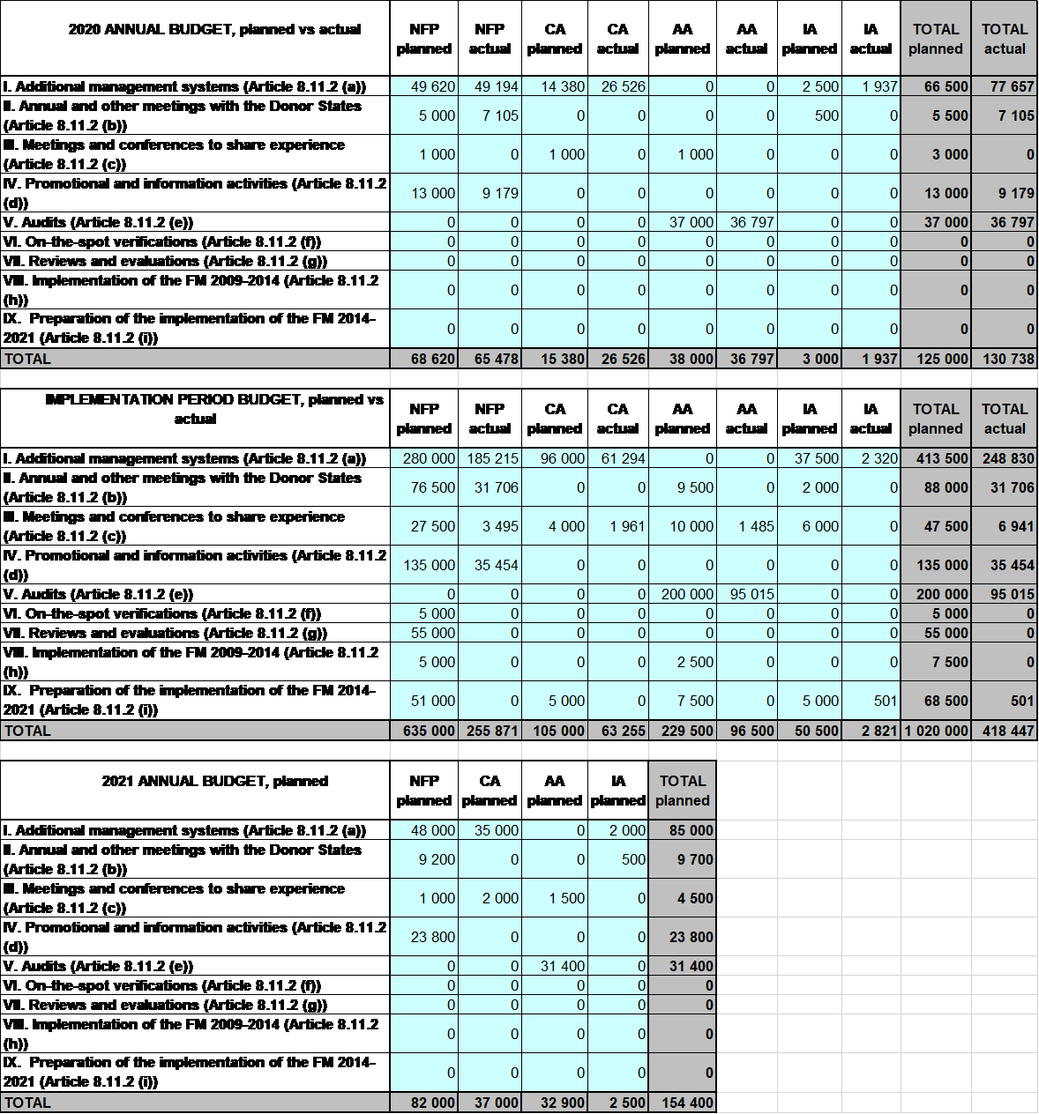

Procurement
No activities have been outsourced by national level institutions.

Staffing

National Focal Point
Name of staff | Official position | Main tasks | Level of effort (% of working time) | Funded through the Grants (Y/N)
Martin Karro | Deputy Director General of the State Shared Service Centre (SSSC) | Head of the National Focal Point | 5 | N
Urmo Merila | Head of the Grants Development Department (GDD) | Head of GDD | 2 | N
Laura Pikkoja | Expert (Service Design Division) of GDD | First contact, overall coordination and implementation of Norway/EEA Grants in Estonia | 100 | Y
Marek Kübarsepp | Legal Expert (Grants Managing Division) of GDD | Legal issues, lawyer, MCS | 10 | Y
Brit Kerbo | Communication specialist of Communication Department | Communication activities | 3 | Y
Mattias Jõesaar | Communication specialist of Communication Department | Communication activities | 2 | Y
Aveliin Sule | Expert (Grants Managing Division) of GDD | Overall eligibility and simplified costs | 1 | Y
Merje Rahn | Expert (Grants Managing Division) of GDD | State aid, application of grants, durability requirements | 1 | Y
Anneli Kimmel | Expert (Grants Managing Division) of GDD | Public Procurement issues | 1 | N
Kärt Kraaving | Expert (Grants Managing Division) of GDD | Payments, incl eligibility | 1 | N
Taisi Valdlo | Business Analyst (Service Design Division) of GDD | Data quality, IT. Identifying business needs and determining solutions. | 1 | N
Mairi Uusen | Head of the Risk Management and Supervision Division of GDD | Risk management, follow-up on audits, irregularities, financial corrections | 2 | N
Kristiina Piikov | Expert (Risk Management and Supervision Division) of GDD | Risk-basis monitoring of payments, financial corrections | 3 | Y
Tiina Tamberg | Expert (Risk Management and Supervision Division) of GDD | Irregularities, financial corrections | 2 | Y
Kaidi Šatilov | Expert (Risk Management and Supervision Division) of GDD | Risk-basis monitoring of payments, financial corrections | 2 | Y
Anne-Ly Aalde | Expert (Risk Management and Supervision Division) of GDD | Risk assessment | 1 | N
Miryam Vahtra | Adviser in the State Budget Department in the Ministry of Finance of Estonia | Evaluation | 2 | N
Certifying Authority
Name of staff | Official position | Main tasks | Level of effort (% of working time) | Funded through the Grants (Y/N)
Tarmo Leppoja | Director General of the SSSC | Head of the Certifying Authority | 2 | N
Karin Viikmaa | Head of the Grants Payments Department (GPD) | Head of GPD | 2 | N
Jaanus Kants | Financial Expert of GPD | Coordination of financial reports, forecasts | 2 | Y
Kärt Kõljalg | Financial Expert of GPD | MCS, coordination of financial reports, forecasts | 15 | Y
Liina Thalfeldt | Financial Specialist of GPD | financial reports, forecasts | 85 | Y
Audit Authority
Name of staff | Official position | Main tasks | Level of effort (% of working time) | Funded through the Grants (Y/N)
Kaur Siruli | Head of the Financial Control Department of the Ministry of Finance | Head of the Audit Authority / Head of the Irregularities Authority | 5 | N
Kadi Peets | Head of the II Audit Unit of the Financial Control Department | Audit Strategy and annual audit work plan. Managing and controlling the work of auditors. | 15 | N
Liina Võrklaev | Lead Auditor of the II Audit Unit in Financial Control Department | Audit work | 65 | Y
Different auditors of the AA | Auditors of the Financial Control Department | Audit work | On the basis of hourly calculation | Y
Irregularities Authority
Name of staff | Official position | Main tasks | Level of effort (% of working time) | Funded through the Grants (Y/N)
Virve Teppart | AFCOS Adviser | Irregularities | 5 | Y

