INFOLEHT |August 202

**Evaluating the effectiveness and impact of measure activities**

**4.3.1, 4.3.2, 4.3.3 ja 4.3.4**

July 2022

**OBJECTIVE AND METHODOLOGY**

* **MAIN OBJECTIVES OF THE EVALUATION**
* find out the effectiveness and impact of the investments made under the activities of the measure funds;
* present the actual contribution of the supported projects to the objectives stated in the Implementation Plan of the Cohesion Funds and goals set in the applying conditions
* to provide an overview of what needs to be changed, to achieve the maximum effect of using the grant to achieve the resource efficiency of companies
* **METHODOLODY**
* interviews with representatives of the Ministry of the Environment and the Center for Environmental Investments;
* document analysis of the measure's activities, incl. regulatory legislation, implementation plans and other strategic documents;
* analysis of statistical data characterizing the activity of projects supported by the measure;
* semi-structured personal interviews with target groups exposed to the measure, including representatives of implementing institutions and units, representatives of professional associations, companies that have received **support, and auditors trained within the measure. A total of 30 interviews were conducted, in which 34 people participated.**

**MAIN RESULTS**

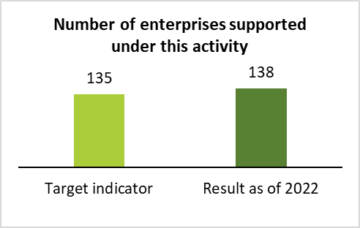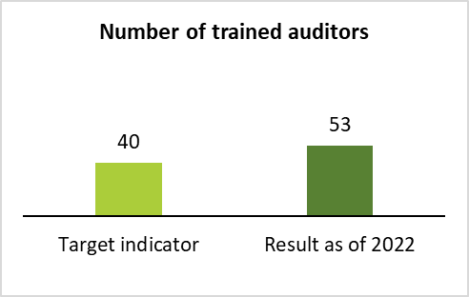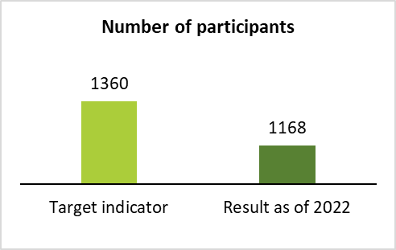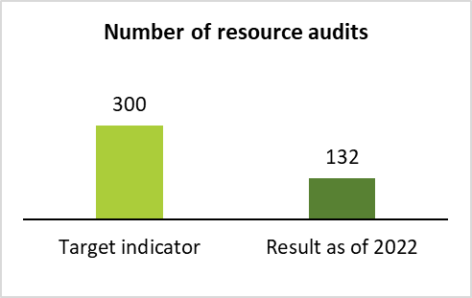

**INFORMATION EVENTS ORGANIZED UNDER ACTIVITY 4.3.3 WERE VISITED 1168 TIMES**

**132 RESOURCE AUDITS WERE CONDUCTED UNDER ACTIVITY 4.3.4 AND ANOTHER 40 AUDITS HAVE BEEN FUNDED FOR SPRING 2022**

**138 COMPANIES WERE SUPPORTED UNDER ACTIVITY 4.3.1 AND 44 PROJECTS ARE STILL IN PROGRESS, IN THE TOTAL AMOUNT OF €135,146,758**

**53 RESOURCE EFFICIENCY AUDITORS WERE TRAINED UNDER ACTIVITY 4.3.2**

* **EVALUATION RESULTS OF ACTIVITY 4.3.1.**

**EFFECTIVENESS |** The activity can be evaluated as effective because the output indicators are met and the set results have been achieved or exceeded.

**IMPACT |** According to entrepreneurs, professional associations and auditors, the support measure has certainly justified itself and contributes to improving the resource efficiency of Estonian companies. The measure also enables industrial companies to invest in more innovative production solutions, which also increases resource circulation, company productivity, and increases the competitiveness of companies and various industries in both the local and international environment.

**CONCLUSIONS AND RECOMMENDATIONS IN ORDER OF IMPORTANCE (FIRST PRIORITY MARKED WITH GREEN)**

|  |  |
| --- | --- |
| **J1. The conditions of applying are unclear and/or too complicated** | **S1. Create additional instructional materials and provide preliminary counselling.**  **Timing: Implement the recommendations by the time of opening the new application round.** |
| **J2. Funded activities do not sufficiently cover problematic areas** | **S2: Consult with potential applicants to determine their needs for the new budget period.**  **Timing: Implement the recommendations by the time of opening the new application round.** |
| **J3. Insufficient time for applying for resource audits, which may create inequality in the market** | **S3: Give sufficient notice before opening the application rounds.**  **Timing: Implement the recommendations by the time of opening the new application round.** |
| **J4. The conditions for organizing the procurement necessary for the implementation of the investment are restrictive for companies** | **S4: Approach the review of applications individually, according to a specific project.**  **Timing: Implement the recommendations by the time of opening the new application round.** |
| **J5. Long processing and implementation time for applications and projects** | **S5: Shorten and standardize the processing time of projects and applications.**  **Timing: Implement the recommendations by the time of opening the new application round.** |
| **J6. Finding self-financing can be problematic for companies** | **S6: Increase state guarantees and/or guarantees for companies with less financial capacity.**  **Timing: Implement the recommendations by the time of opening the new application round.** |
| **J7. Insufficient metrics for evaluating the effectiveness of the measure** | **S7: Update the resource efficiency evaluation metrics.**  **Timing: Implement the recommendations by the time of opening the new application round.** |

* **EVALUATION RESULTS OF ACTIVITY 4.3.2.**

**EFFECTIVENESS |** The activity can be evaluated as effective because the output indicators are met and the set results are achieved or exceeded.

**IMPACT |** According to the target groups, conducting trainings is an important and unavoidable activity as an activity of the measure, which helps to harmonize the knowledge and practices of engineers from different backgrounds in conducting resource audits. The activity thus also has an impact on the achievement of resource efficiency in companies. In the new budget period, it is undoubtedly important to continue with trips to companies that have applied for funds from the measure.

**CONCLUSIONS AND RECOMMENDATIONS IN ORDER OF IMPORTANCE (FIRST PRIORITY MARKED WITH GREEN)**

|  |  |
| --- | --- |
| **J8. According to the auditors, the trainings are not sufficient or useful enough** | **S8: Reduce the volume of general trainings that try to cover a wide spectre of topics and increase the more specifically targeted trainings.**  **Timing: implement the recommendations when making directives for the new funding period.** |
| **J9. The nominal number of people who participated in the trainings is not the best metric for effectiveness evaluation** | **S9: Create an indicator with the experts involved, which would not only take into account the number of people who participated in the trainings.**  **Timing: implement the recommendations when making directives for the new funding period.** |

fdtyjtyuj

**MÕJUANALÜÜSI ARUANDE TÄISVERSIOONIGA SAAB TUTVUDA: *lisada siia link***

* **EVALUATION RESULTS OF ACTIVITY 4.3.3.**

**EFFECTIVENESS |** The set output indicators have been exceeded within one sub-activity. The result indicators of other activities have not yet been achieved but will be achieved by the end of the activity.

**IMPACT |** The impact of this measure activity has been positive. According to the auditors, regardless of the problems encountered or deficiencies related to the trainings, enough auditors who know how to deal with resource efficiency and who now also have extensive practical experience in conducting resource audits, have been trained. Also, as a result of the improvement in the level of training and work experience, auditors are increasingly more familiar with the needs of companies, and the cooperation between auditors and companies has also increased.

**CONCLUSIONS AND RECOMMENDATIONS IN ORDER OF IMPORTANCE (FIRST PRIORITY MARKED WITH GREEN)**

|  |  |
| --- | --- |
| **J10. According to the entrepreneurs, awareness raising events do not fulfill their purpose, and are being partly seen as advertising events for the training company** | **S10:** **Create specific instructional materials for the organization of awareness raising events that private companies (who conduct the trainings) could also use. This would thereby help to ensure a uniform quality standard and organization of these events.**  **Timing: implement the recommendations when making directives for the new funding period.** |
| **J11. Awareness raising events taking place after opening the application round** | **S11: Establish a schedule of information events and take into account that the events should start taking place 9 - 12 months before the opening of the grant application rounds.**  **Timing: implement the recommendations when making directives for the new funding period.** |
| **J12. It is necessary to involve more companies that have already completed and implemented projects, in order to share recommendations and experiences.** | **S12: Involve entrepreneurs in information events who can talk about their implemented projects, in cooperation with the auditors to give specific examples and answer the entrepreneurs' questions.**  **Timing: implement the recommendations when making directives for the new funding period.** |
| **J13. The nominal number of companies that participated in the event is not the best metric for evaluating performance** | **S13: Create a result indicator, involving experts if necessary, which would not only take into account the number of entrepreneurs who participated in information events.**  **Time: implement the recommendations when making directives for the new funding period.** |

* **EVALUATION RESULTS OF ACTIVITY 4.3.4.**

**EFFECTIVENESS |** The output indicators have not been met and therefore this activity cannot be evaluated as effective.

**IMPACT |** The impact of this measure activity has been positive. According to the auditors, regardless of the problems encountered or deficiencies related to the trainings, enough auditors who know how to deal with resource efficiency and who now also have extensive practical experience in conducting resource audits, have been trained. Also, as a result of the improvement in the level of training and work experience, auditors are increasingly more familiar with the needs of companies, and the cooperation between auditors and companies has also increased.

**CONCLUSIONS AND RECOMMENDATIONS (FIRST PRIORITY MARKED WITH GREEN)**

|  |  |
| --- | --- |
| **J14. There is no uniform logic for measuring, evaluating and calculating resource efficiency** | **S14:** **Introduce the calculated value R of resource efficiency improvement as a result indicator. The indicator should be calculated by the implementation department and unit, involving experts if necessary. A unified resource efficiency assessment methodology that could be used across various industries is also needed.**  **Timing: Implement the recommendations by the time of opening the new application round.** |
| **J15. The calculations and activities required in the resource audit do not correspond to the activity of the measure 4.3.1.** | **S15: Align the requirements of the activities of the measures more closely, in order to speed up the process of conducting resource audits and reduce the cost of resource audits.**  **Timing: Implement the recommendations by the time of opening the new application round.** |
| **J16. Companies have no certainty that it will be possible to apply for the measure even after conducting the resource audit** | **S16: Publish and supplement the schedule of the measure with a future perspective of at least one year, which would give entrepreneurs the confidence to start thinking about both conducting a resource audit and making investments more broadly.**  **Timing: Implement the recommendations by the time of opening the new application round.** |

**SEE THE FULL VERSION OF THE IMPACT ANALYSIS REPORT:** [**Measure of the resource efficiency of enterprises**](https://ringmajandus.envir.ee/en/measure-resource-efficiency-enterprises)