STRATEGIC REPORT
FM14-21

Estonia

Reporting period:
01 April 2022 - 31 December 2022

Contents
1. EXECUTIVE SUMMARY 4
2. Political, economic and social context 5
3. Effects of the Grants 5
4. Status of programmes 11
EE-INNOVATION Competitiveness 11
EE-LOCALDEV Local Development and Poverty Reduction 13
EE-RESEARCH Research and Education 17
EE-CLIMATE Climate Change Mitigation and Adaptation 23
5. Status of bilateral funds 25
6. Management and implementation 32
a. Management and control systems (MCS) 32
b. Complaints 33
c. Irregularities 33
d. Audit 34
Summary of the audits conducted by AA and findings of audits 34
7. Monitoring and evaluation 36
a. Monitoring 36
b. Evaluation 39
8. Issues for the annual meeting 39
ANNEXES 39
Annex A: Risk assessment and management plan 40
Annex B: Evaluation plan 44
Annex C: Cooperation with Donor Programme Partners and International Partner Organisations 45
Annex D: Technical assistance report 47
Overview of main activities 47
Budget overview 48
Procurement 49
Staffing 49
Annex E: Communication summary 53
1. Summary of communication activities and achievements in the past 12 months 53
2. Summary of activities to promote bilateral cooperation opportunities in the past 12 months 53
3. Events 54
4. Best practices 54
5. Media coverage 55
6. Website and social media 56
7. Visuals 57

1. EXECUTIVE SUMMARY
State Shared Service Centre, acting as the National Focal Point (further referred as NFP) for the implementation of the EEA and Norwegian Financial Mechanism in Estonia has prepared the Annual Strategic Report No. 5 on the Implementation of the EEA and Norwegian Financial Mechanisms 2014-2021 in Estonia (further referred as the Strategic Report). The Strategic Report reflects the implementation of the financial mechanisms during the period from 1 April 2022 (next day of the cut-off of previous Strategic Report) to 31 December 2022.
While in 2021 and 2022 programmes/projects and Estonia overall begun to cope with the long lasting COVID-19 situation quite well, the new crisis caused by Russia’s invasion to Ukraine brought new uncertainty. Nevertheless the status of programmes can be considered good. The commitment rate is 96% (31 December 2022) compared to 86% with the cut-off date of the previous Strategic Report (31 March 2022). The disbursement rate[1] has almost doubled since the cut-off date of the previous Strategic Report (from 24% to 41%). By the end of 2023 NFP foresees the commitment rate to be around 99% and the disbursement rate to be around 65%. The years of 2023-2024 are foreseen to be the most difficult implementing years, while the end of eligibility date is very near and we have to monitor the status closely and have to be ready to react quickly if challenges occur.
All programmes are in full implementation now. All initially decided 13 pre-defined projects concerning all 4 programmes are carrying out their activities. In 2023 additional pre-defined project "Trauma-informed counselling in educational support services" under EE-Localdev programme was approved by the donors. All 22 calls have been launched. No new calls are foreseen. The surpluses will be reallocated to ongoing projects keeping in mind the flexibility options presented in FMO letters in 2022.
Given the complicated situation the absorption of Bilateral Funds can be considered satisfactory and looking at the 2022 year only, Bilateral Fund projects have progressed surprisingly well. Two bilateral initiatives have successfully finished their activities during the reporting period. And there are many more good examples in ongoing initiatives with events recently organised or events coming up. The Joint Committee for Bilateral Funds (JCBF) came together in 2022 three times instead of regular two and had 6 written approvals. JCBF is very flexible with needed changes regarding bilateral initiatives (extensions, budget/activities modifications) in order to maximise the value of formed partnerships in these quite difficult and confusing times in the world.
The main risks faced are the delays that are likely to occur due to the situation caused by COVID-19 and the refugee crisis caused by Russia’s invasion to Ukraine. Changes in the economic environment (inflation, logistics, demand etc) caused by Russia’s invasion to Ukraine may lead to insufficient project financial resources to acquire all needed goods and services for the successful implementation and delivering all results promised. Overall risk level of programmes is 2 on a scale of 1 to 4. Although the complicated situation in the world is a big threat to meeting indicators, staying in the timeframe, bilateral cooperation etc, the overall risk is not considered very high due to the good communication and active monitoring of the situation.
Looking forward, the most crucial challenge in 2023 is to react effectively to the consequences of the crises in the world and the risks foreseen (Annex A) in order to minimize the negative effect they might have on the EEA and Norwegian Financial Mechanisms 2014-2021 in Estonia. All parties have to communicate/cooperate and respond quickly in order to have projects implemented before the end of the eligibility period and outputs, outcomes, objectives of programmes achieved.

[1] Incurred expenditure (payments to PPs) on the basis of our information system SFOS

2. Political, economic and social context
During the reporting period the main external factors that have affected the implementation of the programmes are war in Ukraine and energy prices increase. High energy costs are passing over to the prices of other goods and services. Inflation has been highest in years a little below 20% in 2022.
According to the prognosis of Estonian Pank energy prices remaining consistently high and prices rising for the goods and services needed for production has not yet entirely been passed on to the end consumers, and so inflation will fall, but slowly, below 10% next year and is expected to remain at around 2-3% in 2024-2025.
In 2023 the economy will grow by 0,4%, mainly due to increasing government spending. In 2024-2025, economic growth can be expected to accelerate to 3-4%, but the war in Ukraine means that there is greater uncertainty than usual around the outlook for economic growth and for inflation.
Unemployment will rise as the economy cools and employment will most likely fall in 2023. Unemployment will peak at around 9% in 2024, and a part of the increase in unemployment will be due to refugees from Ukraine looking for jobs in Estonia and starting to be reflected in the labour market statistics.
Number of registered unemployed persons in the Estonian Unemployment Insurance Fund (including the number of new registered unemployed persons) was 36 681 on 29.02.2020 and 57 103 on 11.02.2021, decreased by the end of 2021 to 44 109 and increased again being 55 054 as of 22.02.2023.
The refugees have been registered as unemployed since 10.03.2022 and on 04.04 there were 2096 persons registered, which is 4,5% of the unemployed persons. By 19.02.2023 there were 6505 persons, which is 11,8% of the registered unemployed persons.

3. Effects of the Grants
The year 2022 has been the 3rd full year of implementation and several outputs are supporting in addition to programme specific outcomes also the national high-level objectives.
Estonian Government has set in the Competitiveness Strategy “Estonia2035” five key strategic goals, with indicators and steps to be taken to cover national development needs and enable moving towards reducing social and economic disparities as well as moving towards global objective of sustainable development. Smart and active people caring for one´s health, open, caring and cooperative society, strong, innovative and responsible economy, good living environment and innovative, reliable and people-centred governance. Support under EEA and Norwegian Financial Mechanisms contributes with activities running under the programmes moving towards every objective.
The innovation capacity of companies has increased in recent years. Innovation capacity is characterized by productivity per employed person. Estonia has set an ambitious goal – to exceed the EU average in terms of labour productivity by 2035 and to reach 110%. By the end of 2021 the level of productivity per person employed was higher than the year before despite the difficult times - 86,6% (82,6% in 2020, 77,8% in 2019 and 77,2% in 2018). Further growth will become increasingly complex and will require the introduction of more research and development, a major step in the digitalisation of enterprises, and the development and implementation of green technologies.
Estonia´s place in the Innovation Scoreboard published in the September of 2022 shows slight decline, Estonia is considered Moderate Innovator with performance at 99,96 of the EU average. Performance gap to the EU has almost disappeared despite the decline between 2021 and 2022.
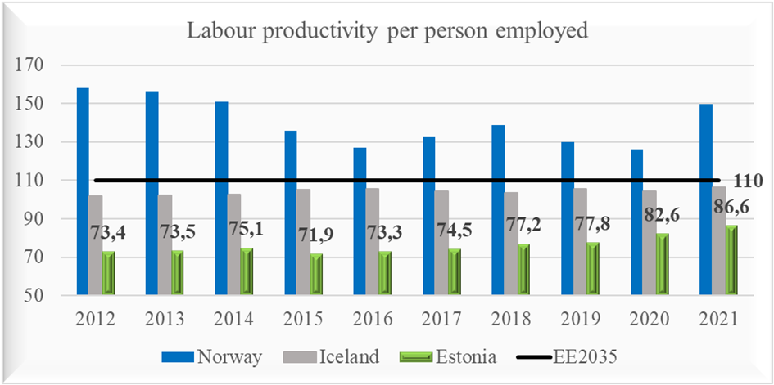
Source: Eurostat
The share of R&D expenditure in gross domestic product (GDP) amounted to 1,75% in 2021 (1,75% in 2020, 1,63% in 2019, 1,41% in 2018). In the national long-term development strategy “Estonia 2035” the objective is to achieve 2% R&D expenditure in the private sector. Baseline reference value was 0,87% in 2019 and in 2021 the achievement level was slightly higher – 0,98% of GDP. In the last seven years, the number of researchers and engineers in the private sector has increased, almost doubled (per 1000 residents 0,95 in 2015 and 1,82 by the end of 2021).
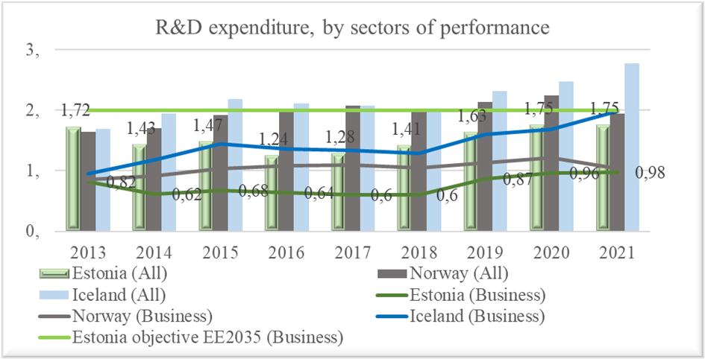
Source: Eurostat
According to Statistics Estonia, in 2022, the labour force participation rate was 73,3%, the employment rate was 69,2%. The number of unemployed persons and the unemployed rate both fell last year, for the second year running. The unemployment rate was 5,6%, down from 6,2% in 2021.
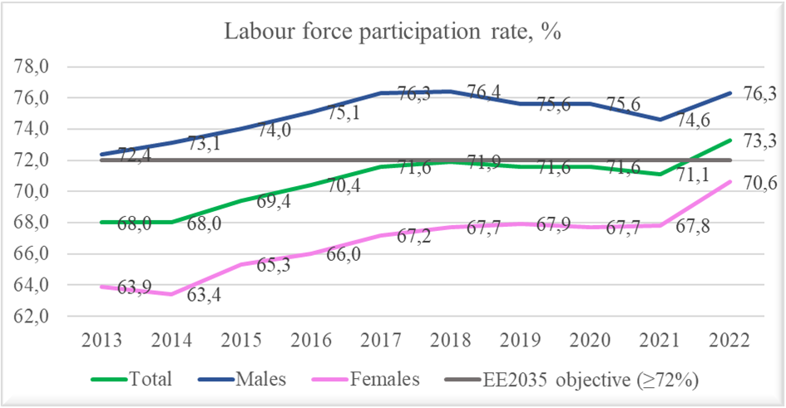
Source: Statistics Estonia (TT332)
The EE-Innovation programme projects with strong focus on innovation contribute to increasing the capacity of R&D and uptake of new technologies, business, and service models, leading to improved value chains and sustainable growth in Estonia´s private sector.
The projects also contribute to raise in share of R&D investments, increased productivity, but also the objectives of lowering the CO2 emissions.
The EE-Research programme contributes among others to the objectives of the Estonian R&D&I strategy 2014-2020 and to the new TAIE Strategy for 2021-2035 to enable high level and diverse research, the efficient networking of research institutions and that Estonia would be active and visible in international RDI co-operation, which helps to solve the tasks that Estonia and other countries are facing in different sectors whether health, technology or environment. As a result of the projects there are by 2022 in total, 30 joint scientific articles submitted to peer-reviewed publications, 127 researchers supported (67 women and 60 men), 33 doctoral students and 14 postdoctoral fellows supported. Competences of students and staff in higher education were increased through development of innovative tools (CCI Learning Module Toolbox (ccitoolbox.com)), digital learning instruments (digital simulations on the basis of SIMIO software for the Estonian Aviation Academy), and hybrid curriculum in patient safety. Programme also contributed to the increased competences of educational staff in working with special education needs (SEN).
The EE-Localdev programme contributes to diverse essential objectives like reducing gender-based violence and increasing gender equality (virtual competence centre, victim support system development, public awareness on domestic violence and trafficking in human beings), decreasing the number of youth unemployment and early leavers from education and training (transition programmes from basic education to VET, smart youth work etc.) and at risk of poverty rate.
As part of the programme a Virtual Competence Centre of Gender Equality has been developed, which combines gender equality statistics, research and training materials, providing necessary information for state and local government level policy makers and employers, representatives of education sectors etc.
According to the European Institute for Gender Equality Estonia ranks 17th in the EU on the Gender Equality Index for the 2022 with 61 points out of 100 (61,6 in 2021). Estonia´s score is 7,6 points below the EU´s score. The target set for 2035 is 70,7 points.
According to Statistics Estonia, in 2021, the gross hourly earnings of female employees were 14,9% smaller than the earning of male employees. The gender pay gap decreased by 0,7 percentage points. The gender pay gap was 14,9% in 2021 compared to 15,6% in 2020 (17,1% in 2019, 18,0% in 2018, 20,9% in 2017, 24,6% in 2012). The objective for 2035 is 5%, achieving it requires still significant effort in raising public awareness and encouraging the career choices of women.
Despite the Estonian government´s clear commitment and measures taken, gender-based violence remains a challenge for Estonia, with projects under Norwegian Grants preventive actions can be taken. The project “Strengthening the victim support system” contributes to improved system of support to victims of domestic and gender-based violence. 2563 victims of gender-based violence were assisted in the supported shelters already in 2020, 2080 in 2021, 1917 in 2022. The system of a volunteer support for working with victims is established.
In the last three years, the number of registered domestic violence crimes has decreased. In 2022, 3244 cases were recorded, 14% less compared to 2021. The number of homicides and murders (including attempts) related to domestic violence increased by four, in 2022, 7 cases were recorded (3 cases in 2021, 14 in 2020).
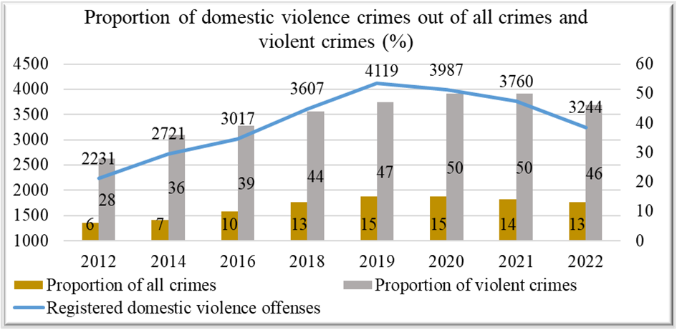
Source: Ministry of Justice
COVID-19 restrictions had negative impact on young people´s ability to cope and learn and increased the risk of exclusion or falling into NEET status. Most NEETs are young people with basic and general secondary education.
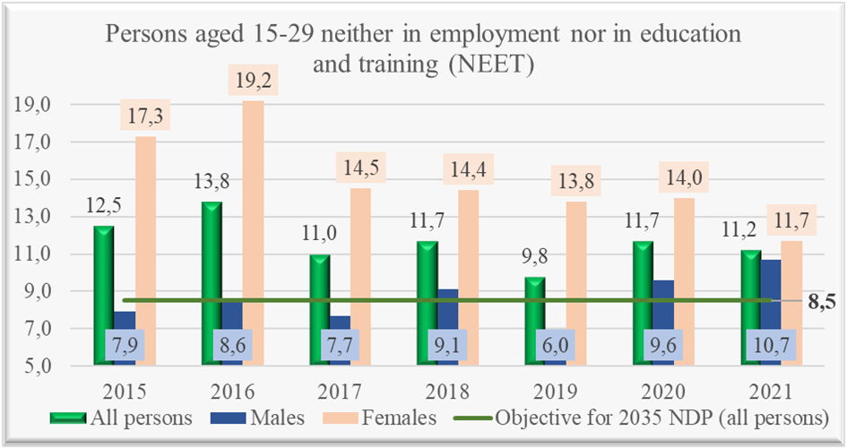
Source: Statistics Estonia LES39
Youth unemployment has been decreasing over the years but increased again during the Covid-19 crisis.
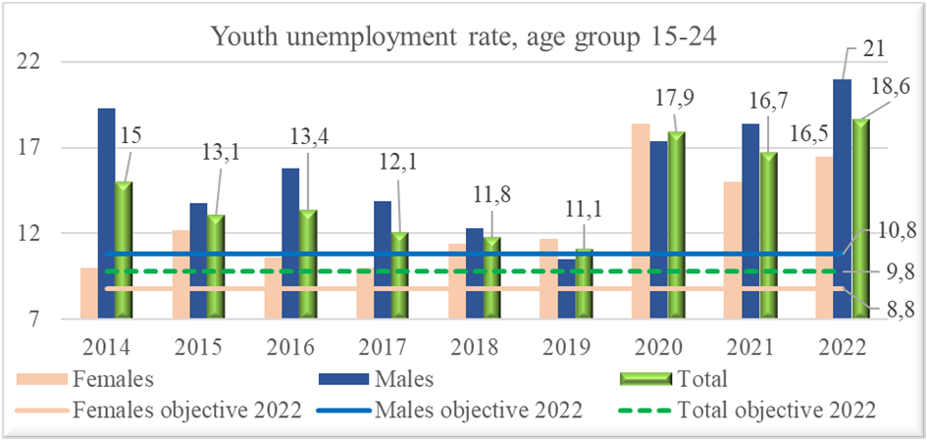
Source: Statistics Estonia
The level of education significantly affects the risk of falling into poverty. The share of early leavers from education and training (18-24-year-olds) was 9,8% in 2021, 8,5% in 2020 (11,2% in 2019, 12,0% in 2018 and 11,8% in 2017).^{[1]} The projects under the open call for proposals “Integrated services provision to prevent early school leaving” contributed to the prevention in several counties when dealing with young people at risk of dropping out of school.
According to Statistics Estonia, 22,8% of Estonia´s population lived at risk of poverty and 1,4% in absolute poverty in 2021. Compared with 2020, the share of people living at risk of poverty rose 2,2% and the share of people living in absolute poverty fell 0,8%.
The EE-Climate programme contributes to national objectives in the field of climate mitigation and adaption activities, to the transition to a low-CO2 economy and to raised environmental awareness. Support under the European Economic Area funds enabled preparation of climate and energy plans for local authorities, 10 SGS projects are supported to come into compliance with national and European Union level mitigation and adaption strategies. Strong base to the circular economy was created with activities under the predefined project “Enhanced capacity on Circular Economy” through the design of the Circular Economy White Paper (including English summary). The White Paper was designed to support different stakeholders – the state, local municipalities, entrepreneurs, and individuals – in mainstreaming the principles of circularity in production, consumption, policies, lifestyle, and values.
The activities under the EE-Climate programme contribute to the objectives of the strategy “Estonia 2035”, to the increased rate of circular material, increased resource productivity use and decreased greenhouse gas emissions.
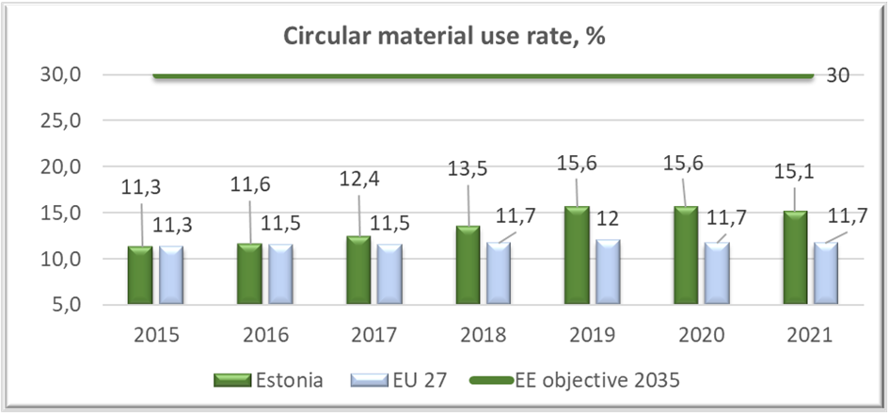
Source: Eurostat
The resource productivity has slightly raised being 0,70 euros/kg in 2021 (0,67 in 2020, 0,64 in 2019, 0,56 in 2018), the objective for 2035 is 0,90.^{[2]} It is essential to increase the production of higher value-added products and the provision of higher value-added services in the value chain, to support resource efficiency measures in enterprises, and to increase the share of renewable electricity.
Greenhouse gas emissions in Estonia are decreasing. Estonia aims to reduce greenhouse gas emissions by almost 80% by 2050 compared to 1990 emission levels. According to the Estonian greenhouse gas inventory data for 2020, the total greenhouse gas emissions were 12,8 million tons of CO2 equivalent (18,8 million tons in 2018 and 14,3 in 2019) the objective for 2035 is 8 million tons of CO2 equivalent.^{[3]}

[1] Source: Eurostat
[2] Source: Statistics Estonia EE01.
[3] Source: Statistics Estonia EE01

4. Status of programmes

EE-INNOVATION Competitiveness
Programme agreement signed | 26.04.2018
Calls (launched/planned) | 5/5
PDPs (positively appraised/planned in total) | 2/2
Total number of projects contracted | 83
Total number of projects with a donor project partner | 21
Total programme budget | € 27,058,824*
Total funds available to projects | € 25,431,765*
Project grant contracted | € 23,610,650*
Total funds disbursed to projects | € 10,732,740*
Total management costs | € 1,627,059*
Management costs disbursed | € 827,500*
*Norway grants + national co-financing, national information system, cut-off 31.12.2022.
All the granted projects serve the purpose of creating increased value and sustainable growth. Programme aims to stipulate and develop innovation-led long-term business cooperation between Estonia and Norway by initiating bilateral cooperation projects and events.
Programme has three different focus areas: Green Industry Innovation, ICT and Welfare Technology. Programme is implemented through open calls (Small Grant Schemes and Main Calls) and pre-defined projects (Health Sense and Open Cyber Range).
With more than a year to go until the end of implementation period in April 2024, most of the projects are still in progress, developing or applying new technologies in aforementioned focus areas. Some of the projects have been terminated due to various reasons, for instance a price increase in supply chains or raw materials due to the crisis caused by Covid-19 and war in Ukraine. Still the first projects have finalised their activities and delivered results.
Most of completed projects have fulfilled the planned results, i.e. creating new jobs, reducing the CO2 footprint and/or energy consumption. Some project promoters may, as a broader trend in the context of the general economic downturn and restrictions resulting from the corona crisis, experience problems in achieving economic goals. Nevertheless, the completed projects have presented reasonable and acceptable achievements also in increasing the annual growth in turnover and operational profit.
There are several good examples of successful bilateral cooperation projects of Estonian and Norwegian enterprises, for example project no EE-INNOVATION-0049 (Development of a marine-certified ultracapacitor modules), implemented by Estonian company Skeleton Technologies OÜ and Norwegian technology company NXTech AS. The cooperation between the aforementioned companies have been sustainable for two Norway Grants implementing periods, the project promoter has expressed hope that the effective cooperation between the two companies will also continue beyond the current funding scheme.
The call for additional activities in ongoing projects was open from the 12th of September until 11th of November 2022. Implementing agency received 13 applications in total grant amount of 1,823,682.99 euros. Grant was awarded to all 13 projects in the amount they applied for. Projects started their activities from the 1st of February 2023.
EE-Innovation programme has surpluses from ended/terminated projects, surpluses from final call and programme management costs and is unable to absorb it in its programme due to close programme implementation deadline on April 30, 2024. Therefore EE-Innovation programme Cooperation Committee decided to reallocate EUR 1,000,000 to other programmes.

EE-LOCALDEV Local Development and Poverty Reduction
Programme agreement signed | 13.09.2019
Calls/SGSs (launched/planned in total) | 8/8
PDPs (positively appraised/planned in total) | 8/9
Total number of projects contracted | 49
Total number of projects with a donor project partner | 16
Total programme budget | € 21,176,470*
Total funds available to projects | € 20,055,882*
Project grant contracted | € 19,748,058*
Total funds disbursed to projects | € 6,860,347*
Total management costs | € 1,120,588*
Management costs disbursed | € 393,515*
*Norway/EEA grants + national co-financing, national information system, cut-off 31.12.2022.
The EE-Localdev programme is an extremely comprehensive programme covering very wide range of policy/intervention areas that are in some extent dealing with quite different objectives like cultural heritage protection, gender-based violence or physical health of children. With this programme structure and financial resources available, it is quite hard to make a real wide-scale statistical change in the whole of the society, but of course the ultimate goal to a better life and regional development in Estonia is followed.
Most programme activities have progressed satisfactorily. The only big and main obstacle concerns the projects in outcome 4 (renovation of buildings in cultural heritage areas) where the renovation prices went way up comparing to year 2019-2020 when the original financial analyses were drawn up; therefore the procurements have failed and project budgets have ended up in deficit due to force majeure. Fortunately EUR 1,000,000 reallocation from EE-Innovation programme has been decided to help EE-Localdev programme outcome 4 renovation projects. Nevertheless there is considerable probability that some of the project promoters in outcome 4 will terminate the project as they still lack the resources necessary or there is not enough time to start the whole procurement process again from the beginning.
All 8 pre-defined projects earmarked in the Programme Agreement are running. The implementation period of 3 pre-defined projects were prolonged to successfully conclude the projects’ activities. No terminations or other essential changes took place. Due to surpluses in outcome 1 (Enhanced wellbeing of children and youth), one additional pre-defined project proposal in the sum of approx. 201 000 euros is currently being prepared in outcome 1 – trauma-informed counselling in educational support services. This project will help to mitigate the refugee crisis situation in Estonia. They hope to start with the activities in March 2023.
Altogether 41 projects have received financing via 8 different calls for proposals as well as small grant schemes (SGS) and are running. Projects financed in outcome 2 (Reduced domestic and gender-based violence and gender inequalities) are already finishing up their activities in the end of 2022 / in the beginning of 2023. In 2022, programme carried out and finalised call for proposals #1 (“Integrated services provision to prevent early school leaving”) and SGS “Developing Restorative Justice Measures in Estonia” #1b with 6+5 projects being financed in the 2nd/3rd quarter of 2022.
Outcome 1: Enhanced wellbeing of children and youth
The pre-defined project by the Ministry of Justice "Specialised juvenile justice approach established" is currently in full implementation phase and has been prolonged until April 2024. The project also received additional grant support in the sum of 77 655 euros (surplus from SGS) for extra restorative justice activities, especially in the criminal justice system. It has launched an International Self-Report Delinquency Study (ISRD), first results are available in spring 2023. Multiple specialised trainings for police, prosecutors, youth workers and child protection services have been carried out as well as a training programme for closed children institutions has been worked out and will be piloted as of the beginning of 2023. New Russian-speaking groups have been compiled in Ida-Viru county (topics concerning family work, crisis solving, youth mediation and restorative justice as a tool in everyday work situations). Voluntary conflict mediation has become quite popular, more volunteers are being trained.
All financed SGS “Developing Restorative Justice Measures in Estonia” projects align with and contribute to the national strategies in regard to reinforcing restorative justice as a special preventive measure in criminal justice policy area.
Pre-defined project “Establishment of a renewed family mediation system” by Social Insurance Board has been progressing well. A national Family Mediation Act came into force as of Sept 1, 2022 laying down unified standards and processes for a nationwide service provision. The piloting of the service has been finished and the service is provided now as a part of national services (in the first two weeks, there were altogether 175 inquiries regarding the service). 28 mediators have passed a qualification exam. By today, already 79 families have received mediation services via the project. For all trained mediators a group covision seminar was held in Pärnu. In Jõhvi, a 3rd training group has started (mainly Russian speaking specialists). Practice with families receiving mediation will continue till the end of the year.
12 projects have been financed through a SGS “Implementation of Vocational Orientation Curriculum in Vocational Education Institutions”, 10 of them started nicely in 2021, while 2 (Kuressaare and Tallinn Lasnamäe School of Mechanics) had launching difficulties. Both relaunched as of schoolyear 2022/2023, but unfortunately Kuressaare has still indicated that it would like to terminate the project because it is not able to gather enough students to formulate a study group. By the end of 2022, altogether 439 students have participated at the career orientation programme.
The open call “Smart Youth Work Solutions” financed 2 projects that started their activities in January 2022 and are progressing as foreseen.
The deadline for call for proposals "Integrated services provision to prevent early school leaving" targeting local governments was Jan 17, 2022. Altogether 6 projects were financed that started their activities in May-June 2022.
Outcome 2: Reduced domestic and gender-based violence and gender inequalities
As the projects in outcome 2 were on of the firsts to start their activities, then they are also the first to reach the finishing stages of the implementation period. SGS “Training of domestic violence specialists and establishment of a programme(s) for sex buyers” projects and open call “Awareness raising activities on domestic violence and to discourage the demand for commercial sex“ project finish their activities in the end of 2022/beginning of 2023. An awareness raising project by NGO Eluliin has carried out campaign discouraging the demand for commercial sex “Think With Your Right Head” in Spring 2022 as well as produced 3 different animated 2 minute tutorial videos concerning violence within the family, against an animal and violence by a friend (in Estonian and in Russian languages).
A pre-defined project "Strengthening the Victim Support System" was prolonged until August 2023. The project has focused on early noticing guidance materials for health care workers on domestic violence (incl. risk evaluation) as the component lagged behind due to Covid-19 pandemic. Additionally, a training programme for judges has been compiled. Women shelters’ specialists have been trained on communication, public speaking and advertising.
In Dec 2022, a pre-defined project "Virtual Competence Centre of Gender Equality" published a new Gender Equality Monitoring Report (the previous one came out in 2016) and prepared for the publicity campaign introducing the virtual competence centre at www.vordsuskeskus.ee and the new analysis/materials on GE (monitoring report; e-modules, compendium “Towards the balanced society III” etc.). Also, the development of e-training modules for politicians is under way. The first module containing the basic ABC on gender equality can be used also for other target groups like teachers employers, etc. The e-training course is being developed in cooperation with the newly established web environment for digital learning called Academy of the Digital State (https://digiriigiakadeemia.ee/). The project was prolonged until February 2023.
Outcome 3: Improved quality of integrated services and public health interventions at local level
The pre-defined project "Increasing physical activity of schoolchildren" by the University of Tartu has a very wide grasp, being the country-wide leading actor in dealing with the issue of increasing physical activity among Estonian schoolchildren. The network of Schools in Motion has increased up to 162 schools. A recognition certificate of youth physical activity was designed and publicised in August 2022. In Nov 2022, an annual event for approx. 400 people was organised in Tartu (Norwegian partners also participated). Target groups were teachers, school directors, LG representatives etc. The goal was to raise awareness on physically active school movement, wider spread and sustainable continuation with the support of the local governments. A study on school environment, teachers and parents shaping the physical activity of children is ongoing with the donor partner the University of South-Eastern Norway.
The pre-defined project "Increasing public health competence and capacity of local governments" by National Institute for Health Development has been progressing well. A county-based analysis of health status of people in different regions in Estonia has been finalised. It gives the local governments a tool to carry out health risk impact analysis in their community and propose targeted measures needed namely for the concrete community. 12 new local governments (LG) joined 9 LGs already engaged in a 1,5-year project to raise their capacity in specific local public health issues. The project helps the local governments envisage a public health action plan basing on the health profiles created for the region – health profile is a self-analysis tool for the local government being updated every 4 years. It is composed of over 100 indicators – some numeric, others not – that paint a complex picture of the situation of the municipality in several areas of life, like demographics and the level of social welfare services and safety of the living environment, but also mental health, drug abuse, obesity etc. Additionally, a pilot on school food quality was finished in 3 schools of Põlva county, feedback and self-analysis are underway. It is planned to move into new regions. Toybox for kindergartens (obesity reduction tool) – renamed “Saladuste Laegas” for Estonia, i.e. “Adventure Box” in English is in pilot phase in 5 kindergartens in Põlva county as well as 9 new kindergartens in Võru county.
The pre-defined project "Development of evaluation model and handling system for chronically mentally ill patients" by Viljandi Hospital is in full motion. The doctors and staff have been provided with different trainings and group supervision seminars (for psychologists and psychiatrists). A bus for mobile cross-sectoral teams has been acquired and renovated for specific needs. The bus is meant for out-patient psychiatric coercive treatment model by cross-sectoral teams in different regions of Estonia. The development of a model for a multidisciplinary forensic psychiatric committee to improve the quality of psychiatric evaluation has started but the adaptation process of evidence-based evaluation instruments has had some obstacles receiving data from the Health Board and Statistics Board, but it is realistic to move forward in the beginning of 2023 in this sector.
The two projects financed within the open call "Integrated services to support health and safety in home environment" are in implementation. Rescue Board dealing with issues regarding reducing the risk of injury in home environment and Foundation Centre for A Child’s Wellbeing is creating a support system to support families at risk with infants and toddlers. By today, an early noticing model for families in risk has been developed and 79 families have been visited / helped during the piloting phase. Altogether 43 midwives have received the training and are qualified to carry out home visits.
Outcome 4: Historic town centres revitalised through heritage-based local development
The pre-defined project "Historic town centres revitalised through heritage-based local development" by the National Heritage Board has been prolonged until April 2023. A summer school “Living old towns: from energy efficiency to recycling” took place in August 2022 in 3 towns – Rakvere, Valga and Kuressaare. An exhibition “Living old town” has been produced and has been travelling through different towns. The exhibition is also available in web (https://muinsuskaitsepaevad.ee/veebinaitus/). Restoration workshop was carried out in Valga; a workshop with Norwegian partners took pace in Lihula Manor and Estonian Arts Academy students were engaged to a practical workshop at Kuressaare Port Storehouse. A photo competition “Living old town” with different categories (architecture, landscape, action etc) took place in Sept 2022. 7 out of 9 walking maps are ready, maps of Pärnu and Kuressaare are still being designed.
Most projects of 7 that were financed within the call for proposals “Historic old town centres with cultural heritage protection areas“ struggled. The financial calculations for projects were made in 2019-2020 and the projects started in May 2021. After preparatory works (design, condition explorations, heritage board permits etc.) the renovation works procurements fell mostly into year 2022 with different problems flaming at that time (the war in Ukraine, inflation and world logistics difficulties). The prices had risen considerably and therefore the procurements failed in the end because of deficit in project budgets. Only the projects running in Kuressaare (Port Warehouse and Holisticum) were making real progress in renovation works. Other projects still operated in design and procurement phase, also trying to find alternatives and searching for possibilities to cancel some parts of action, but still maintaining the main objective to finish the project so, that the building would be taken into use, at least in part.
PO has actively been searching for alleviative measures. In 2023 additional funds in the sum of 1 MEUR will become available for projects financed under outcome 4 - to offer them an equal possibility to apply for additional support up to 25%. But even when there will be additional grant support, there is considerable probability that several of the 7 financed projects will terminate the project implementation as they still lack the resources necessary or there is not enough time to start the whole procurement process again from the beginning. The situation will become clearer in 2nd quarter of 2023 regarding which projects will continue and in what amount.

EE-RESEARCH Research and Education
Programme agreement signed | 18.06.2018
Calls/SGSs (launched/planned in total) | 4/4
PDPs (positively appraised/planned in total) | 2/2
Total number of projects contracted | 20
Total number of projects with a donor project partner | 20
Total programme budget | € 8,352,941*
Total funds available to projects | € 7,684,706*
Project grant contracted | € 7,605,015*
Total funds disbursed to projects | € 6,080,605*
Total management costs | € 668,235*
Management costs disbursed | € 304,754*
* EEA grants + national co-financing, national information system, cut-off 31.12.2022.
Overall implementation of projects has gone according to plan and has met our expectations. Projects under outcome 1 (Enhanced performance of Baltic research internationally) have progressed as planned and there are no significant deviations in the implementation of the projects. All 7 research projects will continue in 2023. Projects under outcome 2 (Improved skills and competences of students and staff in higher education) will end in 2022 and 2023. In 2022, 3 projects submitted their final reports and received final payment. The pre-defined project for the study programme of Norwegian language and literature has been very popular among the students, and it was decided to prolong its deadline until the end of the 2022/23 academic year. The pre-defined project under outcome 3 (Competence of educational staff increased, related to working with special education needs (SEN)) was planned to finalise in 31.01.2023, but in order to successfully implement all the actions of the project and achieve a greater impact, it was necessary to extend the implementation of the project activities until 31.01.2024. In 2022, efforts to further enhance collaboration between beneficiary and donor state entities continued, and the results achieved in terms of performance indicators can be highly appreciated.
Outcome 1: Enhanced performance of Baltic research internationally
The best results were delivered in submission of joint scientific articles in peer-reviewed publications – 14 publications. The cumulative number of joint publications is now 30, which is 60% of desired target value. This goal is still expected to be achieved by the end of the programme. The Norwegian partners have been involved in all 14 publications submitted in a joint capacity of at least one Baltic State and one Donor State. There are Lithuanian co-authors in 6 and Latvian co-authors in 5 joint publications. 6 joint publications have co-authors from third countries.
Based on scientific peer-reviewed joint publications submitted, the most outstanding result was delivered by project EE-RESEARCH-0010 (Optimised Residential Battery Energy Storage Systems (ORBES), EMP474) which submitted 8 articles. In addition, this project submitted 7 peer-reviewed scientific publications (without involving donor partners). The cumulative number of joint publications submitted by EMP474 has increased to 18. Their share of all joint publications submitted within the programme is as high as 60%!
Number of researchers supported by the programme has increased by 16 compared to the previous year (9 women and 7 men), bringing the total cumulative number to 127 (67 women and 60 men). Thus, the target value for output 1.1 is achieved. The gender distribution remains well balanced.
In 2022, 5 PhD students (3 female and 2 male) and 2 postdocs (1 female, 1 male) joined the EEA project teams. The cumulative number of doctoral students supported by the programme is 33 (18 female and 15 male) and 14 postdoctoral fellows (7 female and 7 male).
Only one project submitted a joint application for further funding - project EE-RESEARCH-0009 (Sustainable use of soil resources in the changing climate (SUCC), EMP442). Unfortunately, this application (submitted to “Horizon Europe Mission: Soil health and food”) was not funded. The modest interest in applying for further funding can still be explained by the pandemic situation that does not encourage taking any new commitments. It can also be related to the timing – you start thinking more about applying for new funding when the existing one is about to end.
None of the projects applied for Intellectual Property Protection in 2022.
In general, there were fewer delays and deviations directly caused by Covid-19. However, in 2022, project implementers continued to mitigate the consequences of previous years and catching up on work plans.
Some deviations in projects related to fieldwork or experiments have been caused by force majeure. For example, in the project EE-RESEARCH-0012 (Solutions to current and future problems on natural and constructed shorelines, eastern Baltic Sea (SolidShore), EMP480), the Lithuanian partner lost its equipment near Palanga due to an autumn storm in 2021 that buried the sensors under the sediments and did not allow retrieving the data from the experiment in Lithuanian waters. In 2022, this gap was filled when the large-scale field experiment was performed in Latvian waters near Skulte.
In some projects, the research results achieved so far have led to the conclusion that the proposed research plan should either be modified or improved. For example, in the project EE-RESEARCH-0008 (Towards elimination of cervical cancer: intelligent and personalised solutions for cancer screening, EMP416), it was considered to expand the research to examine stakeholders’ acceptance of risk-stratified (risk-tailored) screening, including reducing the frequency of screening at low risk and using personal risk information, which is considered more important for developing future implementation strategies than testing the medium (web, app) and risk prediction algorithm application that was originally proposed.
No project requested a budget change to such an extent that it would have required the conclusion of a new project contract addendum. However, the projects have taken advantage of the flexibility allowed to them (reallocations up to 10% of the full grant). For example, in the project EE-RESEARCH-0009 (SUCC), it was agreed within consortium that the subcontracting costs originally planned for all partners will be made only by the promoter.
Outcome 2: Improved skills and competences of students and staff in higher education
During 2022, 3 of the granted projects have ended.
- Estonian Business School project’s ‘Creative Industries Learning Module (CCILM)’ aim was to develop the creative industries (CCI) learning module for universities. The partners (BI Norwegian Business School, University of Iceland, Creativity Lab, Creative Estonia) created the “CCI Learning Module Toolbox” (www.ccitoolbox.com) that provides all the necessary building blocks that teachers and trainers can use to put together an innovative flipped classroom creative industries course for bachelor students. During the implementation of the project, there were some changes in planned activities, but this did not affect the overall aim and planned impact of the project.
Impact of the project is wide. Toolbox enabled altogether 142 students to learn more about the CCI and earn ECTS. There has also been a great impact on the participating organisations that have learned from each other’s practises, experience, and knowledge during the intensive study course “Challenges and problems in CCI” held in Norway and later during working on the IO together. The intensive study course “Challenges and problems in CCI” brought together three different universities from three different countries, plus organisations working directly with the CCI companies. This created a unique opportunity to learn from each other, exchange opinions on the contents, methods, and approaches used in each HEI’s studies (e.g. we learned about the storytelling method Norwegian HEI is using; how different HEIs divide CCI into subsections in their studies). The CCI is a relatively young field and therefore the opportunity to share experiences with peers is invaluable. There has also been outside recognition of this project as other academics have praised their job in conferences as well as journalistic interest in covering the project and writing an article about it.
The cooperation between project partners will continue beyond the funding of this project. For example, partners are preparing together a project to create a cluster of CCI BSOs and HEIs that will develop an NFTs infused CCI business model and promote it on an online innovation space and knowledge hub. Furthermore, project partners EBS and BI Norwegian Business School are preparing an academic study together on the topic of “Onsite Culture at Stake in Online Times - Online-Onsite Separation, Substitution and Integration in the Creative Industries”. Hence, the cooperation project ‘Creative Industries Learning Module (CCILM)’ has been an initiator of good synergy out of which new projects can be born.
- The Estonian Aviation Academy implemented the project ‘Simulation-based Learning in Aviation’ in cooperation with UiT Arctic University of Norway. During the project's lifetime, the digital learning instruments into the teaching process of aviation-related subjects were implemented. The result of the project was a set (module) of digital simulations (models) created on the basis of SIMIO software. The main result was a set of courses, forming an "Aviation Operation Simulation Module". Models were developed in cooperation with partner institutions and integrated into partner academic courses and designed based on aviation sector data. Within the courses, students will be taught how to create and use models and design simulations on their own. This allows students to comprehensively understand complex aviation processes, increases their creativity and digital skills.
The project activities included special webinars for the staff of the partner institutions. During the webinars a theoretical context for the use of simulation methods in the learning process were given and opportunities for digital simulation programmes were discussed. There was an overview of created models and inspired teachers to implement digital simulation in their study courses.
The development of digital simulation instruments allows closer cooperation between academia and industry. During the implementation of the project, aviation industry representatives were introduced with the prospects of digital modelling and its efficient use in managing real processes in aviation. From a perspective, the acquired capacity of the partner institution to use modelling skills allows them to provide their expertise to the aviation sector on a larger scale.
The implementation of the project provided a basis for future academic cooperation between partner institutions. The joint project allowed for the expansion of international cooperation and practice in international teamwork. This is the basis for future joint projects and activities. Also, both institutions became more visible internationally and domestically.
- University of Tartu implemented the project ‘Hybrid curriculum in patient safety: integration of academic master’s education and continuous professional education in Estonia and in Norway’. This project focused on the training of the teaching staff, development of the innovative teaching and learning resources, and exchange of knowledge and experience between University of Tartu (Estonia) and Western Norway University of Applied Sciences (Norway).
During this project was developed the new hybrid curriculum of the patient safety course for master’s degree students and for the CPE of healthcare staff entitled Improvement of patient safety in advanced nursing: teamwork, safety culture, and patient involvement. The volume of the course is 3 ECTS and it covers the following topics: the concepts of teamwork, safety culture, and patient involvement in the context of the improvement of the patient safety in nursing. This course is designed to fulfil the gaps in the existing curricula of the under- and postgraduate training programs in nursing/health sciences in Estonia and in Norway as well in continuous professional training for practicing nurses in both countries. This course is using the principles of intra-professional shared learning, the target groups are nursing master students and registered nurses (practitioners). To implement the course, package of appropriate learning materials as well the guidelines and supportive materials for the teachers were developed.
Thirdly, the assessment tool was developed. This tool provides the framework and tips for the teachers how to assess the achievement of learning outcomes in the shared learning process. Finally, with the permission of the author the H-PEPSS (Health Professional Education in Patient Safety Survey) instrument was translated and adapted which will be used as an evaluation form to assess the students’ needs before the course as well for the evaluation their knowledge and skills after the course.
During the project two in-person and three online workshops for the teaching staff of the participating universities were held. The project activities and results were presented in several conferences and published in the international peer-reviewed journal (BMJ Open Quality). By the end of the project, two one-day conferences were organized – one in Estonia (June of 10th, 2022) and another one in Norway (June 17th, 2022). In this way the results of the project were delivered to bigger number of participants from both countries. The primary objective of these conferences was to inform the stakeholders about the new hybrid curriculum and its benefits for the students and practising health staff; moreover, the innovative teaching and learning materials were introduced, too.
The most remarkable impact and benefit is foreseen for the students who will have a new and innovative opportunity to obtain knowledge and skills in patient safety. For the society the most important benefit is the improved safety of health services witch influences healthcare costs, satisfaction with care and overall trust of patients to the healthcare organization. The impact and benefit for the teaching staff is improved knowledge and skills as well the real innovative teaching resources which improve the teaching environment and thereby the motivation of the teaching staff, too. For the participating organizations the main benefit is the updated curriculum for the patient safety module, innovative teaching and learning resources as well the assessment tool and course evaluation form. For the staff in higher education administration the impact and benefit are related to the improved image of the institution, increased interest for the offered training as well the additional resources for the development of other training modules in the future.
All materials were developed jointly in English and translated into Estonian and Norwegian languages. Thus, they will be available in English, Estonian and Norwegian languages on the websites of both universities (https://tervis.ut.ee/et/sisu/projekt-patsiendiohutuse-hubriidoppekava-magistrioppe-ja-taiendkoolituse-integreerimine-eestis). Therefore, the potential use of the output of this project goes beyond the limits of the project consortium. Moreover, this curriculum and resources are applicable for the undergraduate training of medical students as well for the CPE of physicians and other health professionals. Therefore, besides the development of new innovative teaching and learning materials and exchange of good practices between the project partners, the results of this project will support the integration between higher education and employment.
As a result of 2022, 9 joint events (courses, summer/winter schools, seminars, etc) were organised and the cumulative number is 13 by now. Cooperation with partners has been generally successful. The COVID-19 pandemic, which the project implementers had to deal with at the beginning of the projects, has certainly played a role, but online solutions for cooperation have been found.
Pre-defined project “Visiting lectureship of Norwegian language and literature at Tartu University”
The end date of the project was 31.12.2022, but due to the need to maintain continuity in the teaching of Norwegian language and literature, it was decided to prolong the project until 31.08.2023. The working relationship with the Norwegian language lecturer at the University of Tartu will continue after the end of this project. In the future, the Norwegian Directorate for Higher Education and Skills has agreed to partially finance the Norwegian language visiting lecturer's salary fund for the academic years 2023/24 and 2024/25 by covering the difference in the salary of a lecturer in Estonia and Norway. The local base salary will be covered by the University of Tartu.
The indicator “Number of students taking part in Norwegian language and literature lecturers at Tartu University” target has already been exceeded (achievement value 357). The list of lectures given by the Norwegian visiting lecturer in 2022 together with the number of students registered to the courses has been really impressive and diverse.
The Norwegian language lecturer Øyvind Rangøy has also been very active in extracurricular activities. In May 2022, university celebrated the 30th anniversary of the Department of Scandinavian Studies, within the framework of which the lecturer organized the Norwegian Culture Day on May 16. In March 2022, the lecturer participated in a podcast with other lecturers of the institute on the topic of translating fiction. In addition, he has been a good cooperation partner for the University of Riga, was a patron of the literature festival Prima Vista in 2021 and participated in a series of seminars introducing Norwegian folk music at the Viljandi Academy of Culture. Øyvind Rangøy is a highly valued lecturer and a beloved colleague.
Outcome 3: Competence of educational staff increased, related to working with special education needs (SEN)
Pre-defined project “Developing and enhancing the teaching quality of inclusive education curriculum”
The aim of the project is to equip both acting and future teachers with the knowledge, skills, and competencies necessary to promote inclusive and reduce the segregation of SEN students. The primary target group is acting and future teachers. In addition, PhD and master students, as well as teaching staff and researchers of universities, will be targeted. The secondary target group is SEN pupils. The capacity and competences of teachers as well as teacher trainers will increase in the field of inclusive education based on scientific research studies. The objective of the project is to enhance inclusive education and to promote the development, testing and implementation of innovative practices in the field of teacher training in inclusive education. The project will help to identify and address the causes that prevent teachers from supporting the integration of SEN pupils into regular classrooms and implementing the principles of inclusive education, as well as to strengthen the competencies and capacities of Estonian universities in this field. All the actions are carried out through the developing, piloting and rolling-out of an evidence-based teacher-training programme (CPD curriculum); capacity building activities and dissemination activities (https://sisu.ut.ee/kaasavharidus/materjalid).
Project finished 4 training courses (2 for schools and 2 for kindergartens) as planned. 42 teachers graduated with certificates from the training course on inclusive education for schools, and 52 for preschool facilities in 2022.
Project had the second year of inclusive education master’s programs for teachers at University of Tartu and at Tallinn University. The interest in the programs has been high and they have received very good and motivated students into the program.
This year, researchers have published 3 new scientific publications and 3 more have been submitted to be published. Currently, in connection with the project, the total number of published scientific publications is 11. In addition, they have published 3 articles in general media and introduced the inclusive education topic and project in a podcast.
Project’s researchers have attended 3 international conferences on inclusive education. In addition, 2 national conferences have taken place on inclusive education. Local team meetings between University of Tartu and Tallinn University were held on a regular basis via Zoom.
The project was planned to finalise in 31.01.2023, but to successfully implement all the actions of the project and to achieve greater impact, it was necessary to extend the implementation of the project activities until 31.01.2024.

EE-CLIMATE Climate Change Mitigation and Adaptation
Programme agreement signed | 18.11.2019
Calls/SGSs (launched/planned in total) | 5/5
PDPs (positively appraised/planned in total) | 1/1
Total number of projects contracted | 25
Total number of projects with a donor project partner | 14
Total programme budget | € 7,058,824*
Total funds available to projects | € 6,353,000*
Project grant contracted | € 6,323,924*
Total funds disbursed to projects | € 578,272*
Total management costs | € 705,824*
Management costs disbursed | € 181,290*
* EEA grants + national co-financing, national information system, cut-off 31.12.2022.
The main objective of the Programme is to mitigate climate change and reduce the vulnerability to climate change. All the outcomes and outputs help to achieve the objectives of the Programme. All the calls have been carried out and projects are in implementation phase. In the SGS ”Climate change mitigation and adaption plans” there are 3 projects already implemented with the result of one developed local and two county level climate and energy plans.
The Programme had two call launches in 2022: "Climate change mitigation and adaption measures" and “Raising awareness on climate change”. One call started in 2021 and ended in 2022: "Circular Economy pilot project".
The pre-defined project "Enhanced capacity of Circular Economy" partnership agreement was signed in February 2022, after which project contract was signed. The project promoter has been actively implementing the project activities during the year. At the end of 2022, a conference on the circular economy was organized, on 16-17 November 2022 for local municipalities, which focused on the possibilities of local governments in promoting the circular economy.
In 2022 the bilateral relations were strengthened through organizing the study trip to Oslo and sharing contacts between the potential project promoters and project partners. Before opening Call II “Climate change mitigation and adaption measures” PO organized a study visit to Oslo on 11-13 May 2022 to introduce to potential applicants’ nature-based solutions in city environment in Oslo. Donor Programme Partner has given good input to strengthen partnership at Project level.
Outcome 1: Ecosystem resilience increased
The activities of the projects of call "Ecosystem resilience increased" started in the second half of the year 2021. Indicator “Number of invasive alien species whose pathways are analysed” will be exceeded by 10 species and indicator “Number of invasive species analysed for impact” will be exceeded by 2 species. The target levels of the indicators will be exceeded because there is possible to achieve more within the budget of the outcome.
Outcome 2: Increased ability at the local level to reduce emissions and adapt to a changing climate
The projects of SGS "Climate change mitigation and adaption plans" started in 2021 and most of the projects have been finished by the end of 2022. All the funded projects in SGS will contribute to achieving results under outcome 2. Instead of the initially planned 6 projects the budget allowed to finance 10 smaller projects. 8 Municipalities of them are already in compliance with national and EU climate mitigation/adaptation strategies. As the activities of the projects of Call 2 “Climate change mitigation and adaption measures” and call 3 “Raising awareness on climate change” started in the second half of the year 2022 the projects are in progress.
Outcome 3: Framework for Circular Economy strengthened
The predefined project “Enhanced capacity on Circular Economy” was appraised in 2021 and contracted in 2022. There are 4 categories of green public procurements developed (office IT equipment, furniture, copy and drawing paper, cleaning products and services, https://ringmajandus.envir.ee/sites/default/files/2022-06/Ringmajandus_valge_raamat.pdf) and the number of officials trained on green procurements is 75.
As part of the project, a study trip took place on 10th-12th May 2022 to the project partner's subsidiary Sintef Ocean AS in Trondheim, Norway. 12 employees from the Ministry of the Environment, the Environmental Agency, the Environmental Board and the Environmental Investment Centre participated in the training. One of the goals of the circular economy project is to raise awareness and increase cooperation in the circular economy sector at the level of local governments. To achieve this more efficiently, the project partner trained, through the practical workshops, to use the engagement methodology, which helps to bind different opinions and see connections between them. The trainees were taught both the methodology and were instructed to use software that helps to visualize the results of the discussions. In addition, Sintef showed their laboratories for environmental studies and trainees had the possibility to see the smart house that was home to the environment protection science centre.
Call "Circular Economy pilot project" was launched on the 13th of December 2021 and the call was open until the 14th of February 2022. 5 project applications were received and 3 of them were funded. The projects have 2 donor state partners.

5. Status of bilateral funds
Cut-off 31.12.2022 | Allocations | Committed | Disbursed*
Initiatives at national level | € 835,000 | € 817,173 | € 305,256
Foreseen in MoU for programmes: | € 425,000 | € 425,000 | € 151,478
EE-Localdev | € 125,000 | € 125,000 | € 0
EE-Research | € 100,000 | € 100,000 | € 36,838
EE-Innovation | € 125,000 | € 125,000 | € 114,640
EE-Climate | € 75,000 | € 75,000 | € 0
BF reserve for the programmes: | € 100,000 | € 100,000 | € 60,558
EE-Research | € 100,000 | € 100,000 | € 60,558
Total Bilateral Fund € | 1,360,000 | 1,342,173 | 517,292
*Disbursed to bilateral initiatives. Shows the amount of eligible costs submitted to NFP and verified by NFP. Does not show the actual level of bilateral activities done by 31.12.2022.
2 crisis (COVID-19, Russia's invasion to Ukraine and its consequences) in the world have influenced bilateral relations but now physical events are part of everyday and activities are really happening and good partnerships are formed and already existing partnerships strengthened. Although COVID-19 restrictions are not an issue anymore, projects have to deal with the consequences and catch-up with the implementation. Project promoters have been flexible in their activities and have skillfully adapted their action plans in the light of the current situation.
Joint Committee for Bilateral Funds (JCBF) is very flexible with needed changes regarding bilateral initiatives (extensions, budget/activities modifications) in order to maximise the value of formed partnerships in these quite difficult and confusing times in the world. There are altogether 6 finished and 8 ongoing initiatives at national level. The funds are almost all committed.
There have been three JCBF meetings (05.04.2022, 09.06.2022, 14.11.2022) and six written procedures of JCBF since the cut-off date of the previous strategic report. 6 new initiatives were approved (including one after the reporting period in 2023): “Estonian - Norwegian Cooperation Towards a Sustainable Architectural Education and Diverse Creative Output", “Supporting the development of laboratory information systems and 3D scanning technology in the Estonian forensic service”, "Co-operation between Pärnu county and Viken county 2", "Creating a comprehensive trauma training programme for Estonia with special attention on the war in Ukraine and its refugee crisis", "Visionary report on Estonian-Norwegian cooperation in renewable energy and green transition, circular economy and digitalisation", „Creating new digital and environmentally friendly solutions for the Fram Museum and the Estonian Maritime Museum permanent exhibitions and visitor services“. Project periods were extended regarding following projects: “Co-operation for decent work and fair competition in labour market“, “e-Healthcare Initiative: providing equal treatment opportunities for everyone“, “Supporting the development of laboratory information systems and 3D scanning technology in the Estonian forensic service",
The next JCBF meeting is aimed to take place in April 2023 together with annual meeting. In addition to that NFP has also actively participated in Cooperation Committee meetings and other meetings with POs where programme level bilateral issues are discussed.
Programme level Bilateral Fund activities are also picking up speed. While EE-Innovation and EE-Research programme have already done many bilateral activities, EE-Localdev and EE-Climate programmes have now also done their first events together with donor partners. All programmes foresee to fully utilise their Bilateral Fund allocations.
Under the COVID-19 and the refugee crisis circumstances and having still more than 2 years until the end of eligibility period of Bilateral Fund initiatives, NFP considers the commitment very good and the absorption satisfactory. Seeing how active and engaged the project promoters are, we foresee high disbursement rate in the end of the programming period.
National Level initiatives finalised in the reporting period
The initiative „Estonian-Icelandic Cooperation Towards a Sustainable Artic“ with the budget of 9 500 EUR was approved by the JCBF in October 2020. The project ended in June 2022. The Estonian School of Diplomacy together with its donor partners (Institute of International Affairs IIA (University of Iceland), Icelandic Centre for Research (Rannis)) was able to finish the project successfully. They organised 1 bigger more substantial and visible event in Iceland with the same budget and same targets instead of 2 smaller physical visits foreseen in the initial proposal. The event took place in the beginning of June 2022. It was a 2-day event engaging minister-level speakers. One topic was: "New Security Challenges of Small States: Perspectives from Northern Europe“.
The initiative “Co-operation between Pärnu county and Viken county 2” with the budget of 4 461 EUR was approved by the JCBF in April, 2022. The project ended in May 2022. The Association of Local Authorities of Pärnu County in cooperation with the donor partner Viken Fylkeskommune, Fylkestinget was able to finish the project successfully. Together with celebrating the 30 years of co-operation, the book “Pärnu and Buskerud county” was published in Estonian under their first finished initiative “Co-operation between Pärnu county and Viken county”. Under this additional initiative, the book was also published in Norwegian. Co-operation between Pärnu county and Viken county will continue.
Ongoing initiatives at National Level
The initiative “Co-operation for decent work and fair competition in labour market” with the budget of 151 500 EUR was approved by JCBF in 2018. As it has become normal in recent years, not all planned activities are performed due to worldwide topics. Due to the Ukrainian war labour inspectorates deal with Ukrainian refugees, that are abused on the labour market. That has also shifted the priorities of the authorities. Project period has been extended until the end of 2023.
The joint campaign (a collaboration between the labour inspectorates of Estonia, Lithuania, Bulgaria, Romania, and Norway) named Know Your Rights was launched with extensive advertising in 2020, also advertised in 2021 and 2022. Estonia has published information about the campaign on their Facebook page, on their webpage and also in their physical newspaper. To raise awareness among Estonian employees they use the developed materials and also link to the homepage till today – so that Estonian employees working in NO could get the essential information in Estonian language (https://www.arbeidstilsynet.no/en/knowyourrights-EE). Estonia is also proud that the campaign found much international recognition and was rewarded with 2 gold medals. All planned activities were fulfilled, but with 2023 budget review a new media campaign is planned.
Learning visits to Norway and to Estonia took place in autumn, 2022. The outcome shortly is increased level of understanding how to conduct interagency controls. All inspectors who took part of the activity were really pleased with the experience they received. In 2023 a new meeting on the topic of tripartite relations is planned.
Due to Covid-19 pandemic and Ukrainian war they were not able to proceed with the plan of joint inspection in 2020, 2021 and 2022. New plans for 2023 have been made with hopefully 3 joint inspections.
The initiative „e-Healthcare Initiative: providing equal treatment opportunities for everyone“ with the budget of 60 000 EUR was approved by JCBF on 26.11.2020. After slow start of the initiative and budget review in the end of 2022, the project period has been extended until the end of June 2023 and the budget has been reduced to 47 364 EUR. The mission for the e-Healthcare Initiative is to educate, promote and activate health and social care institutions in the use of distance-spanning technologies with the goal of providing equal treatment opportunities for everyone. The start of this initiative has been complicated but in 2022 one successful international visit and 2 successful workshops were organised by SA Tallinn Science Park Tehnopol. Initially planned 3 international visits (educate & promote) and 3 workshops (promote & activate) will be altogether organised by the end of the project period.
Regarding international visit to Oslo in September 2022 there was a Linkedin post https://www.linkedin.com/feed/update/urn:li:activity:6978623864775815170/. According to Estonian Connected Health Cluster it was very interesting to visit healthtech organisations such as Akershus universitetssykehus, Stiftelsen Norsk Luftambulanse, ShareLab and Aleap. It was good to see how innovation and cooperation between startups, corporates and government have such a great impact in improving the healthcare system for each part and how everyone can benefit if we take it further. There were 9 participants from Estonia and 12 from Norway and there were more organisations involved than initially hoped for.
The initiative ECOC 2024 Duo networking“ with the budget of 83 600 EUR was approved by JCBF in July 2021. The planned end of the project was initially October 2022, but in order to organise the related events with comfortable pace and knowing that Tartu and Bodø will be capitals of culture in 2024, the project period was extended until the end of 2024. The outcome of this initiative should be a well-connected matrix of cultural partners in the two cities, ready for the final stages of European Capital of Culture (ECOC) preparations.
Bodø 2024 team visited Tartu in the end of March. 33 people participated in the study trip, 22 of them from Tartu 2024 (host) and 11 from Bodø 2024 (guests). The reason for the higher number of “people-to-people” meeting participants on the part of Tartu was the interest of the communication and marketing departments of both ECoC teams in deeper cooperation and exchange of experiences. At the same time, the active cooperation of the institutions of Tartu Loodusmaja and Re Innovation and the interest in building an additional line of cooperation on outdoor education made it possible to involve more participants from Tartu Loodusmaja and the Tartu 2024 team to the meetings. In addition to the "people-to-people" meetings the study visit also included a diplomatic dimension, including a separate meeting between Bodø 2024 and the Norwegian ambassador to Estonia, Else Berit Eikeland.
Tartu 2024 team visited Bodø in the beginning of June 2022. 32 people participated in the study visit, 15 of them from Tartu 2024 (guests) and 17 from Bodø 2024 (host). One of the goals of the trip was to continue the well-established cooperation between the communication and marketing teams of Tartu 2024 and Bodø 2024, which required a larger delegation from the guests. The "Connecting Waste" project also involved additional participants from the recipient side in order to strengthen and improve the project's ideas. Several participants were already involved in the development of various collaborative ideas.
Bodø 2024 team visited Tartu in the end of June 2022. 8 people participated in the study visit, 6 of them from Tartu (host) and 2 from Bodø (guests). It was a visit of institution Duodje Nordlánnda to Tartu. The host organized diverse and multi-level meetings, which promised to involve more potential partners and create important additional contacts.
In 2022 there have also been subsequent co-operation visits of Tartu 2024 team visiting Bodø in August 2022 and Bodø 2024 team visiting Tartu in October 2022.
The Tallinn University and Norwegian University of Science and Technology (NTNU) co-operation initiative „From Nidaros to Novgorod: Cultures Along the Historic St Olav Routes. An Estonian-Norwegian Cooperation Project in Humanities Research“ with the budget of 150 000 EUR was approved by JCBF in August 2021. The planned project period end is in October 2023. Scandinavian-led Nordic-Baltic trade system in the period between the Viking age and the area of the domination of the Hanseatic League is a largely unexplored field of research. This initiative allows to launch an active debate about the cultures along the historic St Olav routes both locally and across regions involving all relevant institutions.
Partner workshops in Estonia as well as virtually take place regularly until Summer Schools 2023. Site visits together with donor partner to Lihula, Saastna, Purtse, Varbola and Saaremaa and field research and archaeological excavations of the Saastna chapel in 2022 have taken place. Results have been promoted: public talks in national media, articles, social media. 2023 plans involve workshops, Summer Schools, final meetings.
Field studies of the Saastna chapel dedicated to St. Olav took place on 30.04-30.08.22. NTNU archaeologists helped to create a wider international context. During the excavations, 514 numbers of finds were collected, the majority of which were coins from the period from the middle of the 15th century to the 16th century. At present, the coin finds have been given over to conservation.
Visit of St Olav Ways (Trondheim) representative Hans Morten Løvrød and meetings in Tallinn, Nõva, Lihula and Saastna have taken place on 24-26. January (https://pilegrimsleden.no/en/trails/st-olavsleden). A seminar in Lihula on September 13 took place, where Estonia's accession to the St Olav Ways organization was established. SA Läänemaa museums led by Anton Pärn will be the first to become a member. Through this, further activities can be planned.
On October 24-26, field work took place on Purtse Taramäe, during which previously unknown walls were discovered. This proves that it is indeed an ancient fortress. The field works were visited by the Minister of Culture of the Republic of Estonia and the Norwegian Ambassador, and the event was covered in the Põhjarannik newspaper (https://pohjarannik.postimees.ee/7636517/arheoloogid-avastasid-liimala-kulas-muinasaegsele-linnusele-viitava-muuri).
On November 23, a virtual workshop was held, where Norwegian colleagues were introduced to the results of the summer field work and the following tasks were set before the Summer School 2023.
2022 started initiatives „Estonian - Norwegian Cooperation Towards a Sustainable Architectural Education and Diverse Creative Output“, „Creating a comprehensive trauma training programme for Estonia with special attention on the war in Ukraine and its refugee crisis“, „Supporting the development of laboratory information systems and 3D scanning technology in the Estonian forensic service“ and „Visionary report on Estonian-Norwegian cooperation in renewable energy and green transition, circular economy and digitalisation“ have started with their activities successfully. First meetings/visits/seminars have been organised, preparatory works started. First results will be delivered in 2023.
The Social Insurance Board initiative „Creating a comprehensive trauma training programme for Estonia with special attention on the war in Ukraine and its refugee crisis“ was approved soon after the war started in Ukraine. Under this initiative a (war) trauma training programme will be created and mental health aid measures for psychosocial support providers will be provided.
EE-Innovation
PO representative Mr Kaupo Läänerand participated in the “Matchmaking for Business Cooperation on Blue Growth in Europe” in Greece in May 2022. The event was targeted to gathering businesses, clusters, researchers, policymakers and other stakeholders from 11 countries in Europe in Athens, Greece. PO gave two presentations of the importance of Blue Growth and of offshore wind in Estonia. The event was hybrid and in addition to the physical participation opened for virtual participants, too.
Estonian and Latvian enterprises accompanied POs of innovation programmes in study tour organised by Innovation Norway in June 2022. Small group of Estonian participants (6 persons) visited central actors to hear about the developments in Norwegian space industry, showcase the developments in the space industry in each country and boost cooperation on space industry between Norway and the Baltics, also with a view to partnerships for Horizon Europe, the European Defence Fund and other funding schemes proved to establish valuable contacts between space industry actors, companies and suppliers.
In 2023, at least three events shall be co-organised together with Innovation Norway, which shall be a good opportunity to boost the contacts and partnerships within the programme.
EE-Localdev
Bilateral activities in the area of restorative justice were finally launched in April 2022 (representatives from Change Factory (NOR) visited Estonia). Change Factory (NOR) had a presentation about “Engaging children and young people to change policies and practices in criminal justice and child welfare systems” and later workshop “Criminal justice seen from children”. Other topics presented and discussed for example: Art therapy methods in working with young people with trauma experience; A parent's thoughts, feelings and needs in supporting the recovery process of a child with a trauma experience; How to reverse the trauma experienced in childhood and with the help of your own experiences to support young people?; How to recognize, understand and help a child with a trauma experience at school?
Regional seminars “Violence prevention in the community” on restorative justice followed in autumn 2022 in Haapsalu and Rapla. Topics presented and discussed for example: Traumatic experience and violence prevention; Introduction of sexual violence crisis centers; Introduction to restorative justice practices.
Bilateral activities in the cultural heritage protection area will be redesigned to an initiative to connect heritage protection topic with climate change challenges.
As a new bilateral project idea, the PO has received information on creating a comprehensive indicator monitoring worksheet regarding the status of children (UN requirement) in cooperation with Iceland that has just recently developed the same worksheet as well as Norway.
EE-Research
Regarding Bilateral Fund MoU allocation fro EE-Research programme PO seminar in Bergen and EARMA annual conference in Oslo took place in 2022. Regarding the latter Baltic Research Programme was represented in discussion table with the theme: A unique opportunity to promote regional cooperation between scientists, research institutions, national policy makers and policy implementers. 2023 plans involve PO seminars, study visits to Norway and Iceland. More distant future involves final conferences (higher education and research).
Bilateral Fund programme reserve initiative „Joint EEA-Baltic Cooperation Platform for Research Managers“
While Covid-19 had a huge effect on this initiative in the beginning and therefore not much was organised in the hopes of better times in the futuure. 2022 it was finally time to catch up and a lot of events were organised and attended:
- Train the trainers´seminar in Tallinn in March 2022. The objective was to get practical knowledge and additional experience on good presentations and knowledge transfer and especially on the design and implementation of training packages, to increase trainer skills for NCPs etc. Participants were from Estonia, Latvia, Lithuania, Norway and Iceland.
- Seminar and networking in Brussels in cooperation with NORCORE and RANNIS „Cities and environment“ (April 26-27, 2022). The two-days training was organised by the Estonian and Lithuanian Liaison Offices for EU RTD in Brussels in cooperation with NORCORE, RANNIS and the Latvian Council of Science and is supported by the EEA and Norway Grants Funds for Bilateral Relations. The aim of the study visit was to increase the professional capacity of project managers by providing targeted information with added value from Brussels. Study visit consisted of presentations and interactive sessions during which the participants were able to share their experience and best practices.
- Nordic-Baltic conference on international research cooperation in Tartu (June 9, 2022).
- Study visit to Iceland took place from May 27 to June 1st, 2022.
- Study visit to Norway took place in autumn 2022.
In the beginning of 2022 we had concerns whether this project is able to achieve its goals, but today after seeing the commitment in 2022, we believe the project can achieve its goals before the end of 2024. 2023 plans involve among other activities also seminar in Norway.
EE-Climate
EE-Climate programme has also done its first bilateral activities. Regarding call „Local level climate mitigation and adaptation measures“ programme operator visited Oslo in May 2022 together with potential project applicants. The fieldtrip provided the representatives of Estonian municipalities with numerous examples on how to make the local environment more green. Among others, they saw examples of green roofs, the reopening of rivers, and urban farming. Oslo also impressed with how well various environmental indicators are being tracked, for example all large trees were documented together with their CO2 removing potential. The conversations with the local representatives were inspiring with their vast knowledge of possible solutions that do not always need to be very costly or done at a massive scale but could rather be implemented at a relatively low cost locally. For that, however, it is needed that the different bodies of the city work together and share common goals. Seeing nature-based solutions implemented in an urban environment really demonstrated how such solutions do not just benefit climate and biodiversity but also the people that live and move around these cities.
Regarding circular economy initiatives on state and local level study trip in 2023 will be organised. Regarding ecosystem resilience measures (marine and inland water alien species) study trip around 2023/2024 will be organised.

6. Management and implementation

a. Management and control systems (MCS)
The Audit Authority has conducted the MCS audit of the Estonian Business and Innovation Agency as a delegated body of the Norwegian Financial Mechanism, JKS-52/2022. The purpose of the audit was to assess the effectiveness of the control of purchases of non-procurement beneficiaries in the EE-Innovation programme. The final report was submitted on 14th of February 2023 and five significant findings were made. One significant finding was made to the National Focal Point (NFP) and Programme Operator (PO):
Finding No 4.1: The provisions of the Norwegian Implementing Regulation regarding full and fair competition and price comparison of purchases from non-procurers have not been established/enforced in the EE-Innovation programme. The control of non-contractors of the EE-Innovation programme does not focus on the relevant points set out in the Norwegian Implementing Regulation, and there are no (unambiguous) grounds for making financial corrections (Significant finding for NFP and PO).
Audit Authority also found errors during project audits in projects under EE-Innovation programme. These findings together with the system audit confirmed the auditors assumptions that the first level controls carried out in the Delegated Body need to be improved and the impact from the high error rate should not be evaluated as systematic for the global management and control system level, since EE-Innovation programme is the only programme which is related with the purchases from the private entities. Nevertheless, NFP needs to follow-up the audit recommendations in close co-operation with Programme Operator and Delegated Body, to ensure that verifications done within the programme will comply with the Implementing Regulation Article 8.15.3 in the future.
NFP has also turned to FMO on the 2nd of February 2023, with the issue that NFP, PO and implementing agency have different views with our Audit Authority regarding non-contracting authority (a private company) and its procurement requirements. FMO sent its feedback on the 22nd of February 2023. NFP will discuss the feedback internally and decide further steps after that.

b. Complaints
Until now the Irregularities Authority has not received any complaints.

c. Irregularities
All irregularity cases were reported by the implementing agencies via SFOS and checked by the Irregularities Authority.
Since the previous Strategic Report (cut-off March 2022) the Irregularities Authority has reported to FMO via GrACE eight new irregularity cases IR 135, 136, 141, 150, 162, 163, 164, and 165. Estonian authorities solved only one of these cases, IR 141, last year. The other cases are still under active discussion and do not have solutions yet.
Six of the new irregularities are EE-Innovation programme projects: three of these (IR 135, 136 and 162) have a conflict of interest’s issues – the contractor is connected to the beneficiary or its project manager; IR 141 had falsification characteristics; IR 150 had beneficiary’s project cancellation and incurred expenses (EUR 254 941.44) compensation wish and IR 165 is public procurement irregularity.
IR 150 was closed by FMO in December 2022 with the explanation: “The project cancellation was explained to us as being done according to the project contract by mutual agreement because of an impossibility to implement the project fully for external reasons (supply chain issues etc.). Cancelling a project is in itself not an irregularity, if the project is cancelled because of an irregularity then that is a different story”.
The other four cases (IR 163 and 164 and two new cases) have problems with public procurement.
Four smaller public procurement irregular cases were not reported to FMO. All cases are still below the reporting threshold (EUR 2000.00) and are open.
From previously notified cases: IR 45, 54, 70, and 75 have been solved by Estonian authorities and closed in 2022 by FMO too.
The fourth quarter report of 2022 (two new cases) was sent by the deadline, by the end of February 2023.

d. Audit

Summary of the audits conducted by AA and findings of audits
The background (methodology, principles etc) is described in the Audit Strategy document of AA and the results of the audits carried out were reported in the Annual Audit Report submitted in February 2023.
Compliance audit
The Audit Authority did not carry out any compliance audits on the reporting period since all the programmes have been audited. All the compliance audits have been carried out in the previous reporting periods and since there have not been any significant changes in the management and control system, compliance audits were not foreseen.
The real functioning of the systems will be tested during the MCS audit, when planned in the AA’s work plan (will be compiled on the basis of risk assessment).
Management and Control System Audit
In 2022 one system audit was carried out: the MCS audit of the Estonian Business and Innovation Agency as a delegated body of the Norwegian Financial Mechanism, JKS-52/2022. The purpose of the audit was to assess the effectiveness of the control of purchases of non-procurement beneficiaries in the EE-Innovation programme financed from Norwegian Financial Mechanism 2014-2021.
The assessment comprises the evaluation of the key requirements (KR) 4 and 5 (in more detail the assessment criteria 4.3 and 5.1) as defined with the Commission Delegated Regulation (EU) No 480/2014 and specified with the EC Guidance for the Commission and Member States on a common methodology for the assessment of management and control systems in the Member States (EGESIF_14-0010 18/12/2014).
The audit report was finalized on 14th of February 2023 and five significant findings were made. One significant finding was made to the National Focal Point (NFP) and Programme Operator (PO) and four significant findings were made to Delegated Body (EISA) with the total financial impact of 241 517 EUR:
Finding No 4.1: The provisions of the Norwegian Implementing Regulation regarding full and fair competition and price comparison of purchases from non-procurers have not been established/enforced in the EE-Innovation programme. The control of non-contractors of the EE-Innovation programme does not focus on the relevant points set out in the Norwegian Implementing Regulation, and there are no (unambiguous) grounds for making financial corrections (Significant finding for NFP and PO).
Finding No 4.2: The Delegated Body (EISA) has failed to verify that the beneficiary 3D Technologies R & D AS has not ensured full and fair competition in the procurement of consulting and software development services for project no. 2014-2021.1.02.20-0055 and has a conflict of interest – detected ineligible expenditure 142 480 EUR (Significant).
Finding No 4.3: The Delegated Body (EISA) has failed to verify that some final beneficiaries have not complied with the requirements of Article 8.15, subsections 1, 3 and 4 of the Implementing Regulation, among other things, have not enabled full and fair competition between service providers and effective price comparison, and have purchased products and services based on offers that did not correspond entirely to the invitation to tender requirements (Significant).
Finding No 4.4: The Delegated Body (EISA) has failed to verify that some final beneficiaries have omitted to indicate tender evaluation criteria and/or tender submission deadlines in the tender invitations or have applied different deadlines to different tenderers, including accepted deadlines from the past. Detected ineligible expenditure in the audited projects total 99 037, 00 EUR (Significant).
Finding No 5.1: The Delegated Body (EISA) control procedures and audit trail for assessing the compliance with the requirements of Article 8.15 (3) and (4) of the Implementing Regulation of procurements/purchases carried out in projects financed by the EE-Innovation programme are not sufficient (Significant).
In conclusion, the system audit issued an opinion of Category II – MCS works, but some improvements are needed. The recommendations of this audit were not yet followed up during the year 2022, as the final audit report was published only shortly before the annual control report (14.02.2023).
The new risk analyses and decisions about the scope of the Management Control System audits of the year 2023 will be made in the first quarter of the year 2023.
Project audits
The audit population was compiled based on the IFRs submitted to the FMC covering the expenditure incurred from 1st of January 2021 until 31st of December 2021. Thus, the reference period for the FMs will be defined as expenditure declared to the FMO during the period 01.07.N-1 – 30.06.N. As the information in IFRs may also contain advance payments to the projects, where there has not been any actual expenditure incurred yet and thus no actual cost documents to check, the audit population will be compiled covering the actual expenditure made until 31st of December 2021.
The audit work was finalized in September 2022:
- Four project audits were finalised with no remarks;
- Two project audits (both from the EE-Innovation programme) pointed out ineligible expenditure.
The results of the project audits are the following:
1. Errors in the project No 2014-2021.1.02.20-0068 “Development and launching Offur”
Audit Authority made one significant finding related to the possible conflict of interest. The final beneficiary (private company not a public entity) has not ensured full and fair competition between potential providers when purchasing the development service, giving preference to former drafters and developers of the project application, and has not avoided a conflict of interest.
2. Errors in the project No 2014-2021.1.02.20-0080 “Development of fully-automated edible insect mass rearing and production technology”
The Audit Authority made one significant audit finding related to the equal treatment of possible service providers. The final beneficiary has not ensured full and fair competition in the procurement of IT services, and the employment contract concluded with the successful tenderer has not been executed correctly.
Since all the errors in the sample were found in the same programme (EE-Innovation) and the system audit confirmed the auditors assumptions that the first level controls carried out in the Delegated Body need to be improved the impact from the high error rate should not be evaluated as systematic for the global management and control system level, since EE-Innovation programme is the only programme which is related with the purchases from the private entities. Nevertheless, NFP needs to follow-up the audit recommendations in close co-operation with Programme Operator and Delegated Body, to ensure that verifications done within the programme will comply with the Implementing Regulation Article 8.15.3 in the future.
The total projected error rate as per ration method is 11,44%. The total projected error rate is above the tolerable error rate of 2%. The auditors’ conclusion would therefore be that the population is misstated and qualified opinion with significant impact is issued for the year 2022.
Audit work plan for 2023
For 2023, the AA has planned the following audit activities:
- carrying out risk assessment of the FMs to detect any high risk areas to be audited with the MCS audits – one system audit will be carried out. The programme implementation to be audited will be selected on the basis of risk assessment and actual expenditure made from the projects;
- carrying out sample based audits on projects as defined with the Art 5.5 (c) of the Regulations – 10 projects have been selected and the audit procedures have started;
- updating the audit strategy for the programming period 2014-2021 of the FMs in accordance with the Art 5.5 (d) of the Regulations.
The results of the audits on projects will be reported in the next Annual Audit Report.

7. Monitoring and evaluation

a. Monitoring
The main activities carried out/findings discovered as a result of the NFP monitoring plan for 2022:
- Control over procurement checking procedure in EE-Innovation programme projects was conducted concerning PPs who are not contracting authorities in national public procurement law. As a result of the additional check, no significant findings nor violations with financial impact were detected.
- Payment procedure risk-based check was conducted in Education and Youth Board, the implementing agency of EE-Research programme higher education part. NFP got the assurance that the procedure works and checks are sufficient. There were little comments regarding information system technical issues, NFP continues to pay more attention to it and help implementing agency in the information system.
- Check of procurements regarding Environmental Investment Centre due to MCS audit regarding Structural Funds. The auditors concluded that the MCS is partially operational and that significant improvements are needed (category III). Among other recommendations, the auditors have proposed for Managing Authority of Structural Funds to carry out additional follow-up checks. Since Structural Funds and NO/EEA funds have the same implementing agency Environmental Investment Centre (NO/EEA programme EE-Climate) it was decided to extend the check to NO/EEA procurements also. As a result of the additional check, no significant findings nor no violations with financial impact were detected.
- The state aid network meetings started. Check of de minimis aid in Education and Youth Board and check of entering the information of de minimis aid into the State Aid Register. NFP advised and guided Education and Youth Board with de minimis aid issues with two private higher education institutions.
- Check of payment processing deadlines on the basis of information system SFOS report and concerning all programmes and projects. Where the deadlines were exceeded, coordinators were notified and asked for clarifications. The results show that payment process deadlines have only been exceeded in justified cases – eg irregularity relation, additional queries.
- Check of irregularity processing deadlines on the basis of information system SFOS report and concerning all programmes and projects. As a result of the check it was discovered that many irregularity cases are exceptional cases where usual deadlines do not apply. For example cases where Audit Authority and NFP, PO, implementing agency have different opinions regarding audits conducted. NFP pays special attention to these issues.
In addition to monitoring activities listed above NFP has ensured effective implementation through following activities:
- NFP is actively involved in Annual Programme Reports commenting; calls for proposal texts commenting; programme agreements, programme MCS and other relevant documents modification commenting.
- NFP advises POs and implementing agencies on any issue that may occur regarding EEA/Norway Grants. For example reallocation possibilities, flexibility options, eligibility issues, regulation interpretation, audit findings and follow-ups.
- NFP organises regular meetings with POs (4 times a year) and implementing agencies in order to get an overview of the programmes, bilateral relations and discuss current and problematic areas.
- Ad-hoc meetings are also organised when there is need.
- NFP organises trainings and network meetings in different areas: procurements, state aid, simplifications, information system etc.
- NFP participates actively in meetings organised by POs (CC, SC and other relevant).
- NFP participates in project events (eg opening/final events) when invited and if it is possible. This also allows to see a little bit into project level and therefore helps to broaden the view and note red flags or discover success stories.
- NFP in cooperation with other organisations (eg Ministry of Finance) organises trainings (eg procurement, state aid, payments/eligibility, financial corrections, irregularities, information system), if needed.
- NFP sends out guidance letters to POs, implementing agencies of any new issue or any issue that needs to be emphasized in the point of view of NFP.
- NFP asks POs for an overview/input if necessary (for Strategic Report, for IFR, for other inquiries).
- NFP carries out risk assessment once a year. NFP gathers together POs risks and assesses risks itself and then risks are being monitored (mitigating measures set). NFP monitors risks also in APRs and assesses key risks again while compiling the Strategic Report.
- NFP checks payments on risk-basis. It means that payments of projects that have open irregularities will be checked in order not to reimburse irregular amounts. NFP also checks financial corrections.
NFP carried out the performance analysis of the functioning of the system, of every aspect of the implementing (payments, eligibility, financial corrections, irregularities, audits etc) similarly to the structural funds. This analysis together with risk assessment provided input to the monitoring plan of 2023 that was the outcome of the performance analysis. The analysis together with monitoring plan is not finalised yet, planned to be finalised before the end of March 2023. As a result of the draft analysis NFP can already say that the overall the system is functioning well but some additional monitoring activities are needed for NFP to get the full confidence. Besides the everyday monitoring activities, the main additional monitoring activities planned for the year 2023 are as follows:
- Check of Project Promotors purchases due to EE-Innovation programme project audits and MCS audit. There is a question whether control procedures have been sufficient and what concrete conditions must be met regarding non-procurers. In addition to the understanding of whether the controls are working, the control should also provide input for the harmonization and development of control practices, the preparation of the necessary instructional materials for the project promoters and implementing agencies, and, if necessary, for the better design of the conditions for giving the support.
- Continue with the annual check of payment processing deadlines on the basis of information system SFOS report and concerning all programmes and projects. This forces us to have a deeper look at the procedures that have been in place until now and decide whether changes may be necessary.
- Continue with the annual check of irregularity processing deadlines on the basis of information system SFOS report and concerning all programmes and projects. This forces us to have a deeper look at the procedures that have been in place until now and decide whether changes may be necessary.
The next performance analysis is planned to be concluded in March 2024.
NFP has a good overview of the implementing of EEA/Norway Grants and communication between NFP and other parties (POs, implementing agencies, CA, AA, Irregularities Authority, FMO, the Royal Norwegian Embassy) is considered very good.

b. Evaluation
The evaluation plan was initially added to the Strategic Report in 2020 and updated with the Strategic Report in 2021. There will be one evaluation regarding each programme, NFP is not planning any extra evaluations. All evaluations will be ex-post evaluations with preparations starting in 2023 with the aim to have the final reports before December 2024. EE-Research Programme will have a joint evaluation together with Latvia and Lithuania with the help of FMO. The joint evaluation has already started, final report is expected before the end of 2023.

8. Issues for the annual meeting

ANNEXES
A. Risk assessment and management plan
B. Evaluation plan
C. Cooperation with Donor Programme Partners and International Partner Organisations
D. Technical assistance report
E. Communication summary

Annex A: Risk assessment and management plan
EE-INNOVATION |  |  | Overall level of risk  2
Risks | Previously planned response | Actual response | Planned future response
Projects are cancelled or activities not started due to the lack of project promoter's co-financing, thus grant cannot be paid to project promoter and set targets are not met. | Thorough assessment of project promoter's financial capability before granting and continuous monitoring of project promoter during the implementation phase. | Thorough assessment of project promoter's financial capability before granting and continuous monitoring of project promoter during the implementation phase. | Thorough assessment of project promoter's financial capability before granting and continuous monitoring of project promoter during the implementation phase.
The delays in the timeframe of a programme may threat the implementation of activities by the final date of eligibility 30.04.2024. | Timely and active communication is crucial. | Timely and active communication | Timely and active communication
Changes in the economic environment (inflation, logistics, demand etc) leads to insufficient project financial resources to acquire all needed goods and services for the successful implementation and delivering all results promised. | Regular communication with the Project Promoter, Implementing Agency and Programme Operator to find flexible solutions least damaging the original goals set by the project and delivering results that constitute an integral part that can be taken into use in real life. | Regular communication with the Project Promoter, Implementing Agency and Programme Operator to find flexible solutions. | Regular communication with the Project Promoter, Implementing Agency and Programme Operator to find flexible solutions.
Insufficient bilateral interest to implement joint cooperation projects. Could result in low level of project cooperation and failure in achieving the bilateral outcome. | Despite all the efforts there are less bilateral cooperation projects than intended. Learning from success stories is needed. | Despite all the efforts there are less bilateral cooperation projects than intended. Learning from success stories is needed. | Despite all the efforts there are less bilateral cooperation projects than intended. Learning from success stories is needed.
Risk of financial corrections to projects regarding non-eligible costs (non-compliance with the public procurement rules, state aid rules etc) | Implementing agency advises and explains the eligibility rules and procedures, on-the-spot checks etc. Implementing agency is closely in contact with the project promoters. | Implementing agency advises and explains the eligibility rules and procedures, on-the-spot checks etc. Implementing agency is closely in contact with the project promoters. | Implementing agency advises and explains the eligibility rules and procedures, on-the-spot checks etc. Implementing agency is closely in contact with the project promoters.
EE-LOCALDEV |  |  | Overall level of risk  2
Risks | Previously planned response | Actual response | Planned future response
Changes in the economic environment (inflation, logistics, demand etc) leads to insufficient project financial resources to acquire all needed goods and services for the successful implementation and delivering all results promised. | Regular communication with the Project Promoter, Implementing Agency and Programme Operator to find flexible solutions least damaging the original goals set by the project and delivering results that constitute an integral part that can be taken into use in real life. | Regular communication with the Project Promoter, Implementing Agency and Programme Operator to find flexible solutions | Regular communication with the Project Promoter, Implementing Agency and Programme Operator to find flexible solutions
The delays in the timeframe of a programme may threat the implementation of activities by the final date of eligibility 30.04.2024. | Timely and active communication is crucial. | Timely and active communication | Timely and active communication
Low quality projects lead to failure in achieving programme objective indicators. | All calls for proposals carried out, projects selected and grants awarded. Information seminars and guidance for project promoters. Implementing agency role in explaining the rules and regulations. | All calls for proposals carried out, projects selected and grants awarded. Information seminars and guidance for project promoters. Implementing agency role in explaining the rules and regulations. | All calls for proposals carried out, projects selected and grants awarded. Information seminars and guidance for project promoters. Implementing agency role in explaining the rules and regulations.
Risk of financial corrections to projects regarding non-eligible costs (non-compliance with the public procurement rules, state aid rules etc) | Implementing agency advises and explains the eligibility rules and procedures, on-the-spot checks etc. Implementing agency is closely in contact with the project promoters. | Implementing agency advises and explains the eligibility rules and procedures, on-the-spot checks etc. Implementing agency is closely in contact with the project promoters. | Implementing agency advises and explains the eligibility rules and procedures, on-the-spot checks etc. Implementing agency is closely in contact with the project promoters.
EE-RESEARCH |  |  | Overall level of risk  2
Risks | Previously planned response | Actual response | Planned future response
The delays in the timeframe of a programme may threat the implementation of activities by the final date of eligibility 30.04.2024. | Since all programmes have to face two crises in the world at the same time, then the issue of being able to implement all activities foreseen before the final eligibility date has become more relevant again. The risk has to be acknowledged and monitored. Timely and active communication is crucial. | Timely and active communication | Timely and active communication
Changes in the economic environment (inflation, logistics, demand etc) leads to insufficient project financial resources to acquire all needed goods and services for the successful implementation and delivering all results promised. | Regular communication with the Project Promoter, Implementing Agency and Programme Operator to find flexible solutions least damaging the original goals set by the project and delivering results that constitute an integral part that can be taken into use in real life. | Regular communication with the Project Promoter, Implementing Agency and Programme Operator to find flexible solutions | Regular communication with the Project Promoter, Implementing Agency and Programme Operator to find flexible solutions
Risk of financial corrections to projects regarding non-eligible costs (non-compliance with the public procurement rules, state aid rules etc) | Implementing agency advises and explains the eligibility rules and procedures, on-the-spot checks etc. Implementing agency is closely in contact with the project promoters. | Implementing agency advises and explains the eligibility rules and procedures, on-the-spot checks etc. Implementing agency is closely in contact with the project promoters. | Implementing agency advises and explains the eligibility rules and procedures, on-the-spot checks etc. Implementing agency is closely in contact with the project promoters.
EE-CLIMATE |  |  | Overall level of risk  2
Risks | Previously planned response | Actual response | Planned future response
The delays in the timeframe of a programme may threat the implementation of activities by the final date of eligibility 30.04.2024. | Since all programmes have to face two crises in the world at the same time, then the issue of being able to implement all activities foreseen before the final eligibility date has become more relevant again. The risk has to be acknowledged and monitored. Timely and active communication is crucial. | Timely and active communication | Timely and active communication
Changes in the economic environment (inflation, logistics, demand etc) leads to insufficient project financial resources to acquire all needed goods and services for the successful implementation and delivering all results promised. | Regular communication with the Project Promoter, Implementing Agency and Programme Operator to find flexible solutions least damaging the original goals set by the project and delivering results that constitute an integral part that can be taken into use in real life. | Regular communication with the Project Promoter, Implementing Agency and Programme Operator to find flexible solutions | Regular communication with the Project Promoter, Implementing Agency and Programme Operator to find flexible solutions
Risk of financial corrections to projects regarding non-eligible costs (non-compliance with the public procurement rules, state aid rules etc) | Implementing agency advises and explains the eligibility rules and procedures, on-the-spot checks etc. Implementing agency is closely in contact with the project promoters. | Implementing agency advises and explains the eligibility rules and procedures, on-the-spot checks etc. Implementing agency is closely in contact with the project promoters. | Implementing agency advises and explains the eligibility rules and procedures, on-the-spot checks etc. Implementing agency is closely in contact with the project promoters.

Annex B: Evaluation plan
Not Available

Annex C: Cooperation with Donor Programme Partners and International Partner Organisations
The cooperation with donor programme partners (DPPs) can be considered very good. DPPs have demonstrated active involvement in organizing bilateral events. Their comprehensive knowledge and experiences support the implementation of the programmes. All critical issues are always closely discussed with the partner organisations and their active involvement in Cooperation Committee and other meetings help to ensure that all the essential topics are mutually deliberated prior to any enforcements. Despite the ongoing difficult situation in the world communication between POs and DPPs has not deteriorated.
EE-Innovation
Cooperation with Innovation Norway (IN) has been excellent. DPP has taken strong initiative to arrange “umbrella” events under the bilateral activities that involve several beneficiary countries. This provides various matchmaking opportunities and sets a ground basis for partner search in all participating countries. In terms of DPP involvement in programme, the comprehensive knowledge and experience has sufficiently supported the evaluation processes of calls. IN was responsible of evaluating the bilateral partnerships in the applications, which resulted with timely and thorough assessments. Due to DPP active involvement in Cooperation Committee meetings, all the essential topics are mutually deliberated prior any enforcements. Cooperation Committee meeting was organised on the 5th of December 2022. Reallocation of remaining funds to other EEA/Norway Grants programmes in Estonia was also discussed at the meeting and later approved.
EE-Localdev
All DPP-s - Norwegian Directorate of Health, Norwegian Institute of Public Health and Directorate of Cultural Heritage – have been active and engaged in programme implementation. Communication has been quick via e-mails and conference calls. After the previous cut-off date of strategic report the Cooperation Committee in-person meetings have taken place in May 2022 and October 2022. After 2 years it was a delight to meet in person and have in depth discussions with the partners. The donor partners have been very concerned about bilateral relations and creating bilateral partnerships between Estonian and donor country organisations. The next meeting is scheduled for April 2023.
EE-Research
Regular virtual meetings were held between the Baltic Research Programme PO´s and implementing agencies from Estonia, Latvia, Lithuania and Norway (RCN). Starting from 2019, DPP-s and Baltic counterparts have been regularly consulted through e-mails, video and phone conferences. Programme operators and implementers took part in the PO´s seminars organised by DPPs in 2021. Cooperation Committee meeting in the field of higher education was held virtually in January 2022. Programme Committee meeting in the field of research was held in February 2022 and in September 2022.
EE-Climate
The cooperation with Donor Programme Partner has been very good. They have helped prepare the calls, find donor state partners for project applicants, and give useful advice and information about potential ones. Donor Programme Partner has given good input to strengthen partnership at Project level. DPP is participating in Cooperation Committee meetings and gives advice and knowhow on the implementing of the programme - the last meeting was held in May 2022.

Annex D: Technical assistance report

Overview of main activities
National Focal Point
Guidance to the POs/implementing agencies (informal communication, regular meetings, ad-hoc meetings);
Preparing and submitting IFRs;
Comments to the Annual Programme Reports, call texts, September IFRs;
Preparing and submitting Strategic Report;
Participating in FMO organised trainings (results and evaluations in May 2022);
Organising the Annual Meeting (June 2022);
Organising the JCBF meetings (April, June, November 2022) and other JCBF activities, incl organising written JCBF approvals;
Conducting risk assessment;
Participating in Cooperation Committee and Selection Committee meetings;
Communication activities (incl being active in (social) media; social media game; ACF funded project clips in TV show/sponsored posts in social media; public opinion survey; meetings with POs, FMO contact, webpage developments);
Participating in the Annual Communication Workshop, in November 2022;
Organising public awareness survey and analysing the results (autumn 2022);
Participating in the NFP workshop, in December 2022;
Conducting performance analysis and adopting the monitoring plan of 2023;
Sharing ideas and experiences in order to make the future programming period better. Ideas of possible simplifications, modifications have been discussed as part of the evaluation interviews and separately with FMO (in the workshop, in Bilateral Fund feedback meeting, exchange of letters) regarding setup, controls, Bilateral Fund, technical assistance, communication/logos, proof of expenditure and lot more.
Certifying Authority
Guidance to the POs;
Putting together forecast of likely payment applications;
Performing checks related to the IFRs;
Performing risk-based checks of NFP´s own expenditures of the Technical Assistance and the funds for Bilateral Relations and the PO´s programme management costs; The process includes procedures for verifying and analysing the risk-based monitoring of POs by the NFP
Participating in Annual Meeting and FMO organised workshop/training.
Audit Authority
Sampling for project audits and conducting project audits;
Carrying out annual risk assessment;
Conducting system audits;
Preparing annual audit report;
Participating in Annual Meeting and FMO organised workshop/training;
Meetings and discussions due to audits.
Irregularities Authority
Guidance to the POs/ implementing agencies;
Quarterly reporting of irregularities;
Quarterly check and analysis of project expenses (SFOS data);
Participating in FMO organised training;
Meetings and discussions due to irregularities.

Budget overview
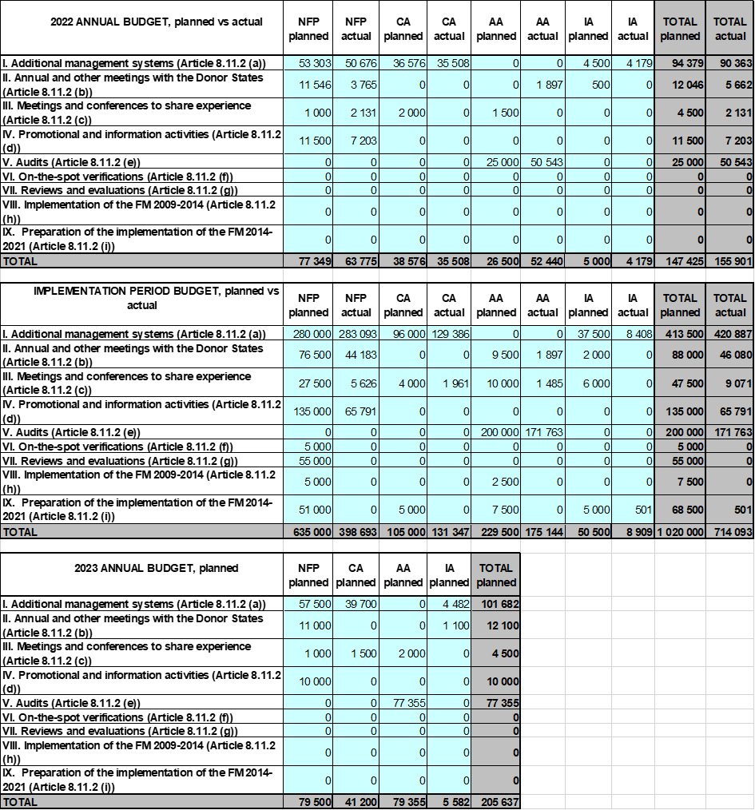

Procurement
No activities have been outsourced by national level institutions.

Staffing

National Focal Point
Name of staff | Official position | Main tasks | Level of effort (% of working time) | Funded through the Grants (Y/N)
Martin Karro | Deputy Director General of the State Shared Service Centre (SSSC) | Head of the National Focal Point | 5 | N
Urmo Merila | Head of the Grants Development Department (GDD) | Head of GDD | 2 | N
Kadi Raudsepp | Head of the Service Design Division of GDD | Head of the Service Design Division of GDD | 2 | N
Laura Pikkoja | Expert (Service Design Division) of GDD | First contact, overall coordination and implementation of Norway/EEA Grants in Estonia | 100 | Y
Marek Kübarsepp | Legal Expert (Grants Managing Division) of GDD | Legal issues, lawyer, MCS | 10 | Y
Annika Mändla | Communication specialist of Communication Department | Communication activities | 3 | Y
Piia Kauts | Communication specialist of Communication Department | Communication activities | 2 | Y
Aveliin Sule | Expert (Grants Managing Division) of GDD | Simplified costs | 1 | Y
Merje Rahn | Expert (Grants Managing Division) of GDD | Application of grants, durability requirements | 1 | Y
Anneli Kimmel | Expert (Grants Managing Division) of GDD | State aid | 1 | N
Kersti Kukk | Expert (Grants Managing Division) of GDD | Public procurement | 1 | N
Kaja Toom | Expert (Grants Managing Division) of GDD | Payments, incl eligibility | 1 | N
Mairi Uusen | Head of the Risk Management and Supervision Division of GDD | Risk management, follow-up on audits, irregularities, financial corrections | 2 | N
Kristiina Piikov | Expert (Risk Management and Supervision Division) of GDD | Risk-basis monitoring of payments, financial corrections | 3 | Y
Tiina Tamberg | Expert (Risk Management and Supervision Division) of GDD | Irregularities, financial corrections | 2 | Y
Kaidi Šatilov | Expert (Risk Management and Supervision Division) of GDD | Risk-basis monitoring of payments, financial corrections | 2 | Y
Anne-Ly Aalde | Expert (Risk Management and Supervision Division) of GDD | Risk assessment | 1 | N
Miryam Vahtra | Adviser in the State Budget Department in the Ministry of Finance of Estonia | Results and evaluation | 2 | N
Certifying Authority
Name of staff | Official position | Main tasks | Level of effort (% of working time) | Funded through the Grants (Y/N)
Pärt-Eo Rannap | Director General of the SSSC | Head of the Certifying Authority | 2 | N
Karin Viikmaa | Head of the Grants Payments Department (GPD) | Head of GPD | 2 | N
Jaanus Kants | Financial Expert of GPD | Coordination of financial reports, forecasts | 2 | Y
Tõnis Virovere | Financial Expert of GPD | MCS, coordination of financial reports, forecasts | 15 | Y
Liina Thalfeldt | Financial Specialist of GPD | financial reports, forecasts | 85 | Y
Audit Authority
Name of staff | Official position | Main tasks | Level of effort (% of working time) | Funded through the Grants (Y/N)
Kaur Siruli | Head of the Financial Control Department of the Ministry of Finance | Head of the Audit Authority / Head of the Irregularities Authority | 5 | N
Kaisa Kallas | Head of the II Audit Unit of the Financial Control Department | Audit Strategy and annual audit work plan. Managing and controlling the work of auditors. | 15 | N
Liina Võrklaev | Lead Auditor of the II Audit Unit in Financial Control Department | Audit work | 30 | Y
Different auditors of the AA | Auditors of the Financial Control Department | Audit work | On the basis of hourly calculation | Y
Irregularities Authority
Name of staff | Official position | Main tasks | Level of effort (% of working time) | Funded through the Grants (Y/N)
Virve Teppart | AFCOS Adviser | Irregularities | 10 | Y

Annex E: Communication summary

1. Summary of communication activities and achievements in the past 12 months
Main activities from April 2022
- Social media quiz/lottery. After answering 3 questions about EEA and Norway grants people entered to win a cooler bag and a bottle branded with EEA and Norway grants logo. 495 participants.
- Two TV clips in a TV show called “Estonia - full of experiences” presenting projects supported through Active Citizen Fund (Jututaja and Improteater) in August (approx 70 616 viewers for Improteater and 67 591 viewers for Jututaja with repetitions). Videos had also sponsored ads on social media (58969 reach and 17 100 views)
- Norway Constitution Day was celebrated with a paid article that was published on one of the biggest news portals Delfi. Article focus was on children and the project Increasing physical activity of schoolchildren. The article had 4387 readers.
- On State Shared Service Centre website funded projects plugin was developed. EEA and Norway grant projects are also visible there: https://www.rtk.ee/toetusfondid-ja-programmid/euroopa-liidu-valisvahendid/toetatud-projektid
- Public awareness survey took place in autumn: public awareness of EEA/Norway Grants is 14%
Main activities in 2023
- We will plan to order two TV clips in a TV show called “Estonia - full of experiences”. Clips will be on air in summer and afterwards we will share and boost them also on social media.
- Social media lottery/quiz again on Facebook in May.
- Ordering article(s) to a newspaper with a large readership.
- Public awareness survey in September.

2. Summary of activities to promote bilateral cooperation opportunities in the past 12 months
Annually in February NFP has a meeting with Norwegian Embassy to plan and discuss communication activities of the year.
Communication specialist in NFP has regular meetings with communication specialist in FMO to find best ways to promote results (NFP has given input to FMO on what projects to film and through that promote, for example) and attends communication workshops organised by FMO.
NFP plans Annual Meetings together with Norwegian Embassy and searches for the most interesting projects to visit together.
NFP always attends Norwegian Embassy receptions (whether cooperation meetings/events or reception to celebrate Norway Constitution Day).
NFP always attends Cooperation Committee meetings and discusses bilateral cooperation there. Last year there were fortunately already several in person meetings.
NFP organises regular meetings 4 times a year with programme operators to discuss status of programmes and bilateral cooperation and the representative of Norwegian Embassy is invited.
NFP is a part of a process, where bilateral activities are approved and promoted under Bilateral Fund with the decision of JCBF. JCBF got together 3 times last year and had 6 written procedures.
NFP has annually TV clips in TV show called "Estonia - full of experiences", is active in social media (games and posts about EEA/Norway Grants).

3. Events
Event description | Audience reached (type and size) | Contribution to communication objectives
Annual Meeting | 26 people from NFP, FMO, Norwegian Embassy, Norwegian Ministry of Foreign Affairs, Embassy of Iceland, Audit Authority, Certifying Authority, Irregularities Authority, Ministry of Finance of Estonia, Ministry of Foreign Affairs of Estonia, Programme Operators, project presenters. Plus after that one-pager was sent out to participants and put on our website together with the minutes and the strategic report (https://rtk.ee/en/funds-and-programs/other-programs/eea-and-norway-grants-estonia#annual-meetings). And additionally post in our FB page: https://www.facebook.com/EEANorwayGrantsEstonia | Increasing the awareness of the public, the media, the target groups of EEA/Norway Grants. Communication previous activities and future plans were discussed. Project visits were organised: “Enhanced capacity on Circular Economy” https://eeagrants.org/archive/2014-2021/projects/EE-CLIMATE-0013; “Development of resource-efficient painted heat-treated wood” https://eeagrants.org/archive/2014-2021/projects/EE-INNOVATION-0051.

4. Best practices
Activity description | Audience reached (type and size) | Contribution to communication objectives
Social media quiz/lottery | 495 participants. Reach 14 280 people. | Increasing the awareness of the public, the media, the target groups of EEA/Norway Grants
TV clips in a TV show called “Estonia - full of experiences” | Projects supported through Active Citizen Fund (Jututaja and Improteater) were presented in August (approx 70 616 viewers for Improteater and 67 591 viewers for Jututaja with repetitions). Videos had also sponsored ads on social media (58969 reach and 17100 views) | Increasing the awareness of the public, the media, the target groups of EEA/Norway Grants
Article in one of the biggest news portals Delfi. Daily more than 430 000 people visit Delfi. | Article focus was on children and the project Increasing physical activity of schoolchildren. The article had 4387 readers. | Increasing the awareness of the public, the media, the target groups of EEA/Norway Grants
Good project example: EE-RESEARCH-0010 (ORBES) – Optimised Residential Battery Energy Storage Systems | This is a good project, considering its very relevant research topic related to the green transition, high quality of research, close communication between all partners, involvement of scientific external experts in Spain and Portugal, active dissemination of results in scientific journals and conferences, as well as with the public and industry representatives. Paper that covers the operation aspects of EV battery converter (IEEE Transactions on Vehicular Technology) became one of the top cited papers of the promoter’s home institute and was nominated for contest “TalTech's Best Research Article of the Year” in 2021. They also take care of academic sustainability through the active involvement of doctoral and postdoctoral students. The consortium includes TalTech (Estonia), NTNU (Norway), RTU (Latvia) and KTU (Lithuania). In addition, external experts from Spain and Portugal are involved. | Bilateral cooperation. The project is focused on two main challenges set by the programme: environmentally friendly solutions and more effective use of resources. These challenges are addressed simultaneously from multiple directions. The ultimate goal is to optimise residential battery storage systems and enhance their potential at different levels: power electronics (hardware) and control (software). The main purpose of such systems is to increase consumption of renewable (photovoltaic) energy on or near the site to reduce the impact on the power grid. However, to make the most of the potential of such systems, their potential and impact on provision of ancillary grid services should also be evaluated. In 2022, the project teams’ work continued on further analysis of the information about state-of-the art in power electronics for residential storage applications. Several contributions related to development of battery interface converters were presented in international conferences and scientific peer-reviewed publications. These achievements and joint publications have been implemented through continuous collaboration and a direct result of cooperation between the project partners.

5. Media coverage

Example 1
Coverage | Type | National
Description | Two TV clips in a TV show called “Estonia - full of experiences” presenting projects supported through Active Citizen Fund (Jututaja and Improteater) in August (approx 70 616 viewers for Improteater and 67 591 viewers for Jututaja with repetitions). Videos had also sponsored ads on social media (58969 reach and 17 100 views)
Relevant links | https://www.facebook.com/100064655442961/videos/431246948789465  https://www.facebook.com/EEANorwayGrantsEstonia/videos/1201405333734602/

Example 2
Coverage | Type | National
Description | Norway Constitution Day was celebrated with a paid article that was published on one of the biggest news portals Delfi. Article focus was on children and the project Increasing physical activity of schoolchildren. The article had 4387 readers. Reach 14 280 people.
Relevant links | https://arileht.delfi.ee/artikkel/96634961/norra-konstitutsioonipaev-on-puhendatud-lastele

6. Website and social media

6.a. Links to the website and social media accounts
Link to the website
https://rtk.ee/en/funds-and-programs/...
Total number of page views in the reporting year | Change in number of (page views) compared to the previous year | Total number of unique visitors in the reporting year | Change in number of (page visitors) compared to the previous year
3712 | 1228 | 3365 | 1037

Specific link or handle for the account | Posts published in the reporting year | Total likes in the reporting year | Total comments in the reporting year | Total shares/Re-tweets etc. in the reporting year | Followers gained since programme launch
Facebook | https://www.facebook.com/EEANorwayGrantsEstonia
 | 45 | 643 | 16 | 62 | 714

6.b. Results of website and social media activities
Last year when writing the strategic report, the EEA and Norway Grants Estonia Facebook page had 648 followers. Now, by February 2023 Facebook page has 714 followers. The initial goal was that by the end of new financing period, EEA and Norway Grants Estonia page in Facebook should have at least 500 followers. As the goal was achieved, we set the next goal to 700 followers. That goal has also been reached and the new goal will be 800 followers.
We actively keep sharing the news about EEA and Norway grants and the projects. We use social media for visibility of results by sharing project articles, coverage of events. General promotion of the grants is also done via social media using sponsored posts.

7. Visuals
2022 Annual Meeting project (https://eeagrants.org/archive/2014-2021/projects/EE-INNOVATION-0051) visit:
https://eealibrary.org/asset/26066/Project%20visit:%20Development%20of%20resource-efficient%20painted%20heat-treated%20wood
https://eealibrary.org/?assetItemIds=48402,48401,48400,48399,48395,48398,48397,48396&page=1

